Global Substance Registration System (GSRS)

User Guide

|  |  |  |  |
| --- | --- | --- | --- |
| Document Version History | | | |
| Version | Description of Change | Document Change By | Effective Date |
| **1.0** | GSRS Version 3.0 | Elizabeth Callahan/ Sarah Stemann | 11/19/21 |
|  |  |  |  |
|  |  |  |  |
|  |  |  |  |
|  |  |  |  |

Table of Contents

Introduction 8

Homepage 8

General Homepage Navigation 8

Registration Page Access Navigation Options 10

Registrars Page 11

Browse 11

Browse Substance Page Components 11

Filter/Facets (Filters) Pane 12

Header Features 13

Export Results 13

Browse Substance Results Pane View Options 15

Results Pane Full View Default Option 16

Results Pane Table View Option 17

Results Pane Tile View Option 17

Substance Actions 18

Search 19

Global Search 20

Advanced Search 20

Check for Duplicate Substances 21

Obtaining Chemical Structures for GSRS 22

Draw Structure 22

Get Structure from Name 23

Load Image (via copy/paste or drag local file) 24

Import Structure from Molfile or SMILES 24

Molfile 24

SMILES String 25

Structure Search 26

Structure Search Type Options 26

Export Structure from the web drawing tool 28

Structure Search from an existing GSRS Substance 29

Sequence Search 30

Sequence Search from Existing Substance Record 32

Register Chemicals 33

Overview – Registering New Chemical 33

Names 38

Structure 40

Codes 42

Relationships 45

Impurity Relationships 46

Metabolite relationships 47

Notes 49

Property 50

References 50

Submit 50

Register Chemical Stereoisomers 52

Register Proteins 56

Check for Duplicates 56

Global Search 56

Sequence Search 56

Protein Registration 56

Definitional Information 56

Names 56

Protein Details 56

Subunits 57

Other Links 59

Disulfide Links 61

Glycosylation 62

Agent Modifications 63

Structural Modifications 64

Physical Modifications 66

Codes 66

Relationships 66

Notes 66

Properties 66

References 66

Submit 66

Register Nucleic Acids 66

Check for Duplicates 66

Global Search 66

Sequence Search 67

Nucleic Acid Registration 67

Overview - Definitional Information 67

Names 67

Nucleic Acid Classification 67

Subunits 68

Links 68

Sugars 69

Agent Modifications 69

Structural Modifications 70

Physical Modifications 70

Codes 70

Relationships 70

Notes 70

Properties 70

References 70

Submit 70

Register Polymers 70

Check for Duplicates 70

Global Search 70

Polymer Registration 71

Definitional Information 71

Names 71

Polymer Classification 71

Monomers 72

Idealized Structure 73

Structural Units 73

Agent Modifications 75

Physical Modifications 75

Codes 75

Relationships 75

Notes 75

Properties 75

References 75

Submit 75

Register Structurally Diverse 75

Check for Duplicates 75

Global Search 75

Structurally Diverse Registration 76

Overview Definitional Information 76

Names 76

Source Material 76

Parts and Fractions 77

Agent Modifications 78

Structural Modifications 78

Physical Modifications 78

Modifications for Gene and Cell Therapies Example 78

Codes 80

Relationships 80

Notes 80

Properties 80

References 81

Submit 81

Register Mixture 81

Check for Duplicates 81

Global Search 81

Mixture Registration 81

Definitional Information 82

Names 82

Mixture Details 82

Components 82

Agent Modifications 82

Structural Modifications 83

Physical Modifications 83

Names 83

Codes 83

Relationships 83

Notes 83

Properties 83

References 83

Submit 83

Register Concept 84

Check for Duplicates 84

Global Search 84

Concept Registration 84

Names 84

Codes 84

Relationships 84

Notes 85

Properties 85

References 85

Submit 85

Approve Substances 85

Edit Substances 88

Advanced Features 88

Change Substance Class 89

Change Status to Pending 90

Change Status to Approved 92

Check for Duplicates 93

# Introduction

This is a guide explaining how to browse, search, and register a new substance (Chemical, Protein, Nucleic Acid, Polymer, Structurally diverse, mixture and concept) in GSRS. This document contains screen shots from GSRS version 3.x. The chemical and protein registration processes are given in detail and some parts of other substance types refer to these details.

The substance type should be identified, and the correct registration form should be used.

GSRS system has registration forms for:

1. Chemical
2. Protein
3. Nucleic Acid
4. Polymer
5. Structurally Diverse
6. Mixture
7. Concept
8. Group 1 Specified Substance – will be covered in a future version

# Homepage

## General Homepage Navigation

1. The blue menu bar also known as the Navigation Pane is accessible from all pages of GSRS, it includes the following:
   1. Menu “hamburger” expands the menu in order to access the features that are also listed in the Quick Links panel on the left

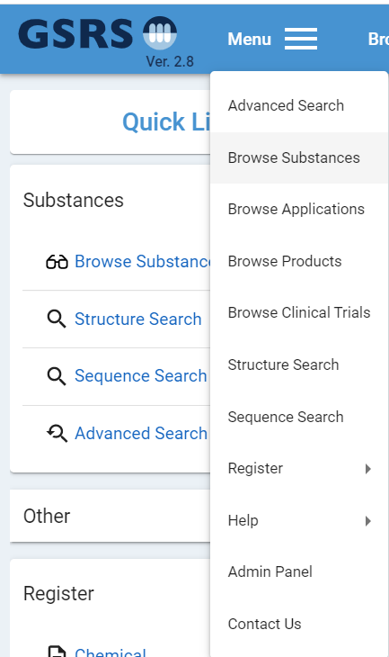

1. Navigation Pane

a.

Figure 1: Navigation Pane, Quick Links, and Hamburger Menu

* 1. Browse Substances (discussed in detail below)
  2. Browse Other which is based on your GSRS instance implementation of additional non-substance modules
  3. Register (discussed in detail below)
  4. Advanced Search (discussed in detail below)
  5. Search Substances, often referred to as global search, which allows you to enter free-text and search across all substance types at once
  6. Login which is based on your GSRS instance and may be hidden if your agency is using single sign-on



Figure 2: Navigation Pane

g.

f.

e.

d.

c.

b. 

a.   

1. The announcement may be displayed or hidden based on the GSRS instance’s configuration
2. In the center pane are options for features which are also accessible from the menu
   1. Under the Total Substances is a break-down with quick link to the browse page, for total substances for each substance type
   2. Below the total substances quick links, are Helpful Resources which are publicly available to support users of GSRS

3..

a.   

b.   

2.   

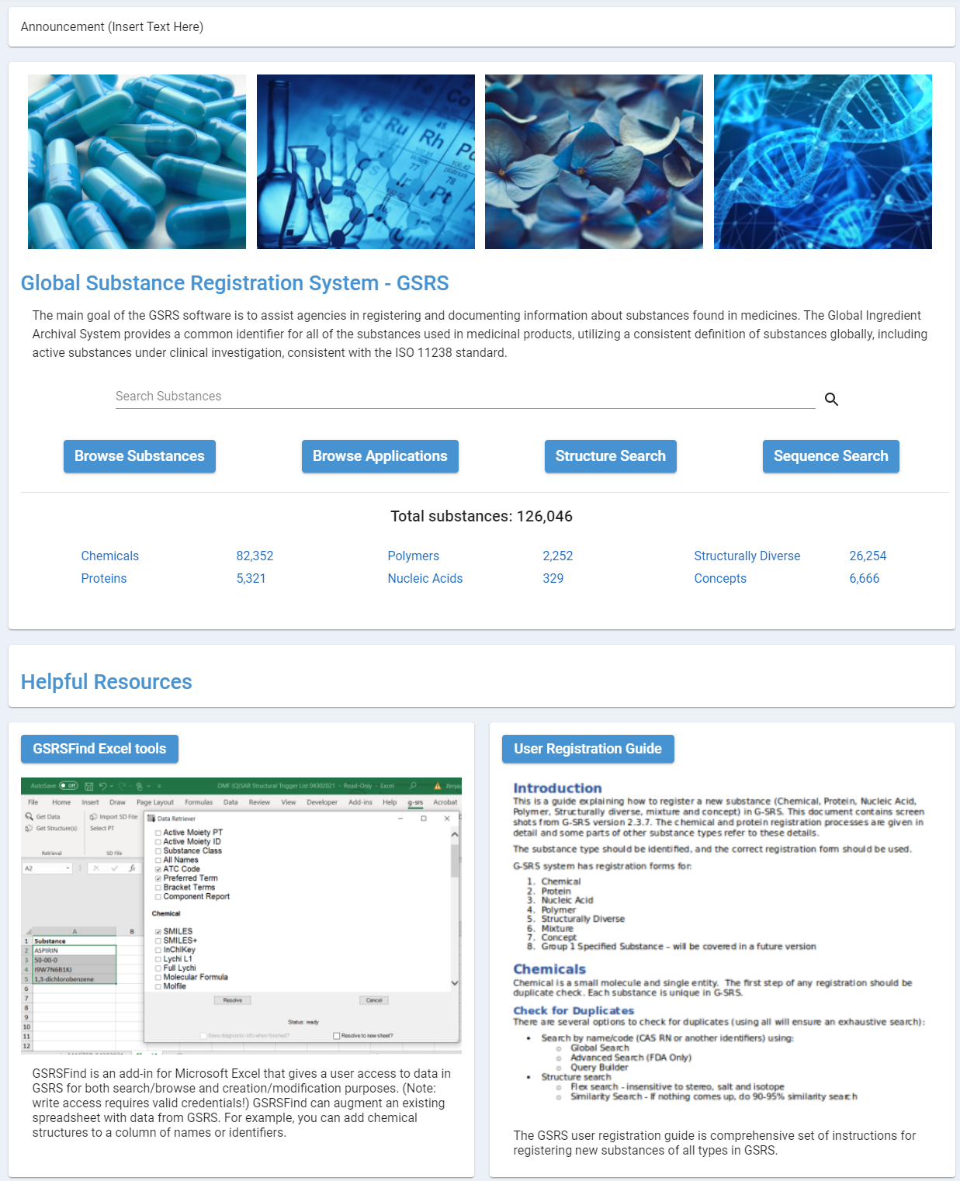

Figure 3-Homepage Center Pane

## Registration Page Access Navigation Options

1. There are several options for selecting the substance registration page.
   1. Select a substance type under Register in the Quick Links section of the Left Nav
   2. Select the Menu hamburger and scroll down to Register and select the type of substance you want to register

b.   

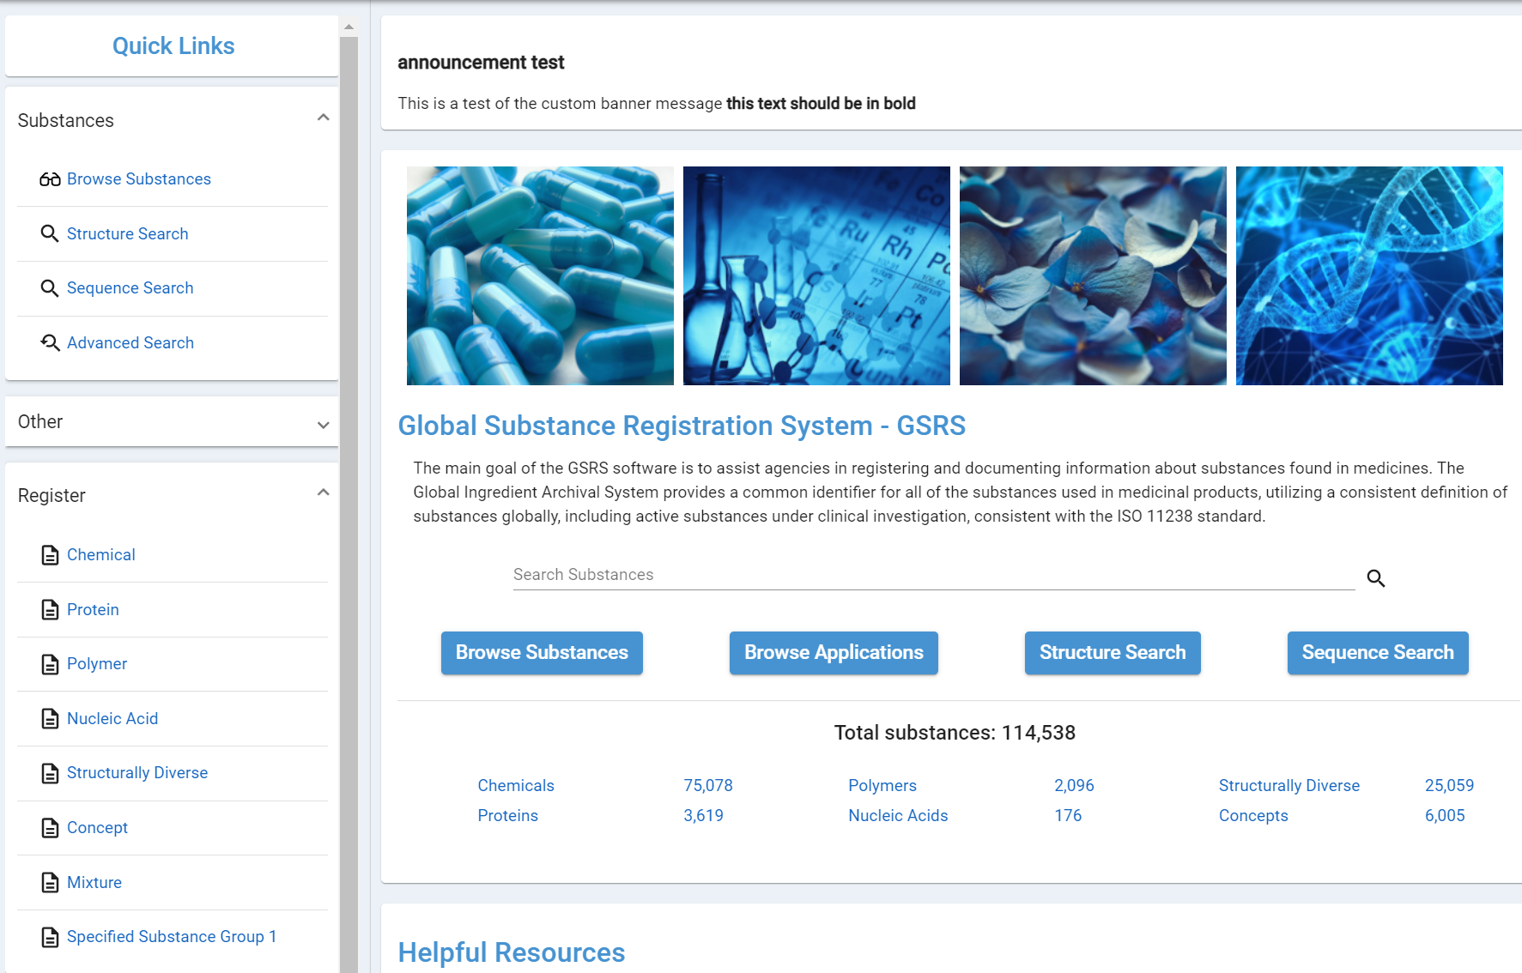 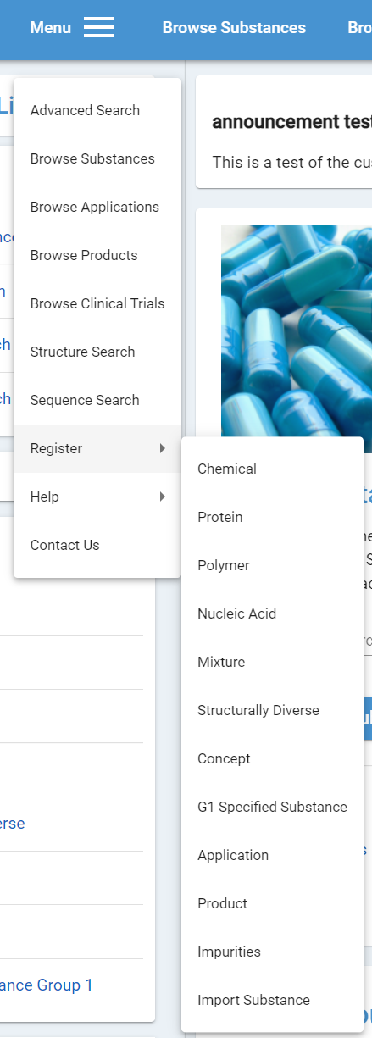

a.   

Figure 4-Registration Page Access Navigation Options

* 1. After login the Register menu appears in the center of the navigation pane if you have the right user access. Scroll down to select the type of substance you want to register
  2. After login the Registrars Link appears on the far right and takes you to the Registrars homepage (this may be hidden based on your user type).

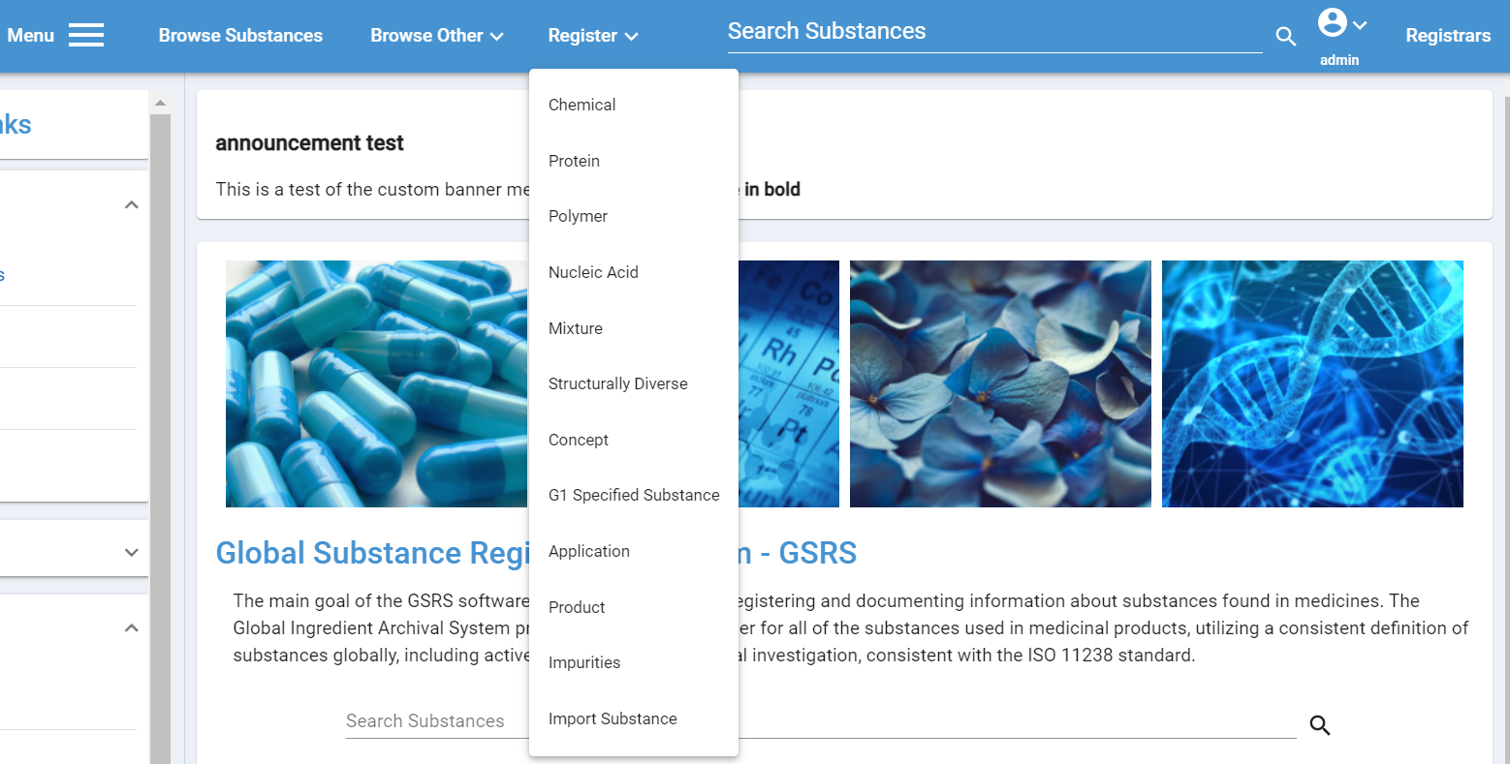

d.

c.

Figure 5-Registration Type Access and Registrar’s Page

# Registrars Page

In addition to the general homepage, users with elevated permissions will have access to the Registrars homepage and can add this to their browser bookmarks. Below is the view of the Registrars page

1. Left Search column gives option to browse or search data
2. Middle Register column allows you to select the type of substance you want to register
3. Far right column is the Registrar’s Quick Links-Statistics/Quick Search pane that includes links to browse results for substances. This particular feature allows registrars to go directly into substances with a UNII in the first column or pending substances in the second column

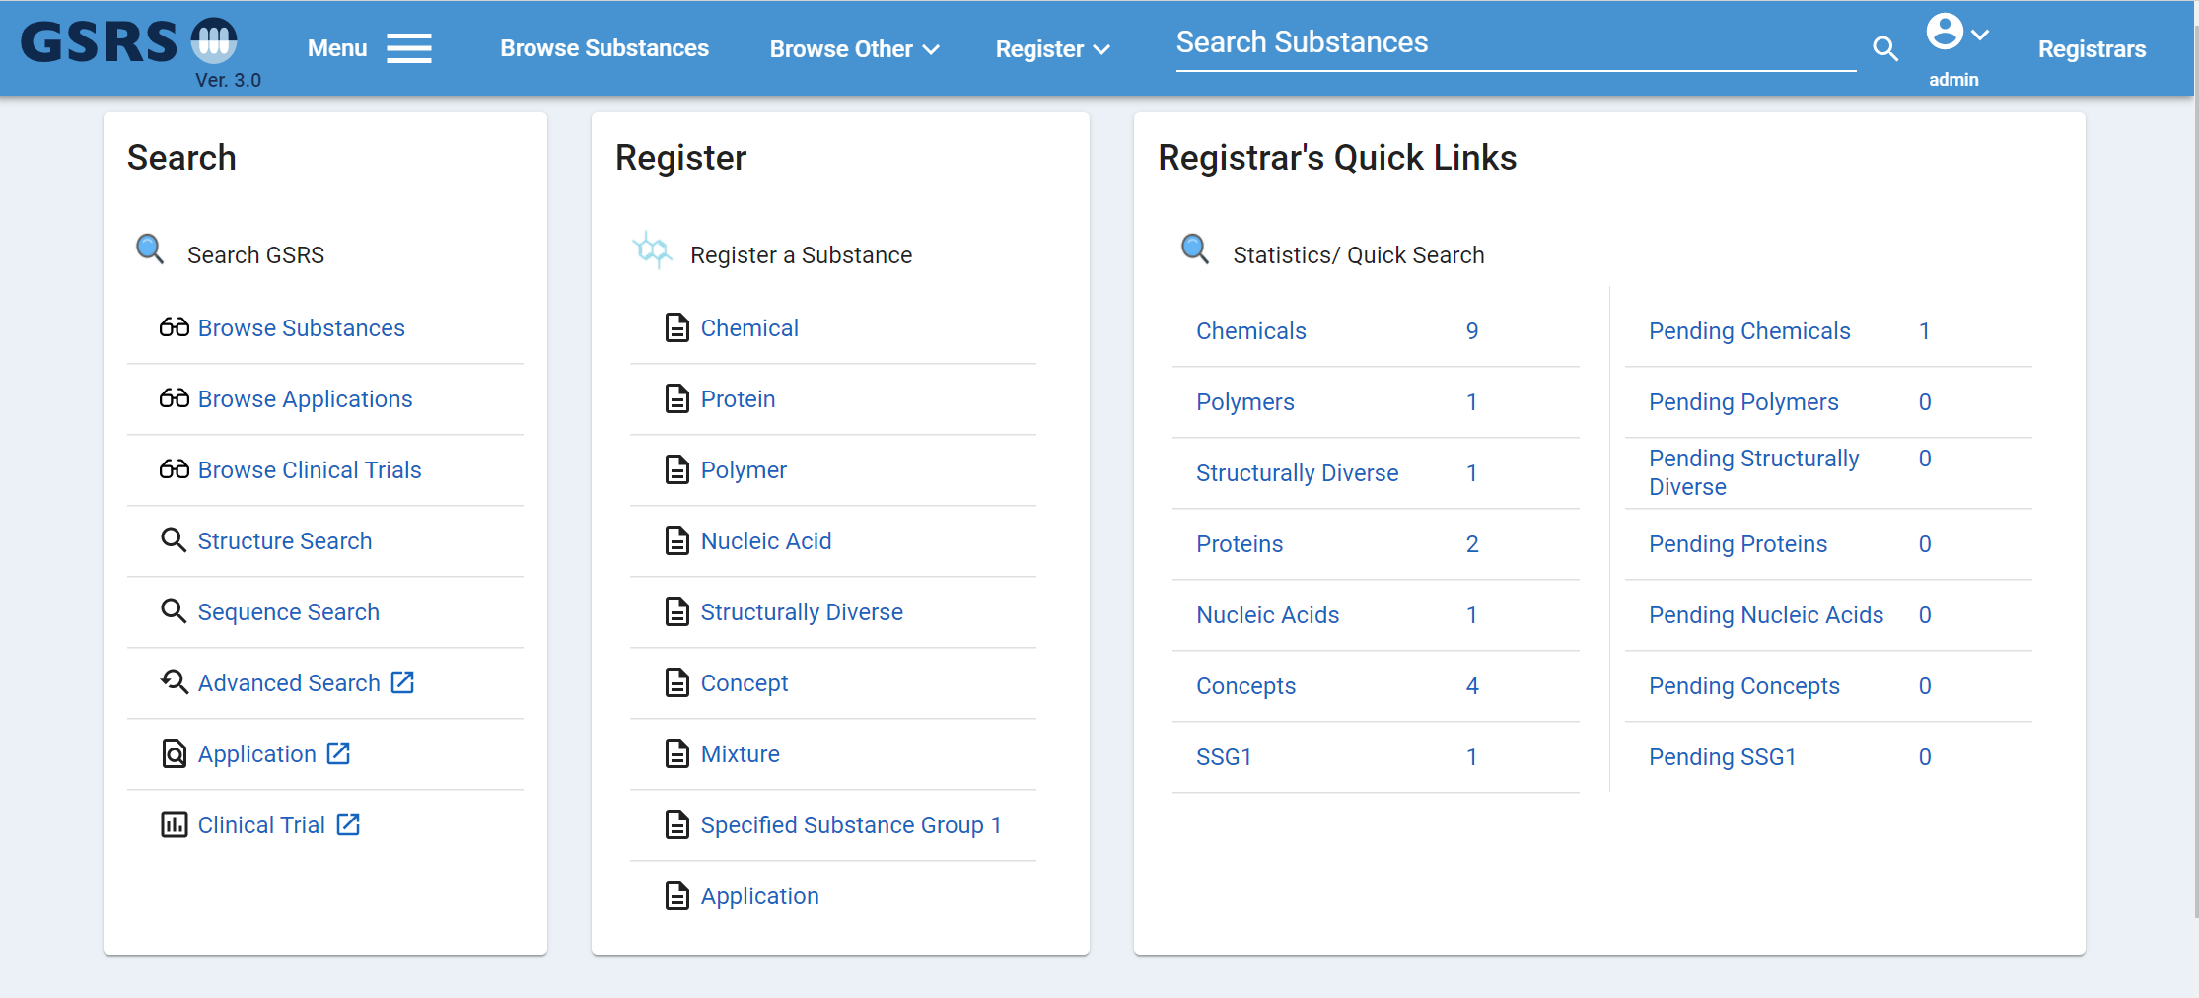

3.

2.   

1.

Figure 6-Registrars Page

# Browse

## Browse Substance Page Components

The Browse Substances page displays a summary view of substances and is divided into three major components, as noted in red in the screenshot below:

1. Filter/Facets Pane
2. Header Section
3. Substance Results pane

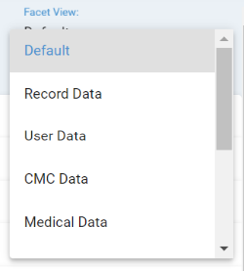

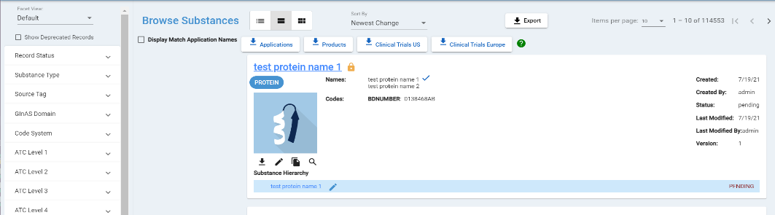

Header Section

Substance Results Pane

Filter/Facets Pane

Figure 7-Filter/Facets and Substance Home Page Labeling

### Filter/Facets (Filters) Pane

The filter view pane is located on the far left of the dashboard. The filter will show “default” until you select the down arrow to view the options by data type. Once the filter view is selected, the items on the facet will dynamically be available for selection for the data type criteria. Expand using the down arrow/caret highlighted above. The user can see the number of substance records stored in the GSRS database that match the filter criteria to the right.

Under each filter title is the “Search [Facet name]…” box to search filter options that are not explicitly displayed. Enter text (full or partial) and search for the filter category within the filter.

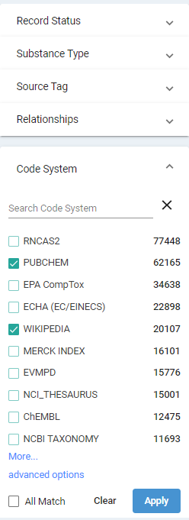

To the left of each filter category name is a checkbox.

At the bottom of the displayed list is a link to “More…”. This will expand the filter list to display the next 20 options.

After making your filter selections the “All Match” option is displayed. By default, the filters are applied as “Any Match” and will return all records that match any one of the selected options. Select “All Match” to return records that match all of the selected options.

Select “Apply” to filter substances based on the selected filters (for one or more filters at once). In this example we selected the Target->inhibitor Relationships and the PUBCHEM and WIKIPEDIA Code System facets. The applied facets are at the top of the display pane in the headers section boxed in red below and can be removed which will update the substance record results. The filtered substances are displayed in the Substance Results pane to the right in the large red box.

Filter Example:

**Relationships** = Target -> Inhibitor

**Code System** = PUBCHEM AND WIKIPEDIA

Figure 8-Filter Categories

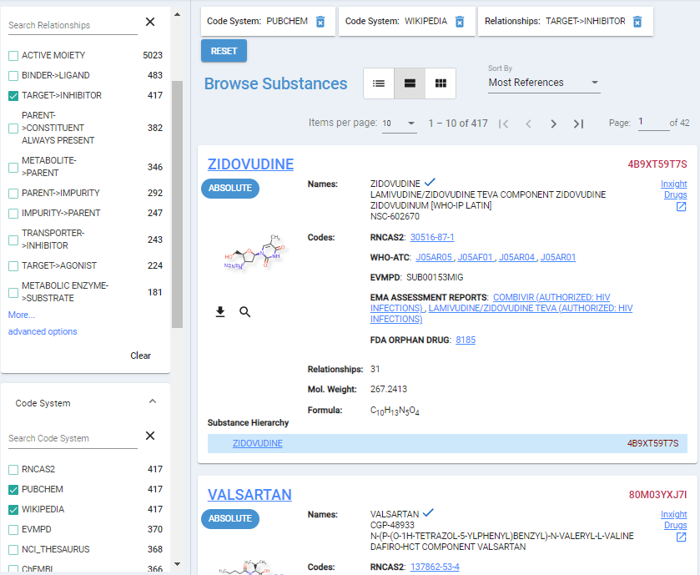

Figure 9-Browse Substance Views and Results Pane

### Header Features

The header for the results or browse screen displays the total number of records returned by GSRS that match the filter criteria. It also includes pagination in order to navigate to a specific page of results. The Items per page can be edited as well as the Sort By using the arrow to see the options.

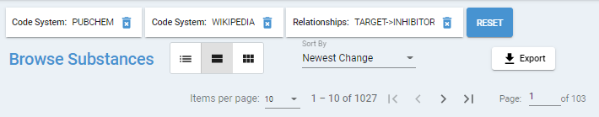

Figure 10-Sort by and Browse Substance Results Quantity

### Export Results

If you have logged into your user account, an Export button appears on the right. The Export button allows the user to export the substance records to one of the following formats in the red box below. If you want private records be sure to select the “Include Private Data” box.

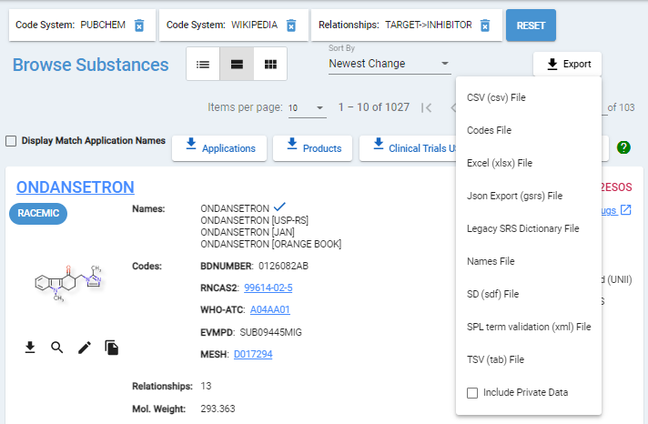

Figure 11-Export Options

After initiating an export, enter a filename (or accept the default date/time) and select Save.

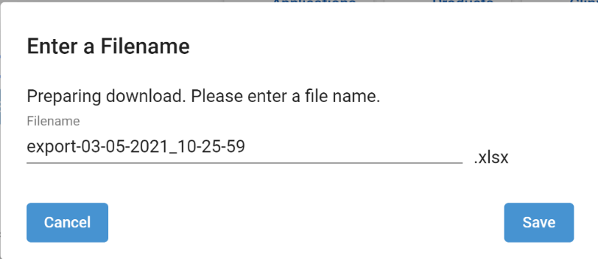

Figure 12-Confirm File Name

While the download is generating, you can continue using GSRS.

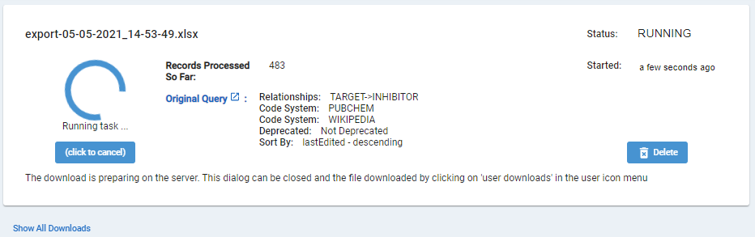

Figure 13-Sample of Download generation in process

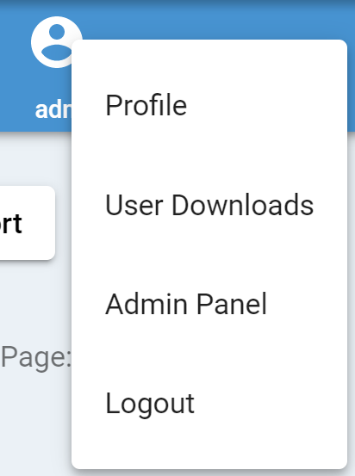When you are ready to access your export, select the down arrow next to your profile from the Navigation pane, and select User Downloads.



Figure 14-User Download in pulldown menu

The User Downloads page displays all downloads that your account has exported from GSRS. Select the Download button to view the results in the selected format. Select Original Query to re-open the substance records results.

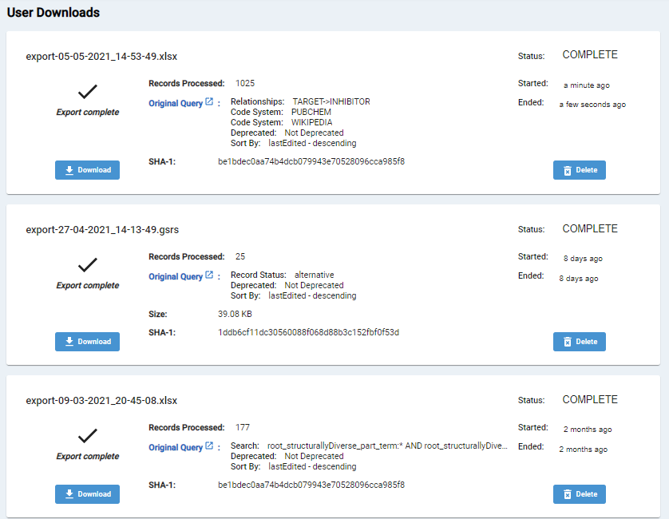

Figure 15-User Download Page

### Browse Substance Results Pane View Options

In the header section, the user can select one of three icons to display the results pane in different views formats.



Figure 16-Browse Substance Results Pane View Options

The middle icon is the default format for the “full view”. The left icon is the “table view” and the right icon is the “tile view”.

#### Results Pane Full View Default Option

The results pane is shown in the screenshot below, outlined in the red box. Here, the substance answers are displayed in the format selected. By default, the full view provides a summary for each record returned by the GSRS database, (this view will contain a high-level preview of Names, Codes, Relationships).

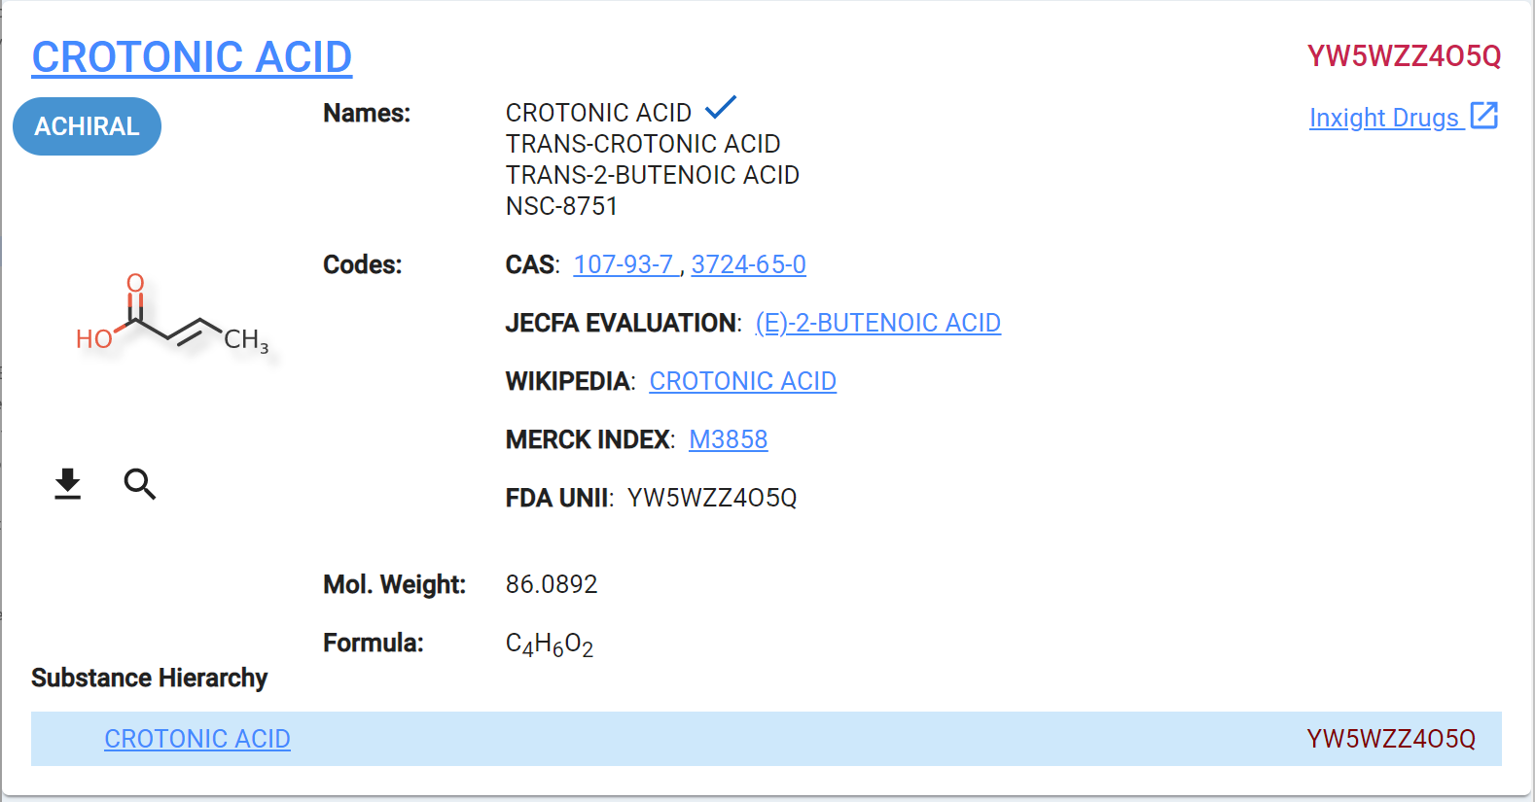

Figure 17-Results Pane Full View

Additional information depending on substance type is presented in the detailed view of each substance if you select the underlined substance name. This is the display name also knows as the preferred term. An example of the default full view for a chemical substance record is shown below.

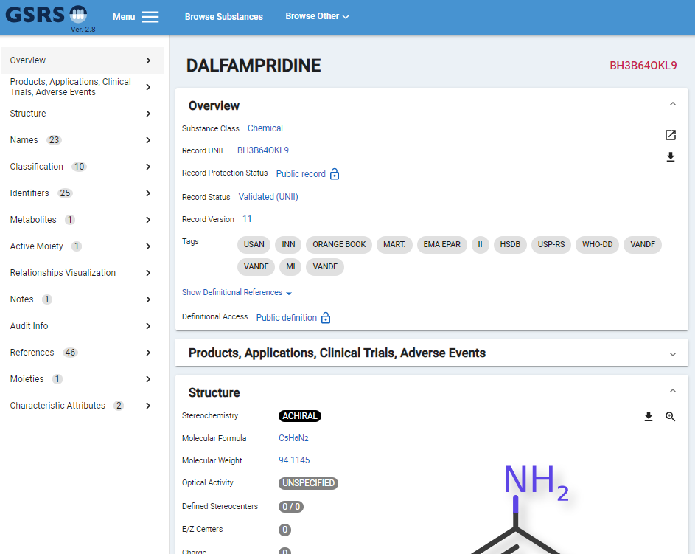

Figure 18-Detailed View of Substance

The additional information incorporated into the detailed view of each substance type is included below:

* Chemical
  + Formula
  + Number of moieties
  + Stereochemistry
  + 2D structure
* Structurally diverse
  + Whole/Part/Full fields
* Mixture
  + Number of components
* Polymer
  + Display structure
  + SRUs generation
* Protein
  + Number of subunits
  + Disulfide Links
  + Glycosylation
* Nucleic Acid
  + Number of subunits
  + Sugars
  + Linkages

#### Results Pane Table View Option

The table view of Browse Substances provides basic information which includes the substance approval ID (UNII code, if any), names, codes (e.g., CAS, WHO-ATC, EVMPD, MESH, Drug Bank.) An example of the Table View is shown below:

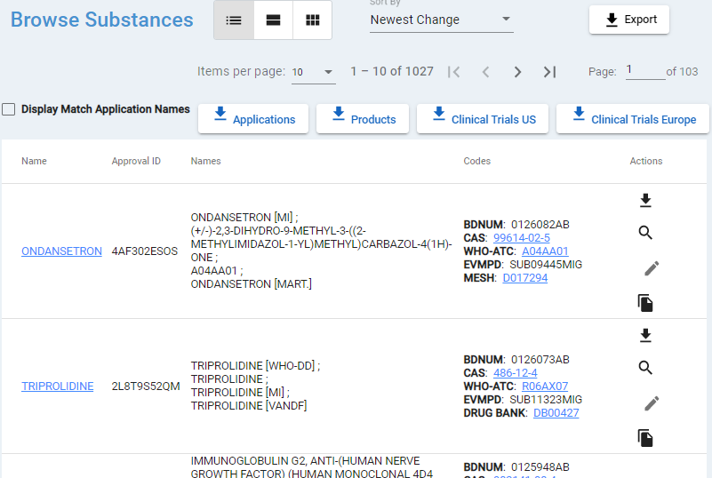

Figure 19-Table View of Substances

#### Results Pane Tile View Option

The tile view of Browse Substances solely presents the approval ID (if any), the preferred name of the substance, and the structure (if the substance is either a chemical or a polymer). It also gives information about the substance record access. An example of the Tile View displaying several chemical substance records is shown below:

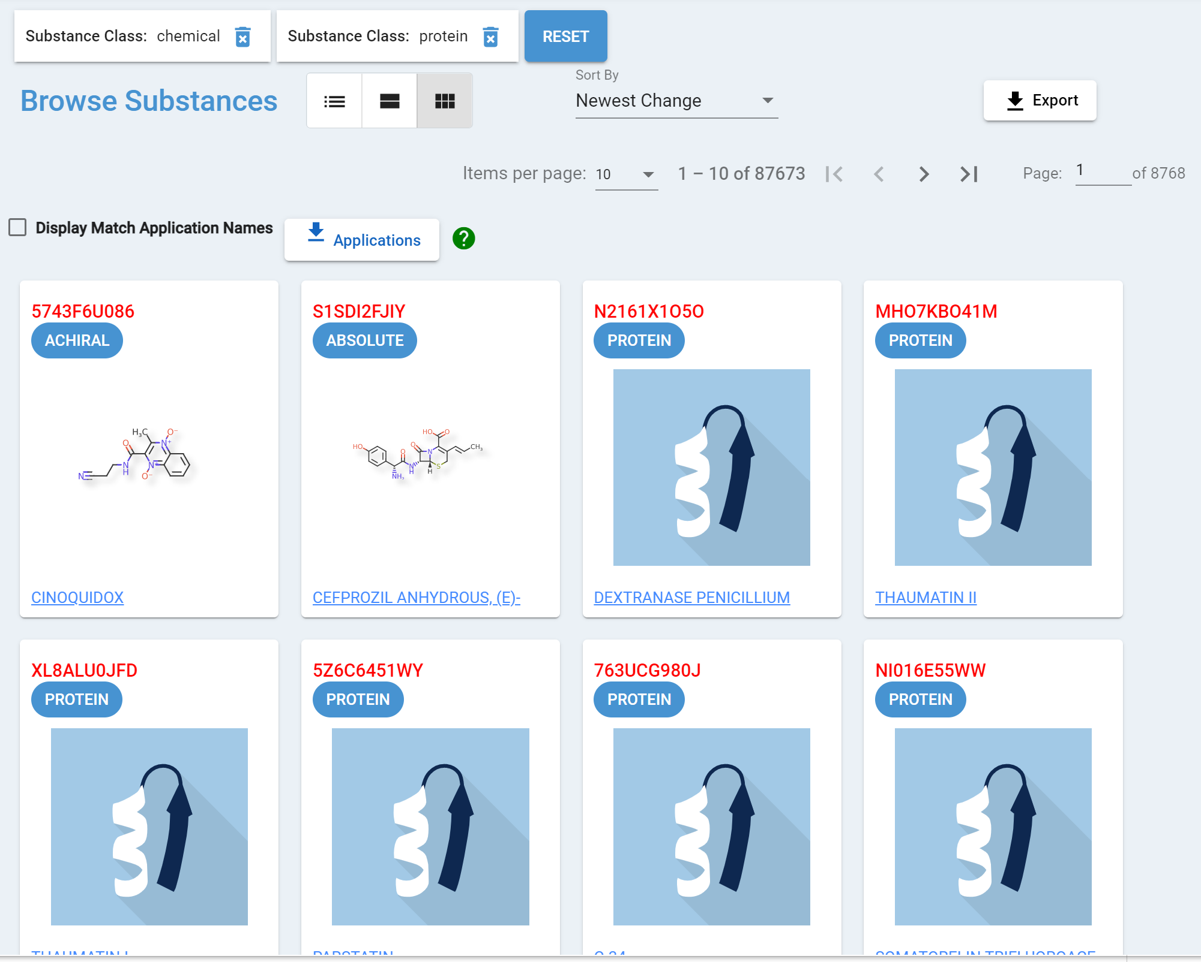

Figure 20-Tile View of Substances

### Substance Actions

From the Browse results pane, frequently used substance actions are available from the icons below the structure/substance icon.

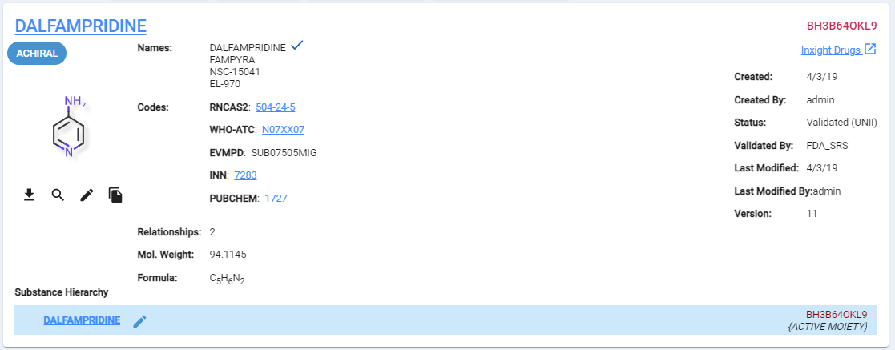

Figure 21-Browse Substances Pane Action Icons

All users are able to:

* Download 
  + Chemicals – Molfile, JSON
  + Protein –Fasta, JSON
  + Polymer – Molfile, JSON
  + Nucleic Acid – Fasta, JSON
  + Download not applicable for Structurally Diverse, Concept, Mixture, Group 1 and Group 3 Specified Substance
* Search 
  + Chemicals – transfer the structure to the Structure Search interface; there is right click option to open in new tab/window.
  + Protein – Sequence Search; select subunit Similarity Search
  + Polymer - transfer the structure to the Structure Search interface
  + Nucleic Acid - Sequence Search; select subunit Similarity Search
  + Search not applicable for Structurally Diverse, Concept, Mixture, Group 1 and Group 3 Specified Substance

For all substance types users with elevated privileges are also able to:

* Edit 
* Copy 
  + You can select Copy Substance to New Form for the whole substance record or select Copy Definition to New Form to get the definition to register a new substance

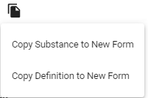

# Search

GSRS supports several means for searching substances based on user-specified criteria. These are Global Search, Advanced Search, Structure Search, and Sequence Search.

1. Global Search
   1. Name – enter name of the substance
   2. Code (CAS RN or another identifiers): enter the numeric and/or alphabetic (numbers/letters) code
   3. Sequence Search – copy and paste a sequence
2. Advanced Search
3. Structure Search
   1. Reference Export Structure from Structure Search once you have confirmed your substance is new and unique
4. Sequence Search

## Global Search

Global search is a free-text search box in the top center of every page as shown in the screen shot below.

1. Type the text you are looking for. Some searches may require your text to be in quotes. You can also try adding an asterisk at the end to make it a begins with search.
2. The type-ahead feature will display the top matches for approval ID and names separated by preferred names and all other name types.
3. You can select from one of the matches from the list or use the magnifying glass for a wider search.
4. Results are presented in the display pane.
5. This search also allows for fielded, wildcard, fuzzy, group, and Boolean searches using word based [Lucene query syntax](https://lucene.apache.org/core/2_9_4/queryparsersyntax.html) (It will look for a dash or a space in the search string when doing the search.) You can also use an Inchi key as well.



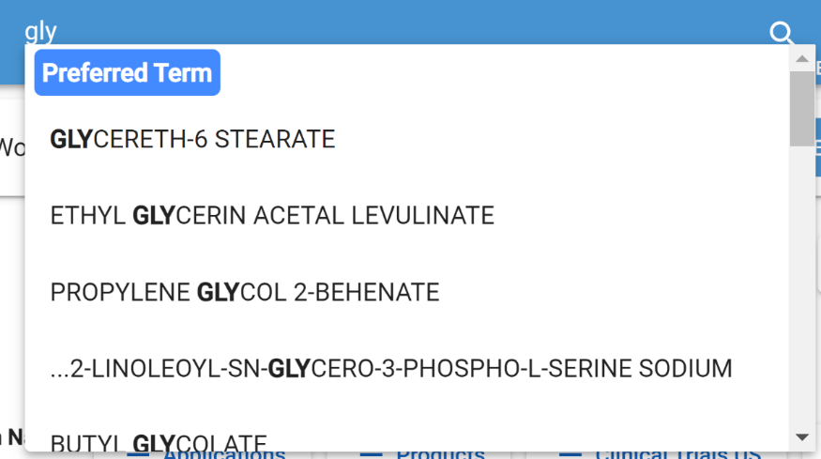

Figure 22-Global Search on Navigation Bar

## Advanced Search

There are few ways to access Advanced Search:

* Next to the Global Search bar, select Advanced Search
* From the hamburger icon on the navigation pane, select Advanced Search
* From the home page Quick Links select Advanced Search

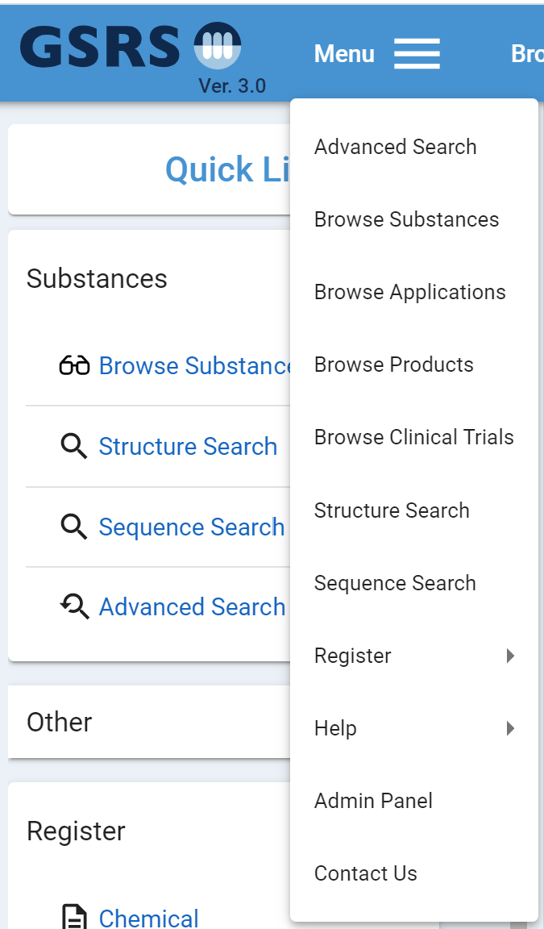

Figure 23-Advanced Search location for selection

### Check for Duplicate Substances

1. To check for duplicate substances using Advanced Search make the following selections:
   1. **Substance tab**
   2. **Search in Fields**: Using the pulldown menu
   3. **For:** Select Contains, Exact Match, Starts with, or Show More Options
   4. **Enter search value**
2. Click the Search button
3. Review the results to ensure the new entry is not already represented by another

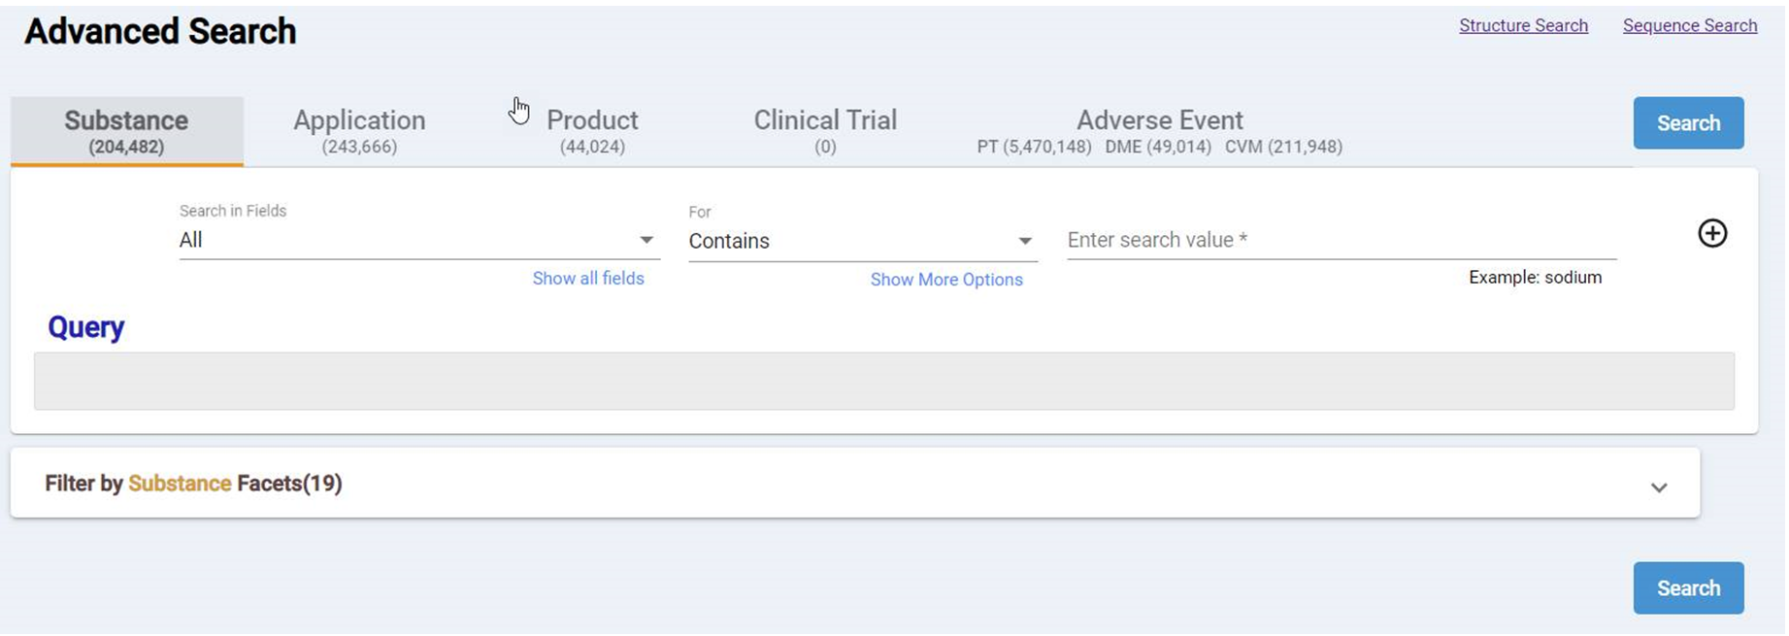

Figure 24-Advanced Search Options

User also has the option to add additional searches to do conditional searching using AND, OR, or NOT. You can delete multiple search criteria by selecting the minus sign.

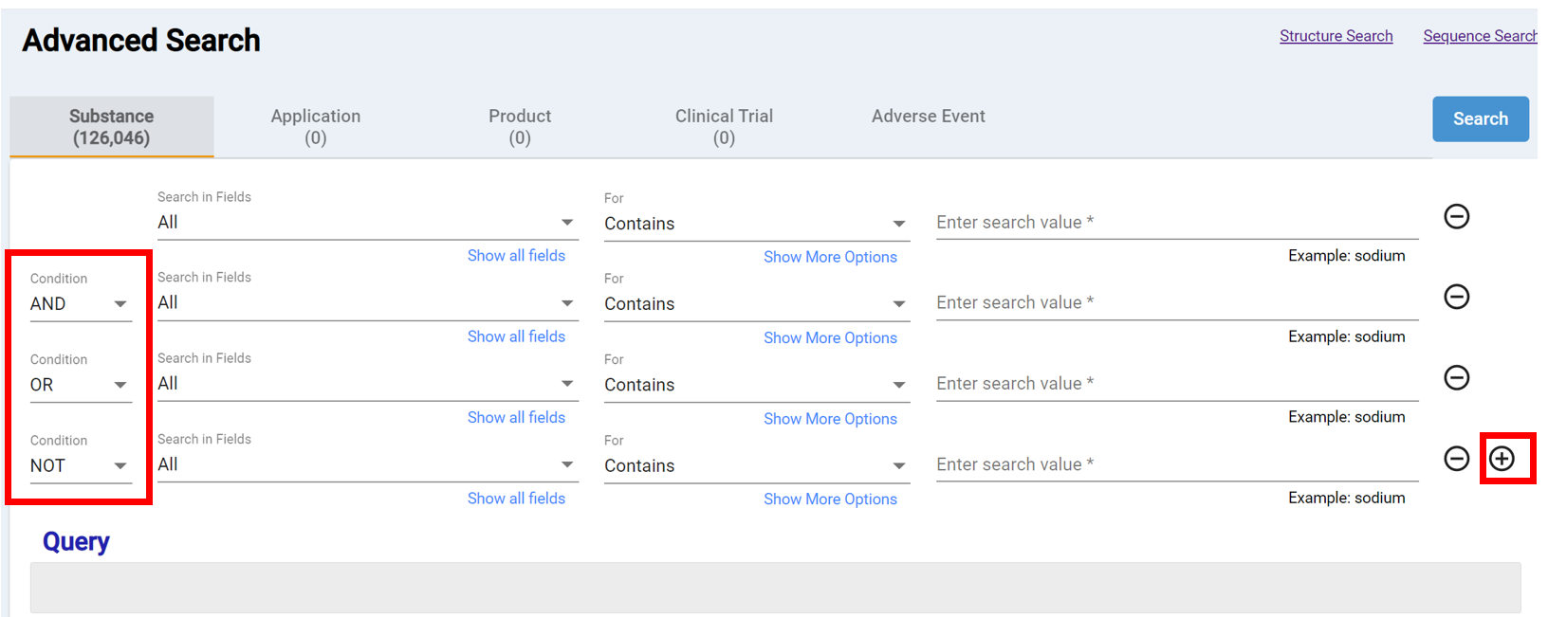

Figure 25-Advanced Search Conditions

## Obtaining Chemical Structures for GSRS

GSRS is a chemically aware system and can make use of chemical structure formats for searching and registration. There are many ways to import, draw or obtain a machine-readable chemical structure. The four main ways that we import structures are:

1. Draw Structure
2. Get Structure from Name
3. Load Image
4. Import Structure from Molfile or SMILES

Draw Structure

1. Use either the default web editor directly or you can import molfiles or SMILES strings from standalone chemical editors using one of the methods below.
   1. Symyx Draw is the preferred standalone because the molfile is its native format.
   2. Scifinder provides an option to export molfiles
   3. Chemdraw generate structures from systematic names

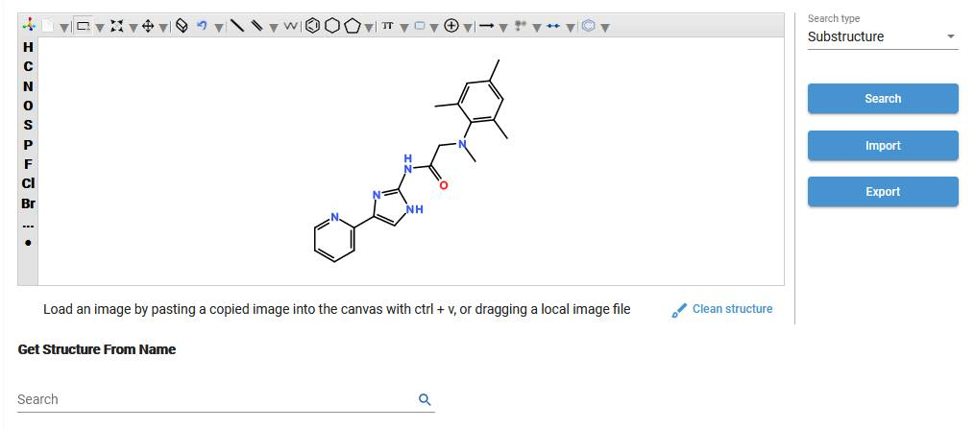

Figure 26-Draw Structure

Get Structure from Name

1. Below the canvas, enter the substance name in the search field
2. Select magnify glass 

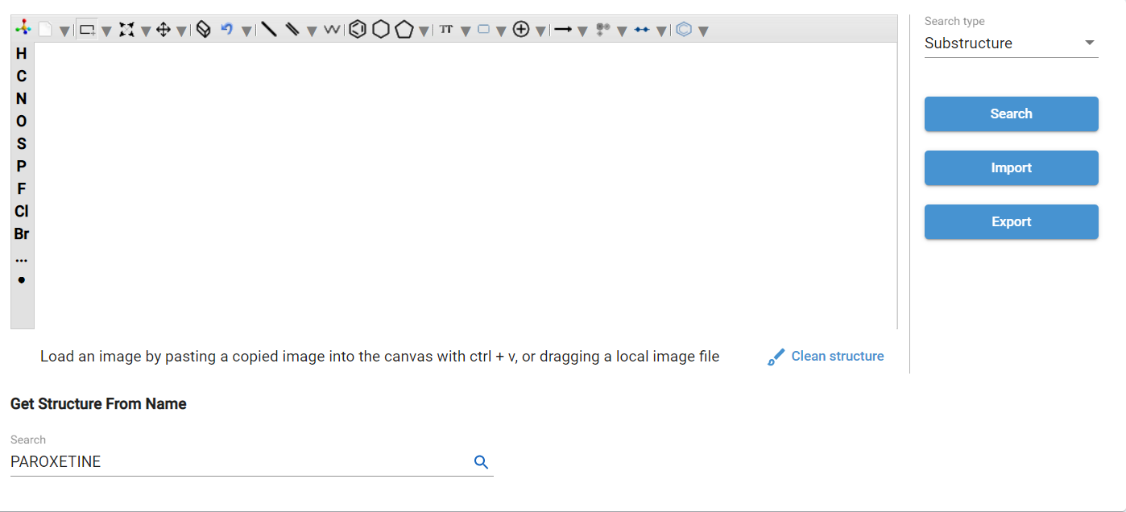

Figure 27-Get Structure from Name

1. Select one of the matching substances (this example selects the one in the red box below).
2. Select Apply Structure to populate the canvas
3. Verify the imported structure, minor adjustments may be required, use the chemical web editor toolbar to make your edits before selecting Search

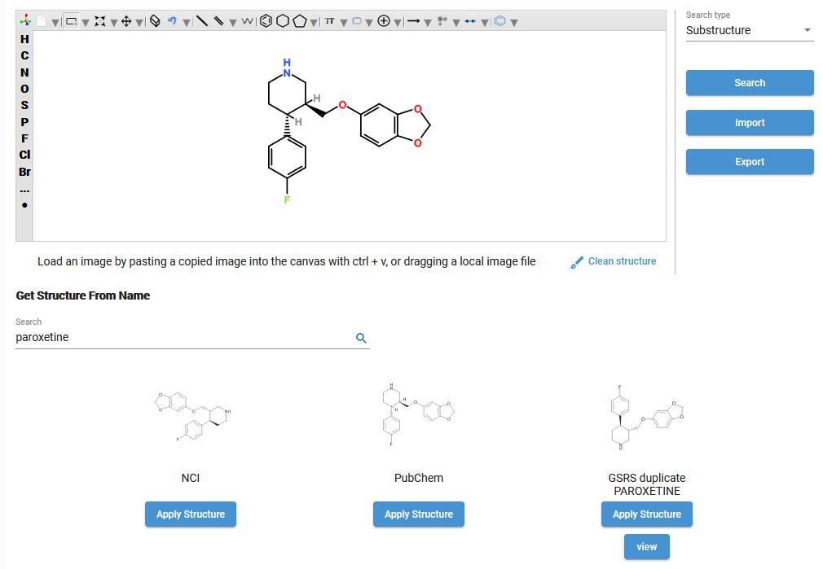

Figure 28-Apply Structure

### Load Image (via copy/paste or drag local file)

GSRS can convert images to structures when it is pasted onto the canvas

1. Copy a source image (ctrl+c) or use a snipping/screenshot tool to load the structure image into your clipboard
2. Click on canvas (canvas border will turn blue),
3. Press ctrl+v or drag a local image file
4. Verify the imported structure, minor adjustments may be required, for example in the structure shown below was not converted correctly, use the ctoolbar to make your edits before selecting Search

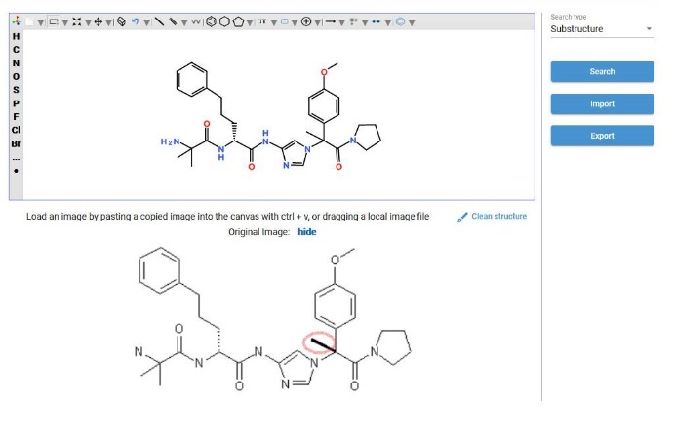

Figure 29-Load Image

### Import Structure from Molfile or SMILES

1. Select Import
2. Select Browse
3. Navigate to structure location (where it’s saved on your computer) and select the image name (e.g., molefile or SMILES string)

#### Molfile

1. Select Open and the Molfile appears
2. Select Import to display the structure on the canvas.

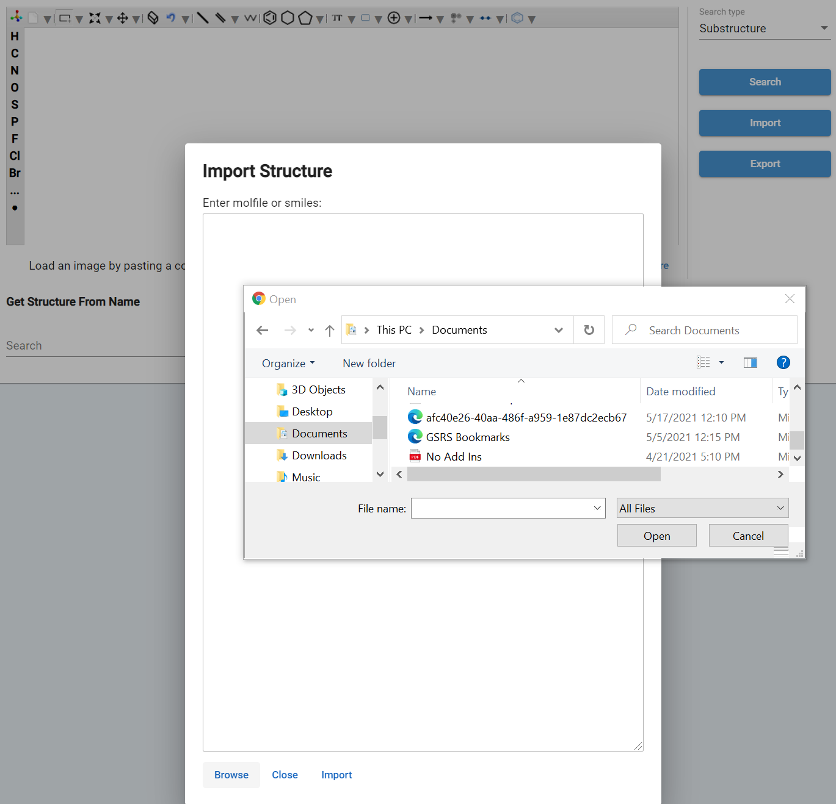 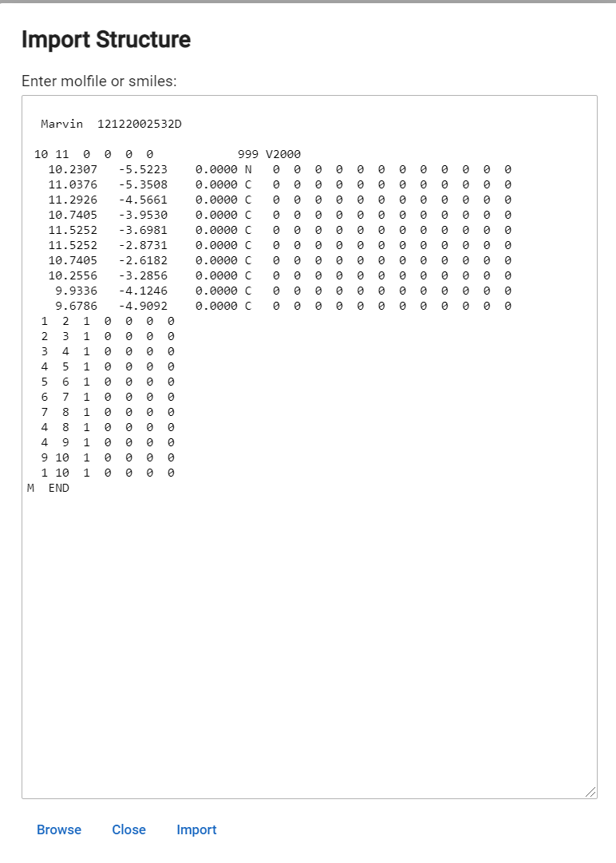

Figure 30-Enter Molfile

1. Verify the imported structure, minor adjustments may be required. Use the chemical web editor toolbar to make your edits before you use the structure.

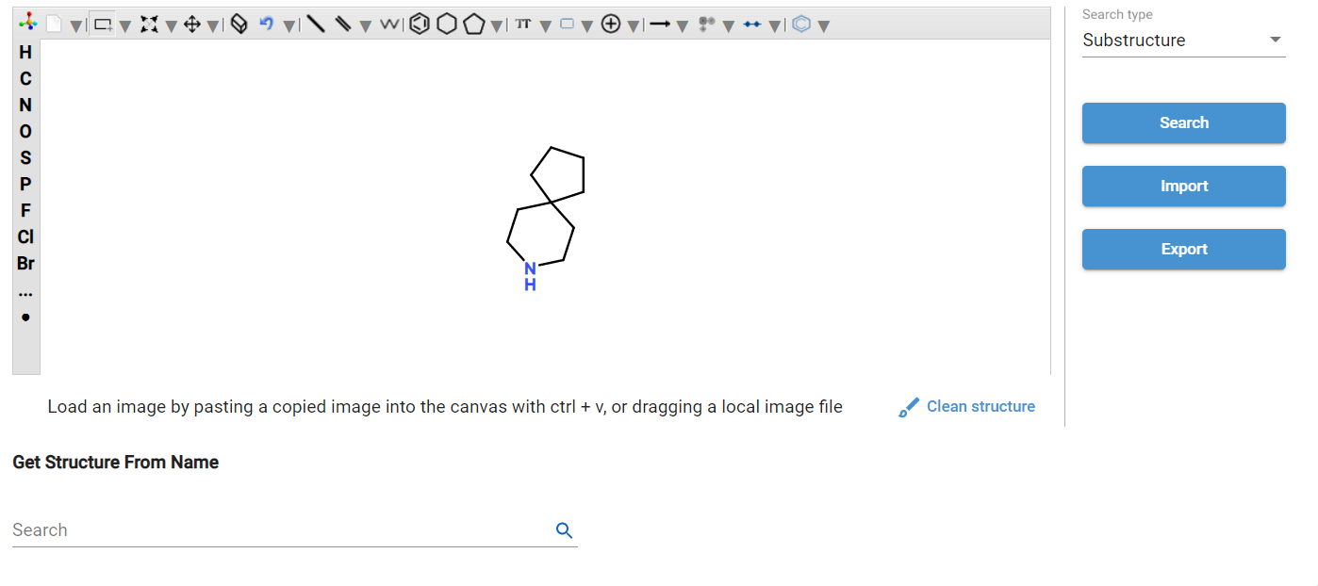

Figure 31-Search for Structure

#### SMILES String

1. Paste the SMILES string directly into the text box and select Import

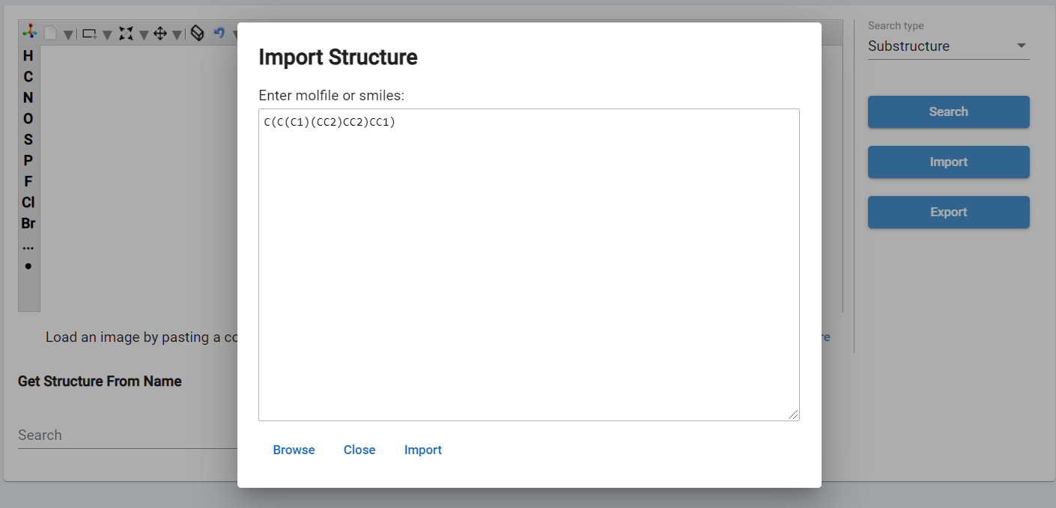

Figure 32-Enter SMILES

1. Verify the imported structure, minor adjustments may be required. Use the chemical web editor toolbar to make your edits before selecting Search

## Structure Search

GSRS Structure Search is a means for searching for specific chemical and polymer records based on their two-dimensional chemical structure. The structure search is available from the home page, Quick Links or at any time from the Menu hamburger. The canvas displays the structure editor pane shown below. The canvas must have a structure in order to perform a meaningful search. You can populate the structure search canvas by obtaining a chemical structure as shown in section above.

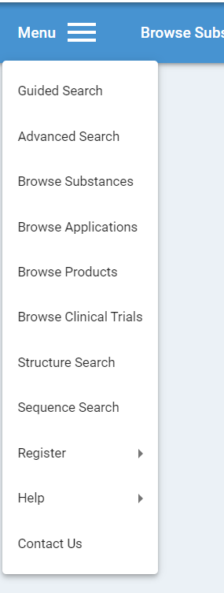 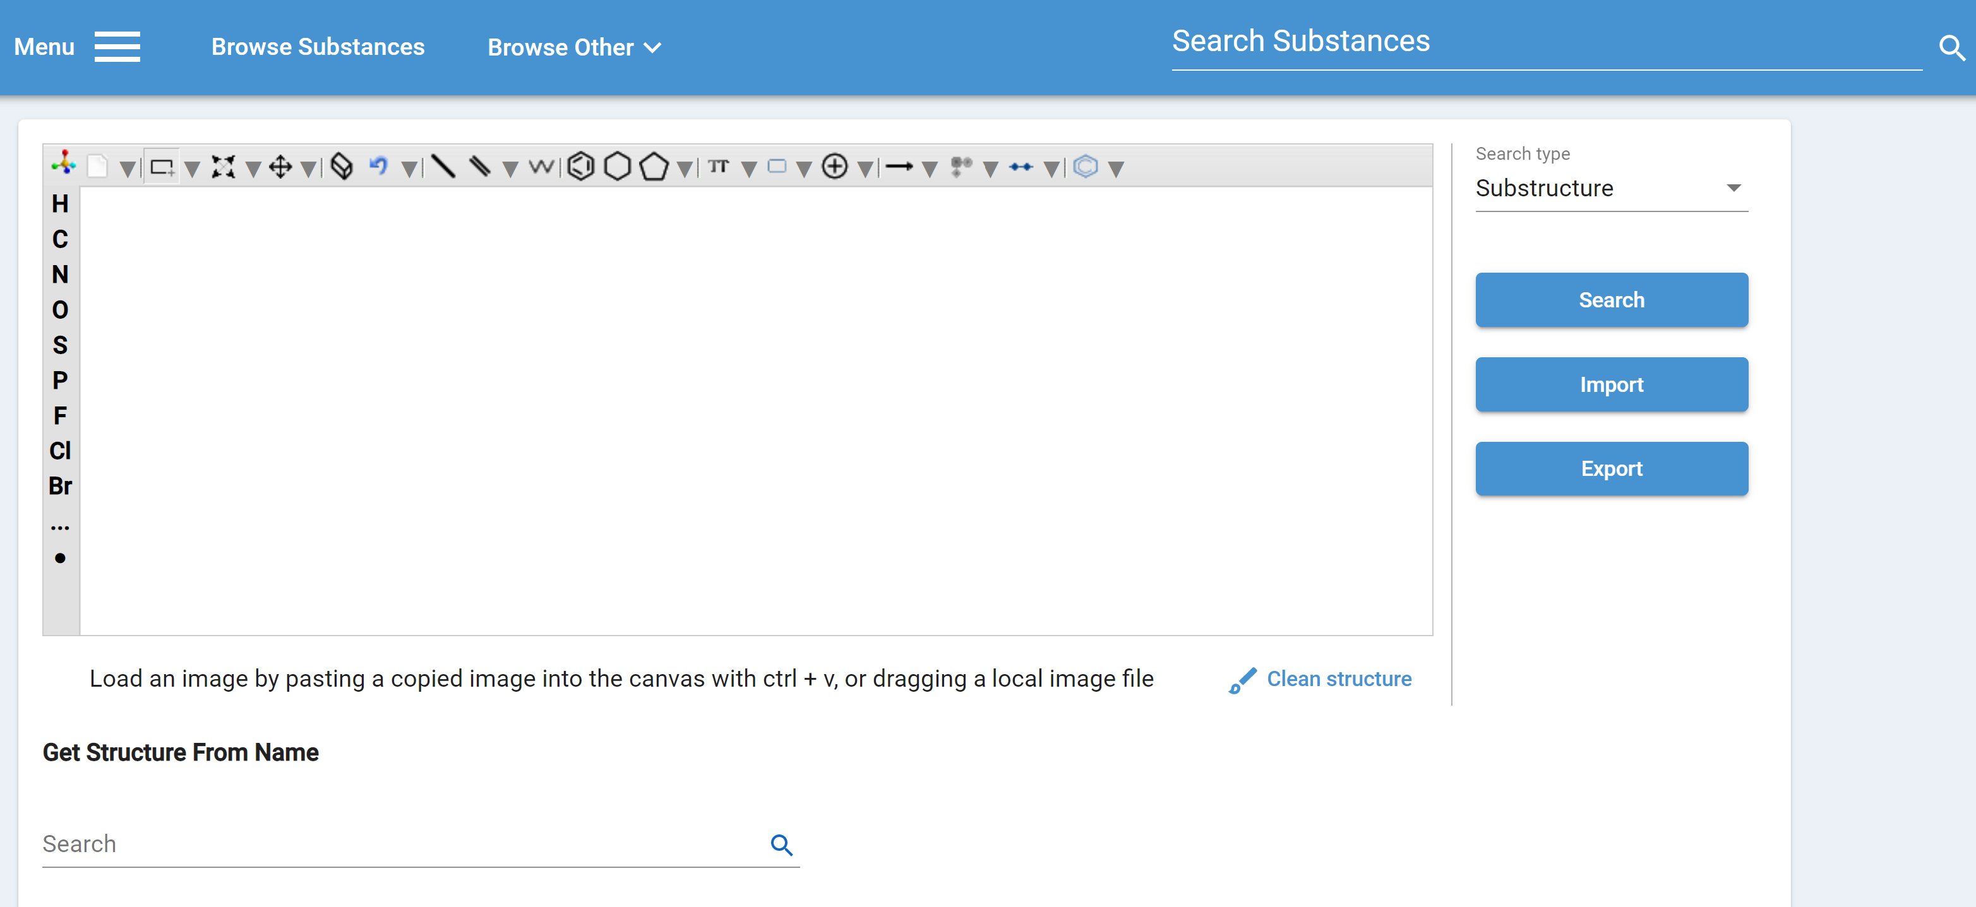

Figure 33-Structure Search

### Structure Search Type Options

Note, there are four Search Type options in the upper right corner displayed to the right of the Chemical web editor plug canvas; they are:

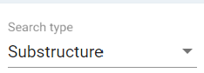

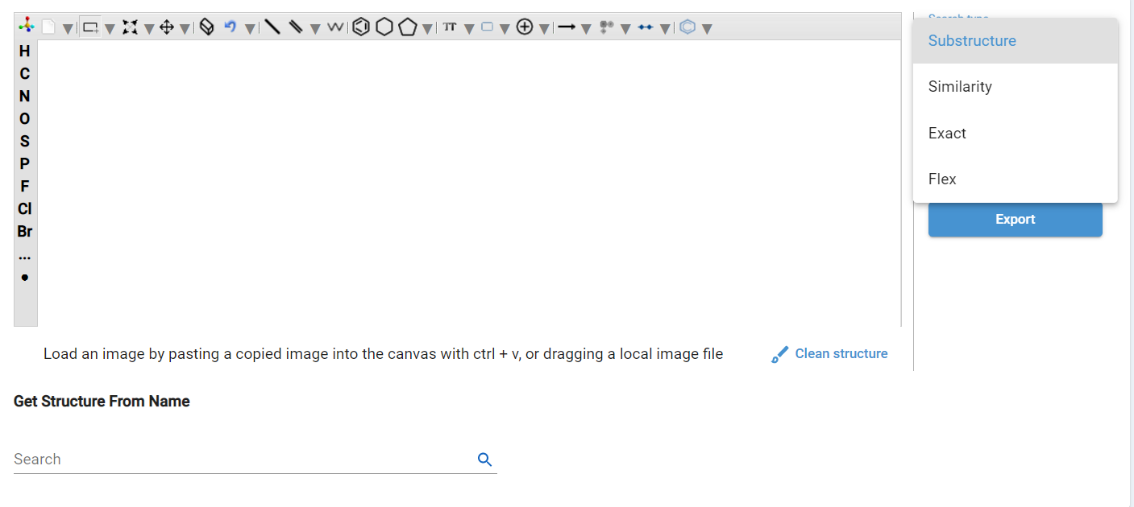

Figure 34-Search Substructure

1. **Substructure:** Find chemical structures that have an embedded query "substructure". This is like a chemical structure "contains" search. This kind of search supports query bonds and query atoms for complex structure searches. This search type is useful for finding a set of compounds that share a common "substructure" or "motif". After populating the Structure, select “Substructure” criteria and select Search as shown on the left, the search results are on the right.

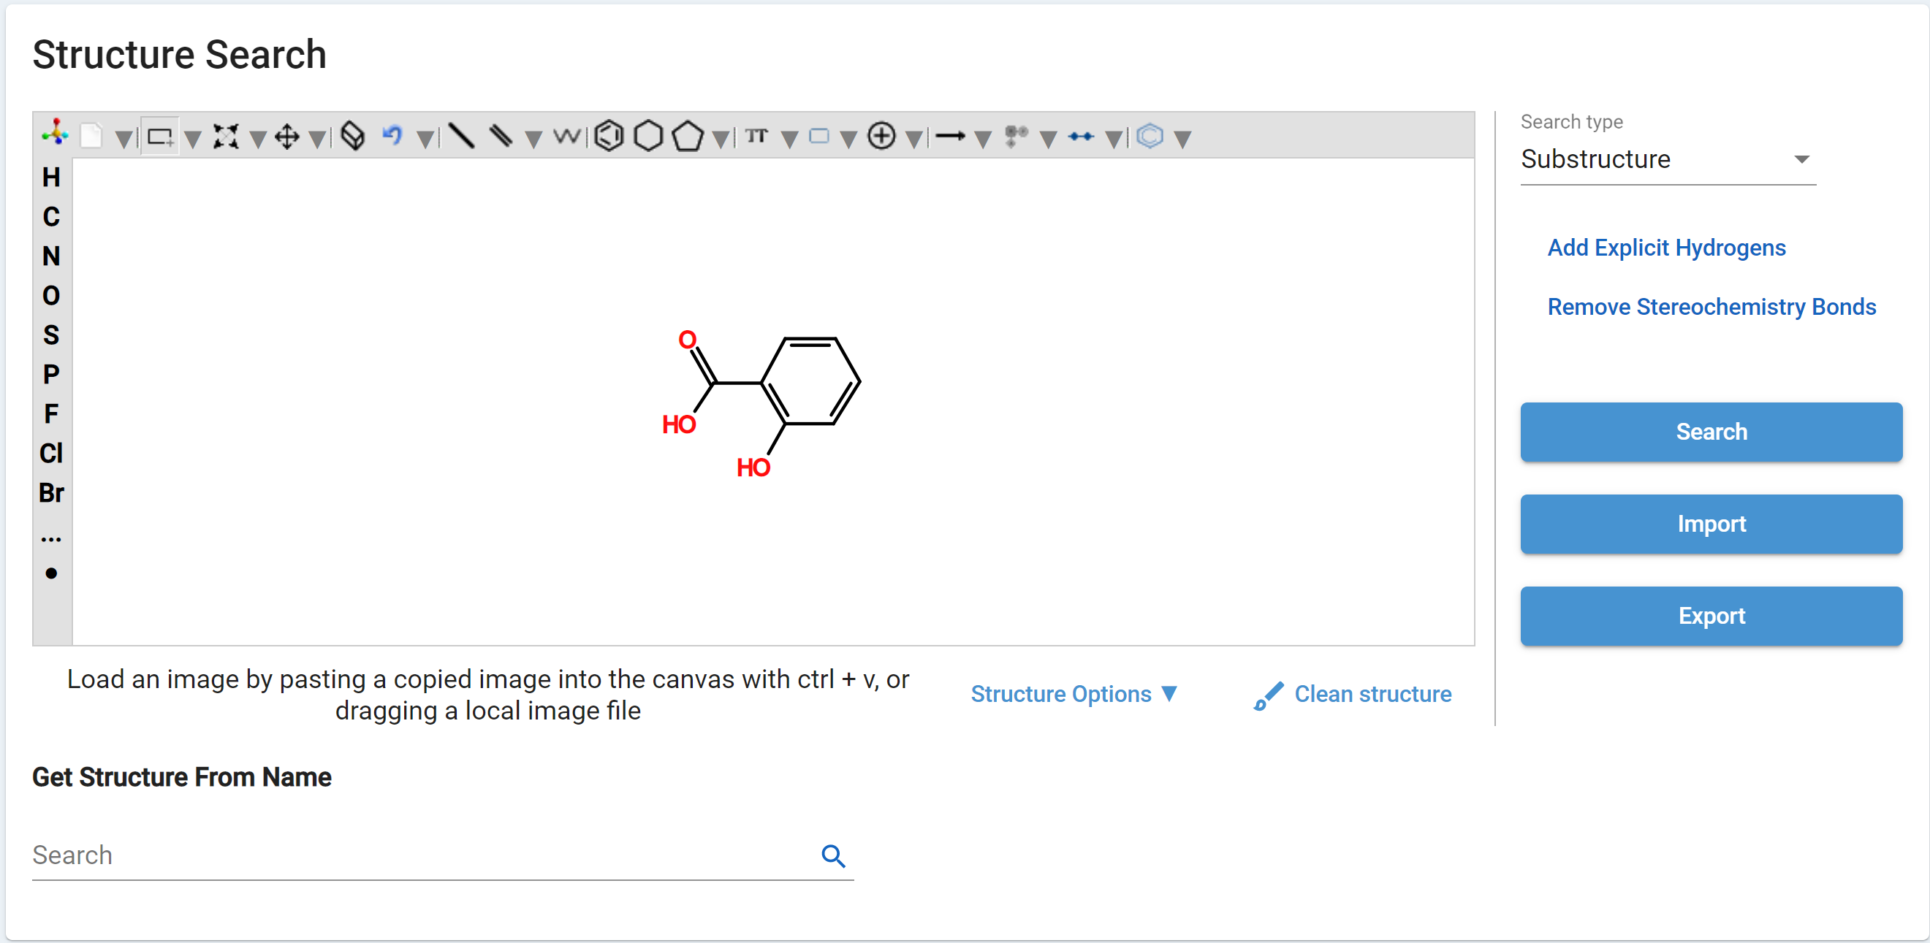 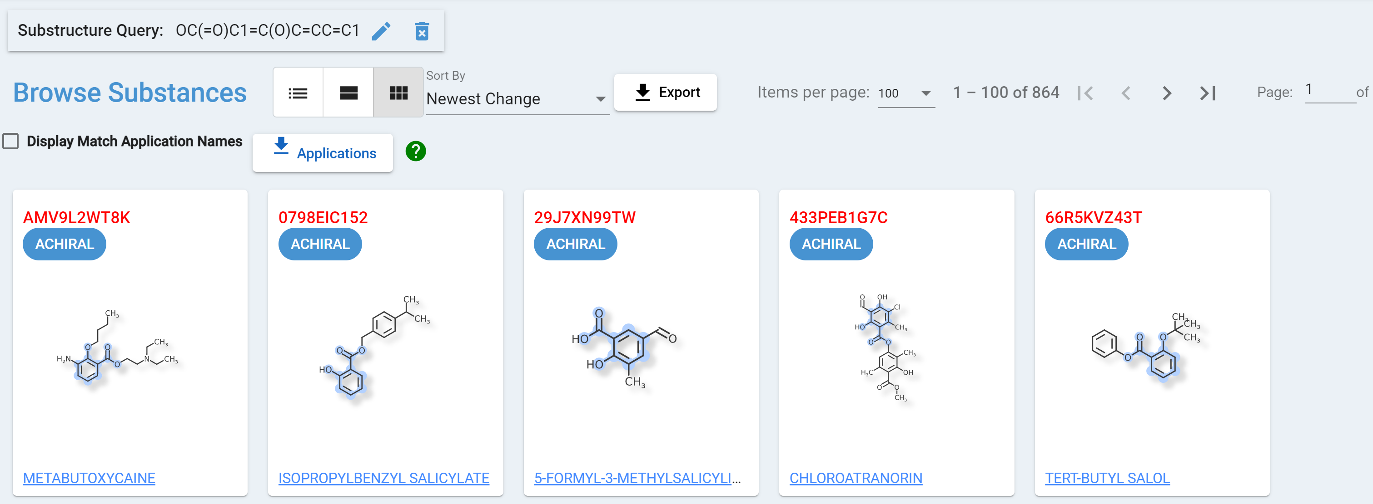

Figure 35-Substructure Search and Tile View

1. **Similarity:** Find chemical structures that have structural features that are similar to those of the query structure. This similarity search is based on a chemical feature fingerprint and the "tanimoto" similarity metric. This kind of search also requires a numeric similarity cutoff; a left to right scroll appears below. A common similarity cutoff to use is 80% (aka 0.80), which suggests that 80% of the shared chemical features between the query and target are found in both the query and target. This search type is useful for finding chemical structures that have similar functional groups and similar overall structure. After populating the Structure, select “Similarity” and “Similarity cutoff” criteria and select Search as shown on the left, the search results are on the right.

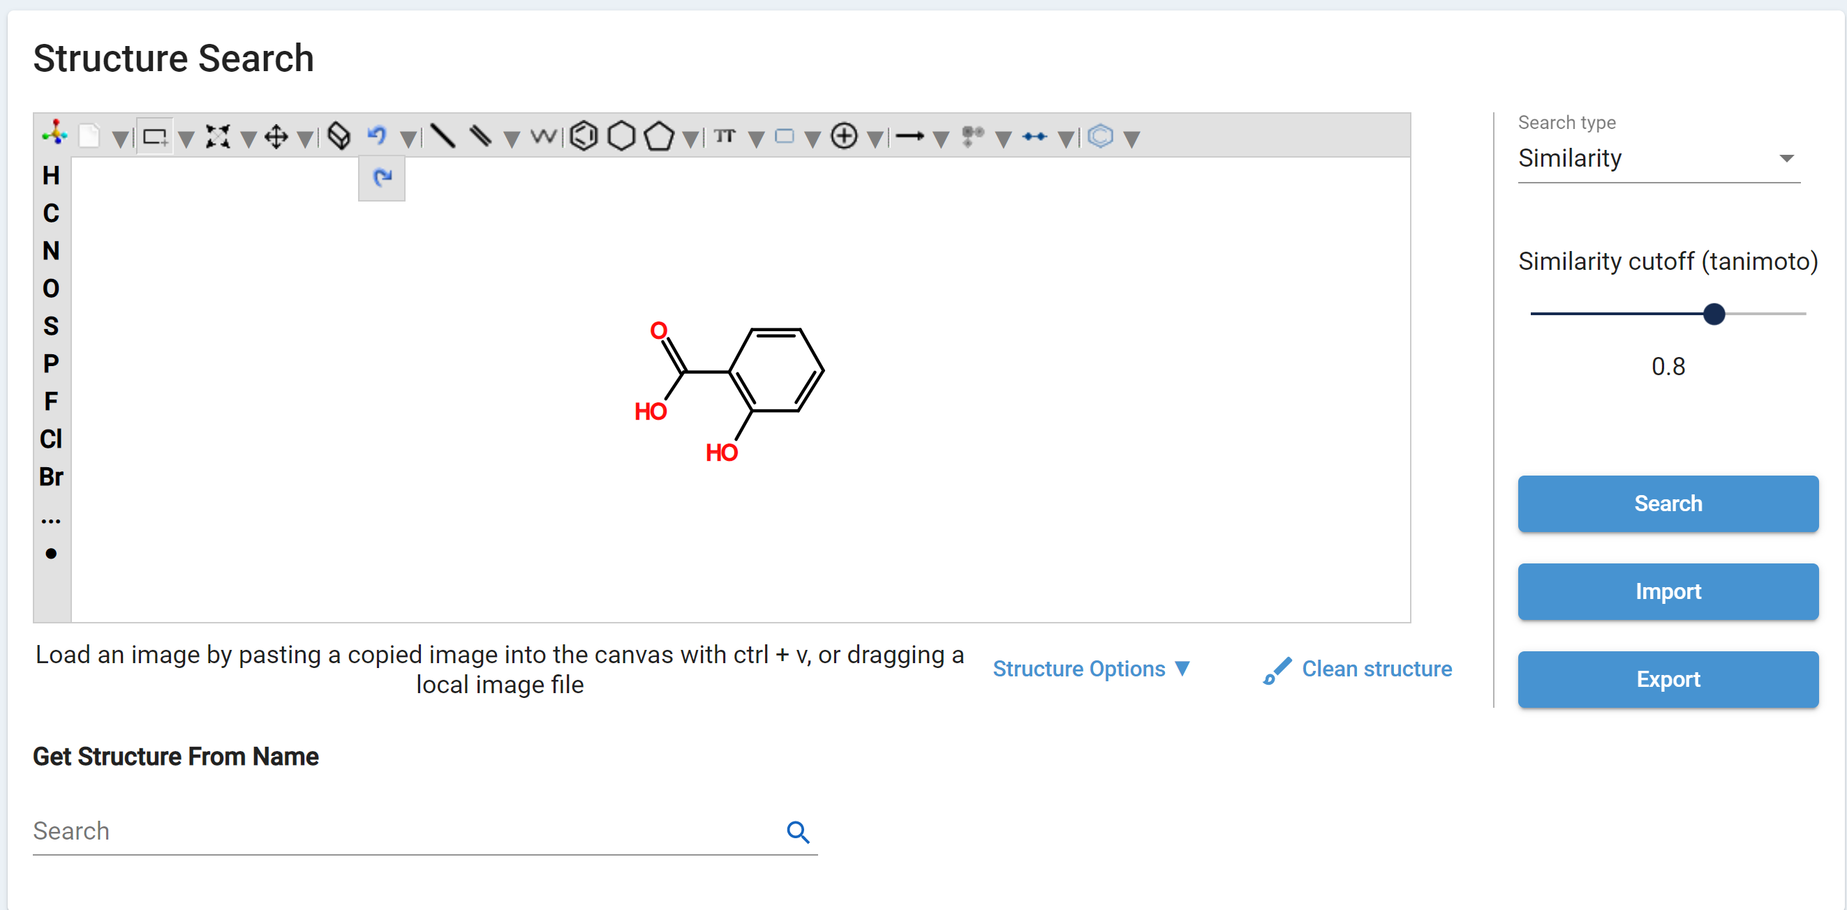

Figure 36-Similarity Search and Cutoff

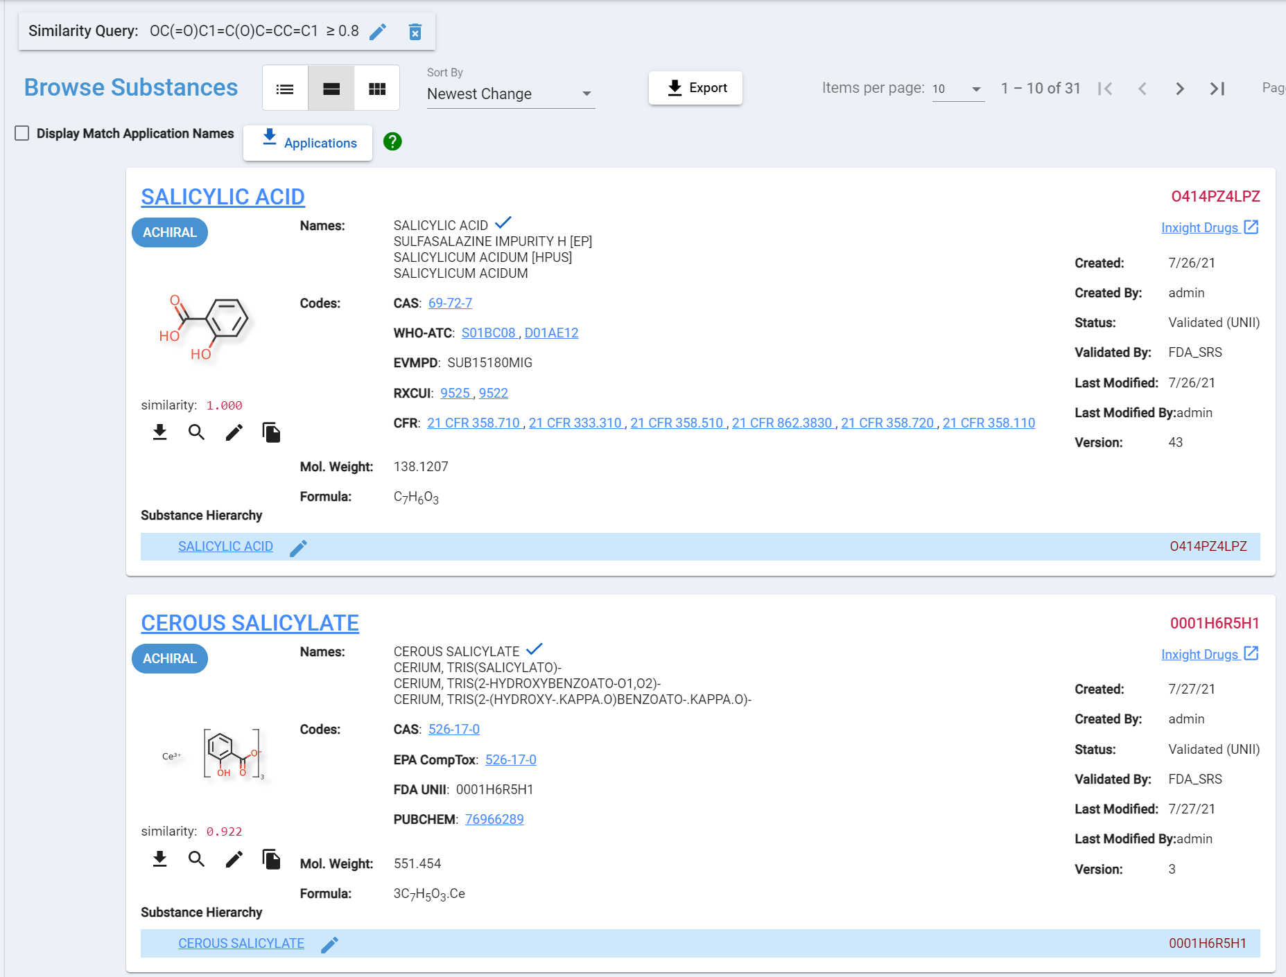

Figure 37-Similarity Value

1. **Exact:** Find chemical structures that match the query structure definition exactly. This search type does allow for returned chemical structures to be of a different tautomeric form or resonance structure, but requires that the returned results are functionally equivalent to the query structure, including stereochemical bonds. This kind of search is useful in finding chemical structures that are essentially identical to the provided structure. Note that an exact match on structure doesn't necessarily mean that the full definitions are equivalent, as there are other defining attributes of substances outside of the chemical structure.
2. **Flex:** Find chemical structures that have isolated connected covalent structures which match the query structure definition, allowing for differences in stereochemistry. This search type does allow for returned chemical structures to be of a different tautomeric form or resonance structure, but requires that the returned results contain a fully isolatable structure that, when charge normalized, is functionally equivalent to the query structure, ignoring stereochemical bonds. This kind of search is useful for finding all salts, solvates, hydrates and stereoisomers of a given covalent structure.

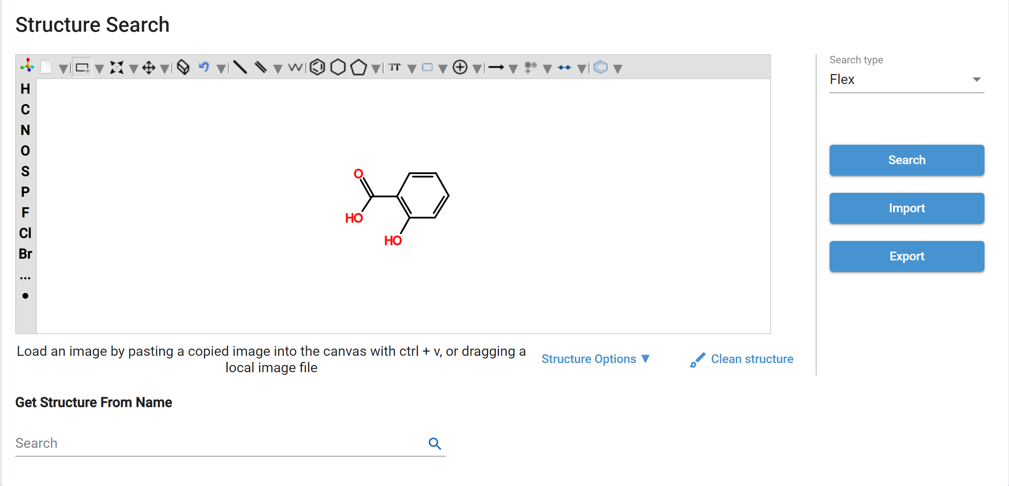 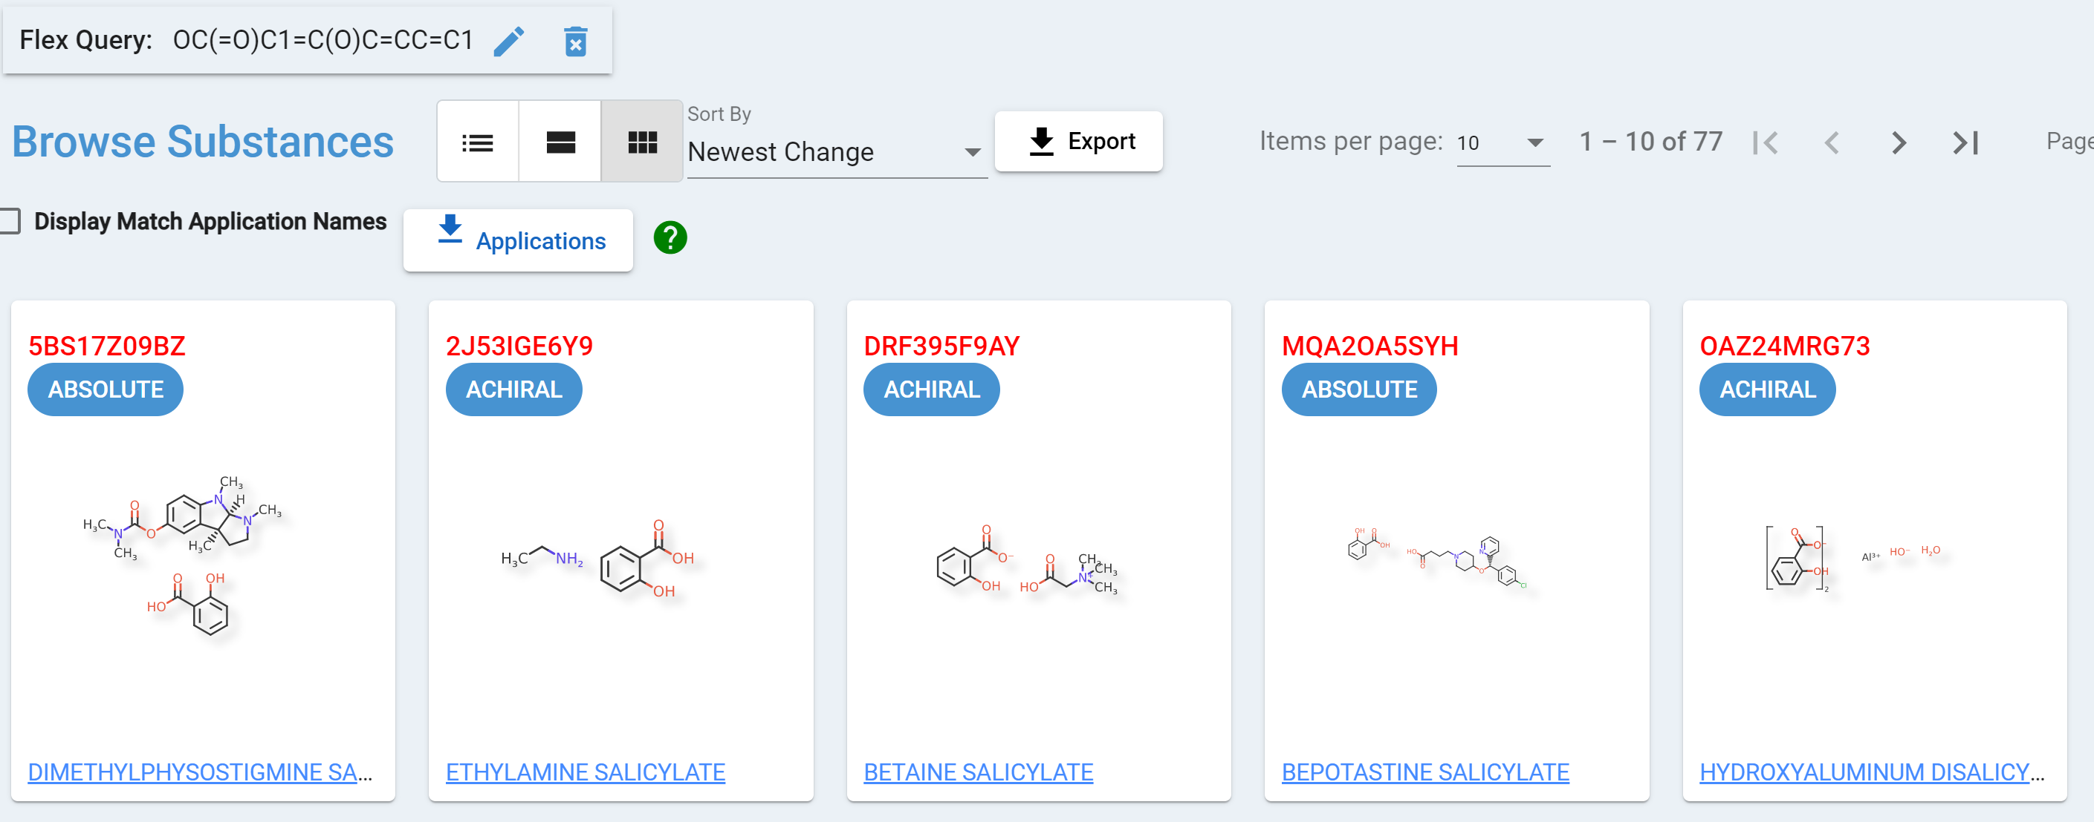

Figure 38-Flex Search and Results in Tile View

Export Structure from the web drawing tool

After drawing or obtaining a chemical structure into the Chemical web editor you can export into a molfile or SMILES string using the export feature. The Molfile by default is going to use Mol 2000.

1. Select Export

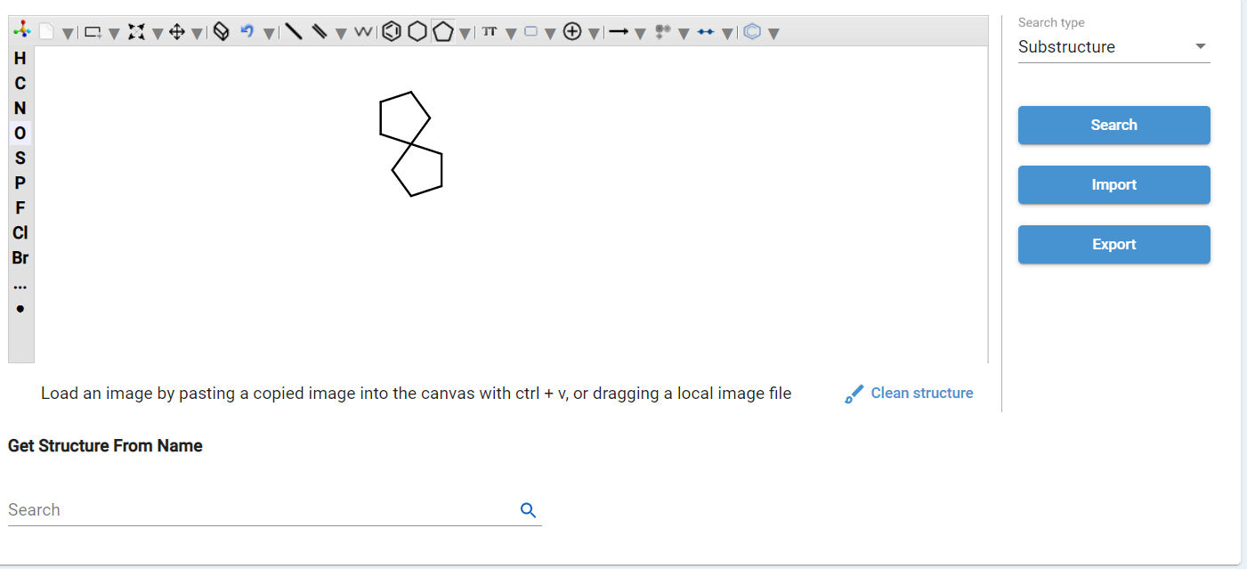

Figure 39-Export Structure

1. The Export Screen appear with two tabs, Molfile and SMILES

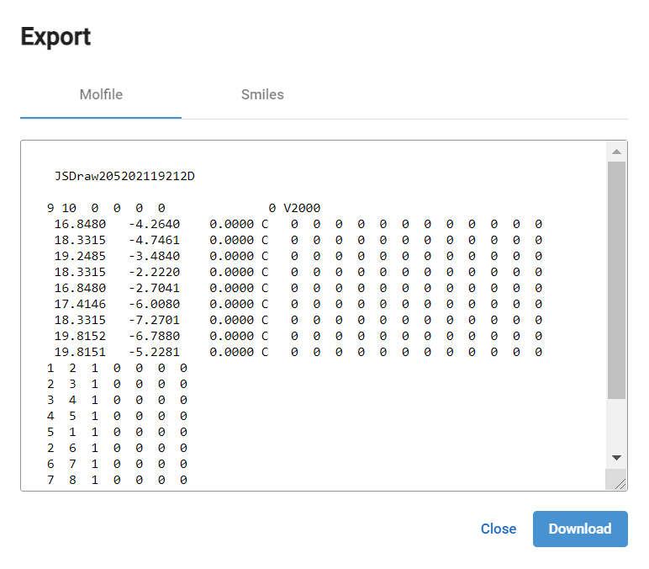 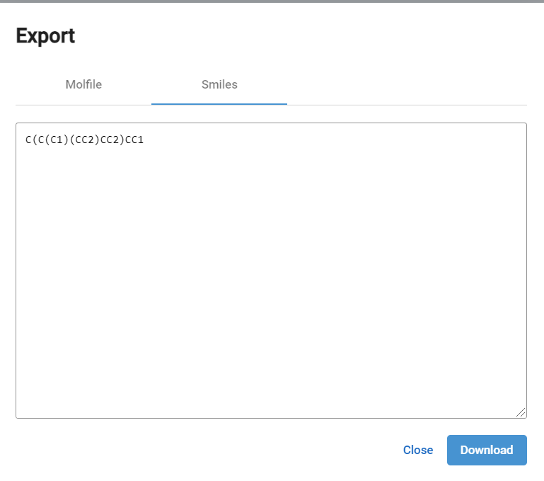

Figure 40-Export Results=Molfile and Smiles

1. Select Download, the file will be saved locally when you are ready to re-use. Clean the structure using Accelrys draw or Chemdraw for cyclic structures. Both Chemical web editor and Accelrys are not for cyclic structures.

Structure Search from an existing GSRS Substance

From an existing GSRS substance record, you can transfer a structure found during a search or browse session from the browse results pane to the Structure Search screen.

1. From your substance, select the magnify glass 
2. Select the words “Search Structure”
3. The structure populates on the canvas
4. Select Search.

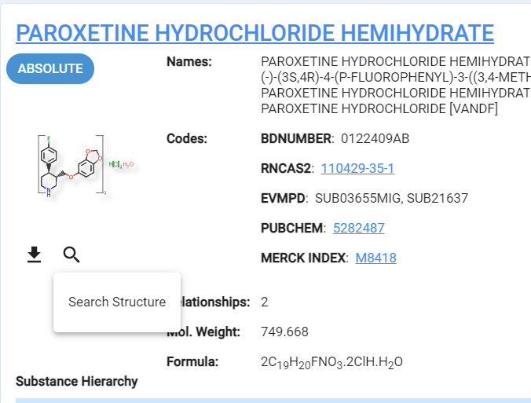 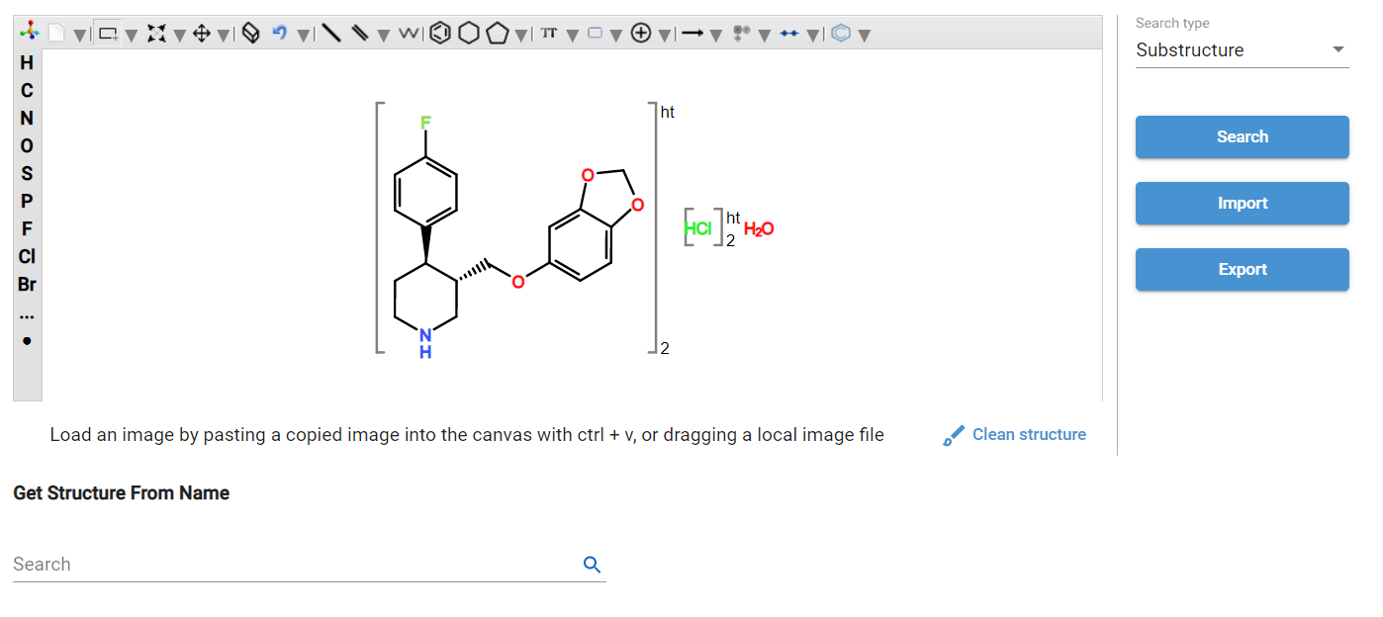

Figure 41-Select Magnify Glass to Search Stucture

## Sequence Search

GSRS also supports searching on sequences to locate protein and nucleic acid substance records via sequence alignment search for DNA, RNA and amino acid sequences using a BLAST-like alignment search.

1. From any page in GSRS select the Menu hamburger icon and scroll to Sequence search. The Sequence Search box displays as shown to the right of the pulldown menu below.

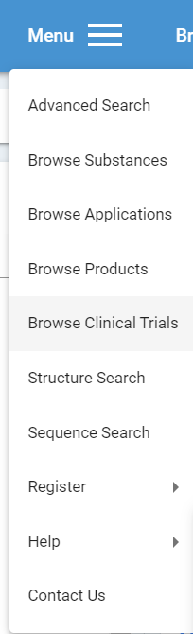 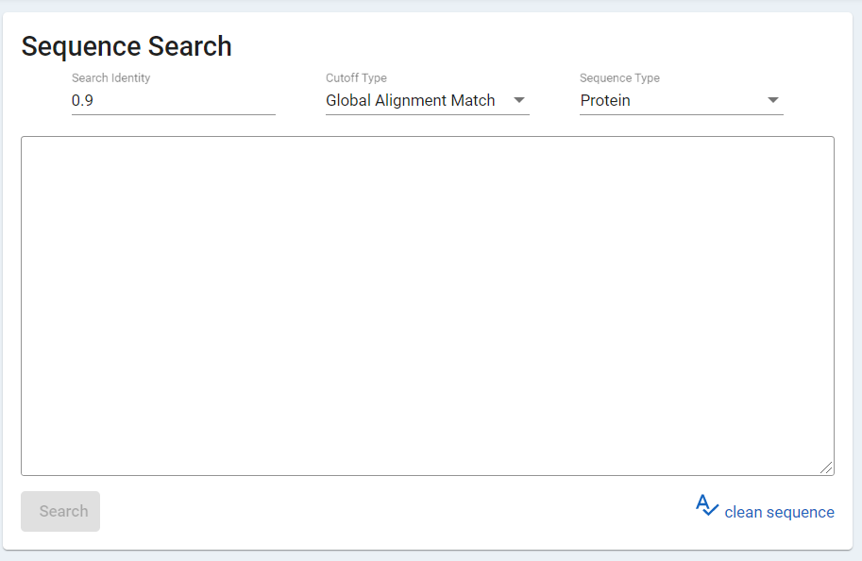

Figure 42-Sequence Search

1. The default search is Search Identity = 0.9, Cutoff Type = Global Alignment Match.

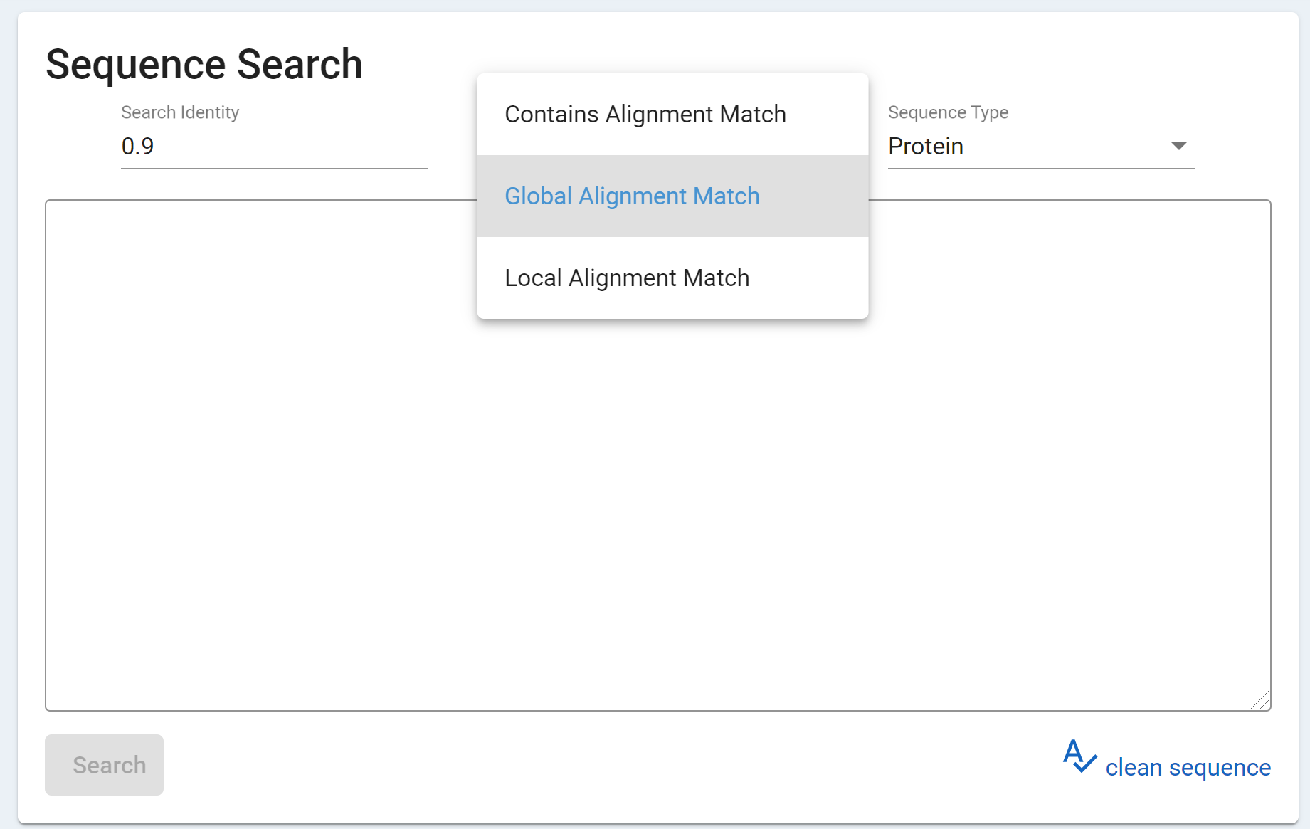

Figure 43-Sequence Search Defaults

1. Cutoff Type provides options for:
   1. Contains Alignment Match. This sequence alignment search type searches for substance sequences (proteins, RNA, DNA) which contain a subsequence similar to the query. This kind of search is useful when searching for a relatively short sequence motif which may be found in a much larger sequence with a few small edits. The score for this alignment is based on how closely the full query aligns with a portion of the target sequence. Searching for a small sequence may return much larger sequences. Searching for a large sequence will not return much smaller sequences. The actual alignment score is based on the global alignment score for the isolated section of the target which is aligned with the query.
   2. Global Alignment Match. This sequence alignment search type searches for substance sequences (proteins, RNA, DNA) which are similar to the complete query. This kind of search is useful when searching for a complete sequence (e.g. a protein subunit, peptide, oligonucleotide, etc) where the goal is to find a substance with a nearly exact complete sequence match. This can be useful in finding potential transcribing errors and typos on existing protein and nucleic acid substances as well as helping to find analogs to a given substance. As with all sequence search types, the search is done across all subunits within a given sequence-containing substance (proteins and nucleic acids). Alignment scores are based on the Levenshtein edit distance between the query and target, divided by the length of the larger sequence.
   3. Local Alignment Match. This sequence alignment search type searches for substance sequences (proteins, RNA, DNA) which share sufficient overlapping sequence portions. This kind of search is useful when searching for either a larger or smaller sequence which share some motifs. This search type is also currently the fastest returning sequence search type. However, the results from these searches may contain some sequences which simply happen to share a few very small regions of sequence overlap. The score for this alignment is based on the global alignment score for the isolated section of the target which is aligned with the isolated section of the query. Some short sequence matches without gaps may rank higher than longer sequence matches with gaps. Care must be taken when using this type.
2. Paste the subunit into the text box.
3. Select Search.

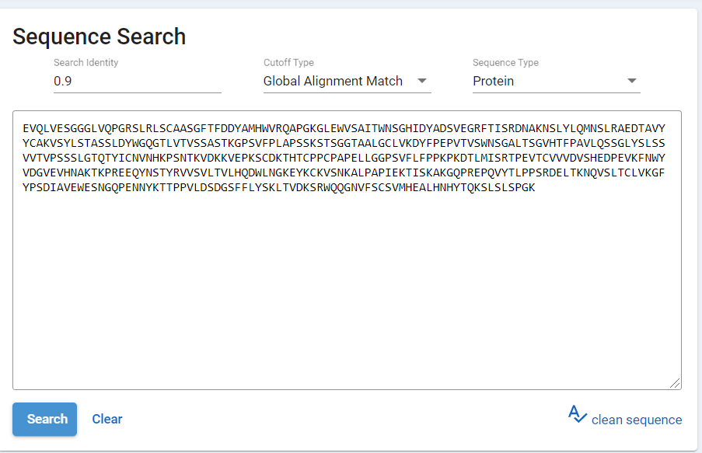

Figure 44-Sequence Search Subunit

1. Matching records are displayed in the Results Pane with additional details about how the records matched the sequence search criteria.

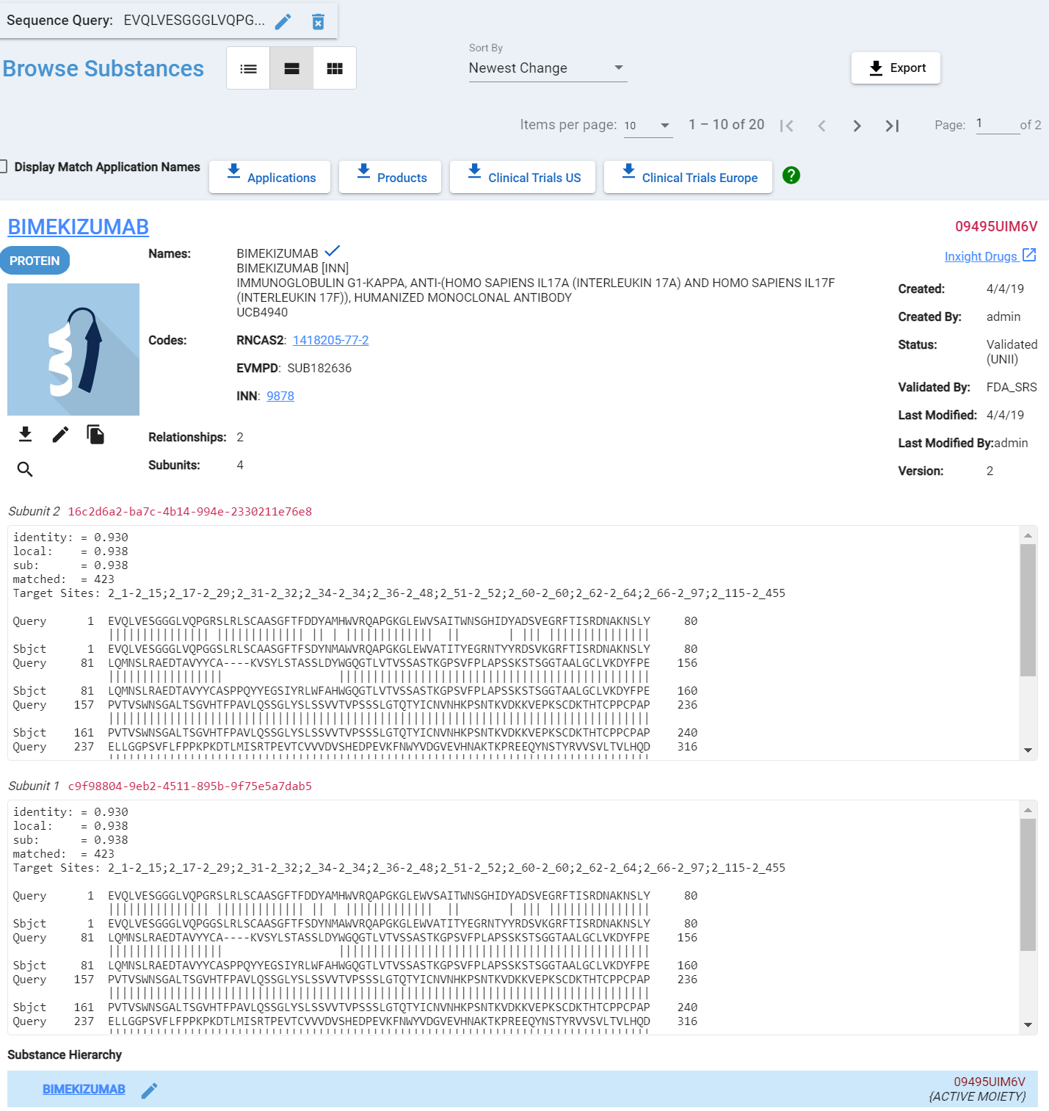

Figure 45-Sequence Search Results

Sequence Search from Existing Substance Record: Transfer a structure found during a search or browse session using the results pane search icon.

From an existing GSRS substance record, you can transfer a sequence found during a search or browse session from the browse results pane to the Sequence Search screen.

1. From your substance, select the magnify glass 
2. Select the subunit (if more than one)
3. The sequence search screen will be displayed and populated with the selected subunit and default matching criteria.

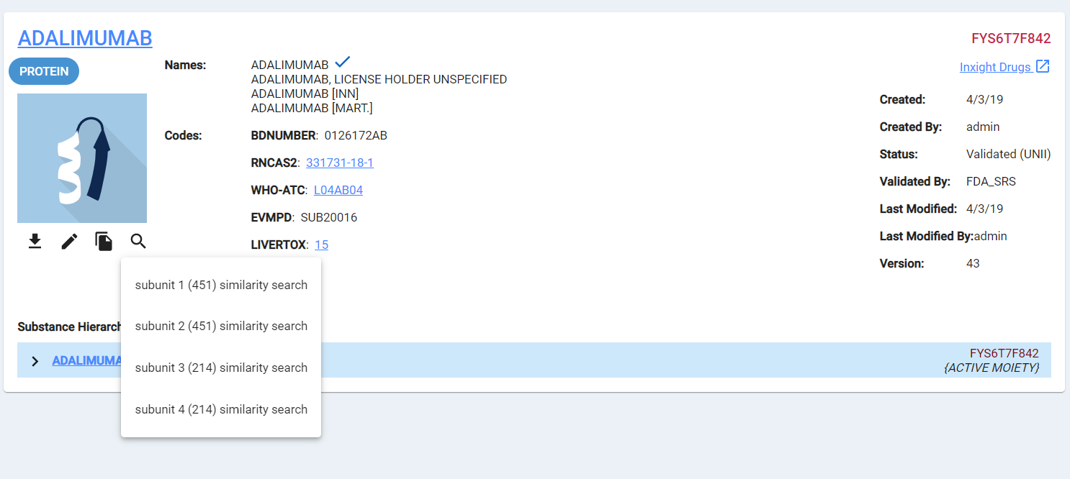

Figure 46-Sequence Search Magnified Glass Subunit Options

# Register Chemicals

A chemical is a small molecule and single entity. The first step of any registration should be to **-**. If no duplicates are found, proceed by selecting Register Chemical. If duplicates are found you will need to investigate further to determine if it’s a true duplicate. Each substance is unique in GSRS. Select Register then Chemical from one of the various options explained in the Registration Page Navigation Options section of this document.

The chemical registration form will be displayed. Section cards are collapsible to ease navigation, however the elements in this form are:

1. Overview
2. Names
3. Structure
4. Codes
5. Relationships
6. Notes
7. Properties
8. References

Below is the Registering New Chemical entry form

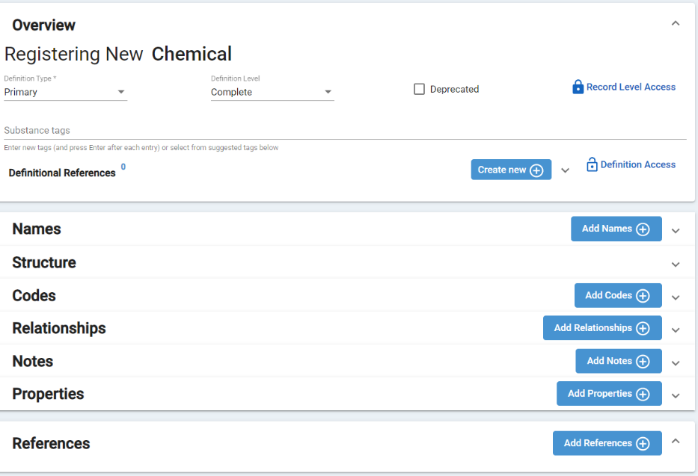

Figure 47-Register Chemical Entry Form with Card Options

### Overview – Registering New Chemical

In order to register a chemical structure (which is the substance identity), and in general for any substance, you need

* a substance identity
* at least one name and
* at least one definitional reference

1. Definition Type - hover over and select the down arrow to activate the Edit drop-down.

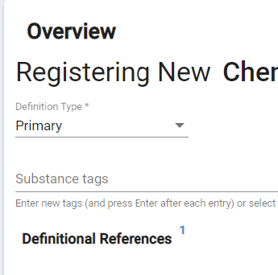 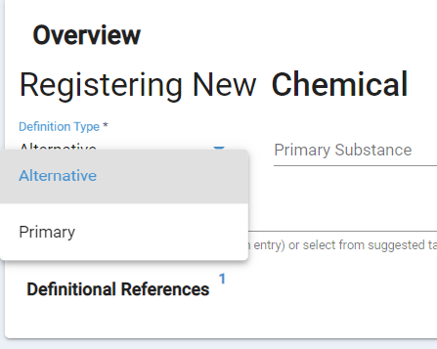

Figure 48-Definition Type Field Options

There are two options:

* 1. Primary
  2. Alternative - Chemical alternative definition of a protein, nucleic acid, polymer, ring/open sugar etc. Once Alternative is selected a Primary Substance Search field appears

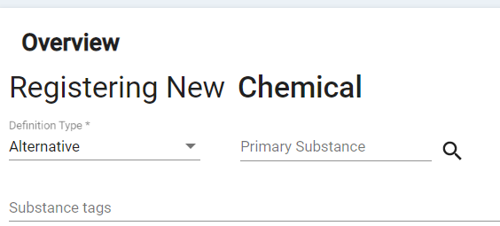

Figure 49-Definition Type-Alternative reveals a Primary Substance Search Option

* + 1. Type the Primary Substance name in search box and select. As you begin, typing a list containing those letters will appear. Make a selection and then select search and the Primary Substance will populate

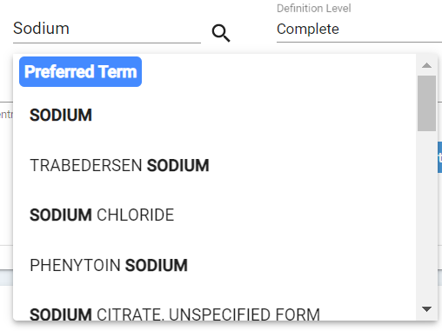 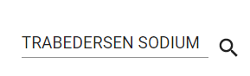 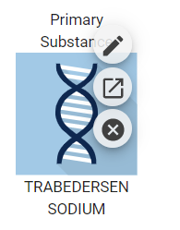

Figure 50-Primary Substance Search, Selection and Result

* + 1. After submission, the system generates a relationship connecting both definitions
    2. Alternative definition registration is similar to Primary definitions, but Names and Codes are not included

1. Definition Level – select the down arrow to activate the Edit drop-down.

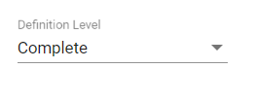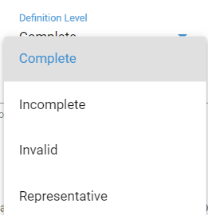

Figure 51-Definition Level Options

* 1. Always try to enter a Complete definition
  2. Incomplete are allowed for incompletely defined substances.
  3. Representatives are too complex to define completely

1. Deprecated box. Selecting this box means it is semi-deleted, or a candidate for deletion". There are other flags for deprecation elsewhere in GSRS, but that one also tells the browse/search functions not to show this record Unless you specifically click the box allowing it to show

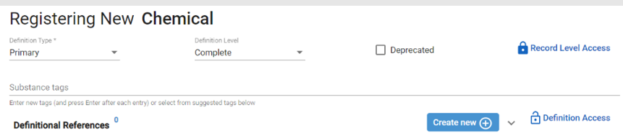

Figure 52-Registering a Chemical - Deprecated Box

1. Record Level Access. Some substances are public in which case set the Record Level Access to Public by deselecting Protected under Record Level Access. Some substance are private in which case we select Protected. Private means not readily available in public sources, domains, website, etc. (e.g., Scifinder, pubchem)

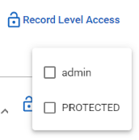

Figure 53-Record Level Access Types

1. Definitional Reference(s)
   1. Select the Create new + button

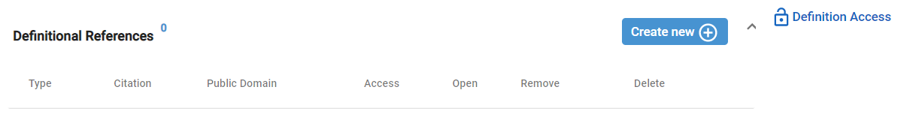

Figure 55-Adding a new Definitional Reference

* 1. The Add Reference screen appears and additional fields will be displayed
     1. Select the down arrow next to Source Type

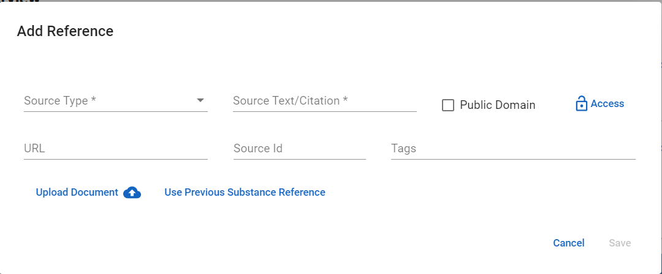

Figure 52-Add Reference Source Type Down Arrow

* + 1. Use the scroll on the right to navigate and select a Source Type

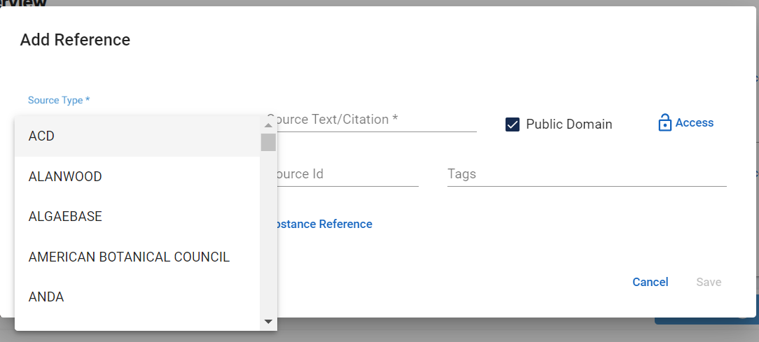

Figure 53-Add Reference Source Type Options

* + 1. Source Text/Citation – identifies where the information comes from
    2. Based on the release sensitivity,

1. Check Public Domain if public
2. If public, add Tags for Public-Domain-Release
3. Update the Access by deselecting PROTECTED, if applicable
4. Select Save

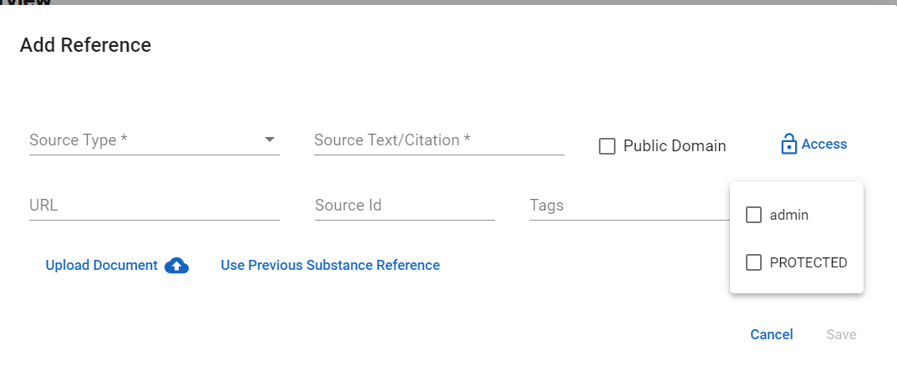

Figure 54-Add Reference Source Text/Citation, Public Domain and Access Options

* + 1. In order to make something Public it has to be made public three times.
  1. Undo the lock
  2. Select the Public Domain checkbox
  3. Enter the Tag as Public Domain Release
  4. Verify the Reference is attached to the Definitional References section located in the upper left hand corner of the record

1. The 0 is replaced with 1; the number will correspond to the number of references added
2. “Apply to” hamburger pull down menu has the options of All, All without references, chemical, or relationships.
   1. Relationships has a right arrow with the options
      1. All relationships
      2. All Relationships without references

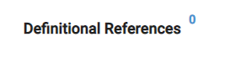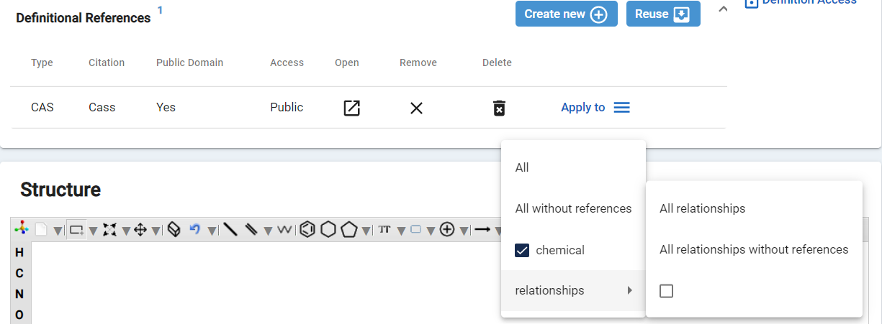

Figure 55-Definitional References Quantity Notation and Apply to Options

1. Click on Create new + to add more references. Or select a previously used ref by clicking on reuse to select a previous substance reference

### Names

The Names card accommodates multiple names. By default, the section is collapsed but can be expanded to view more names.

1. Select the Add names + button or the down arrow next to Add Names



1. The Names screen appears and additional fields will be displayed
2. Names
   1. All CAPS – select the Standardize Names button prior to leaving the Names card
   2. No Brackets – use parenthesis for brackets. Exception to the bracket is when referencing substance tags (e.g., [USP], [EP]
3. Type– select using the down arrow to the right

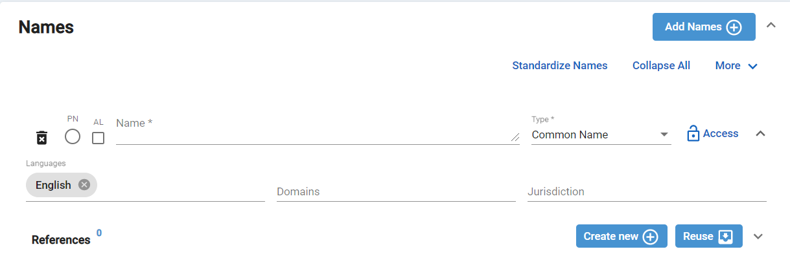

Figure 56-Names Card and Field Options

* + 1. Scroll, on the right, to view all name types and navigate and select a Type (Codes are usually seen as letters dash numbers (e.g., ABC-123); Systematic Name for a Chemical is a name you can derive a structure from directly). Common name is the default for any new name being entered and must be changed if the name being entered into GSRS is a code, systematic name, etc; an official name is a name from an official body such as INN, USAN, JP, etc

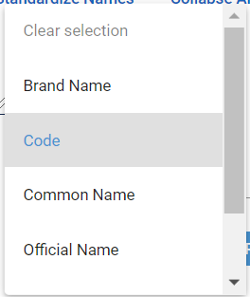 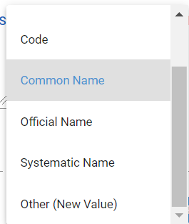

Figure 57-Names Card Type Field Options

* 1. Access - Update the Access by deselecting PROTECTED, if applicable

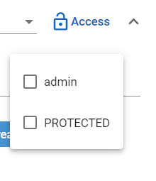

Figure 58-Names Card Access Options

* 1. Languages – Select inside the Language field to pull up the Language menu; scroll on the right to view all Languages and select a Language
  2. Domains – Select inside the Domains field to pull up the Domains menu; scroll on the right to view all Domains and select a Domain; this is typically done when adding an official name to the document. Any other type of name (e.g., code, systematic name) you do not need to select a Domain.
  3. Jurisdiction – Select the Jurisdiction field to pull up the Jurisdiction menu; scroll on the right to view all Jurisdictions and select a Jurisdiction

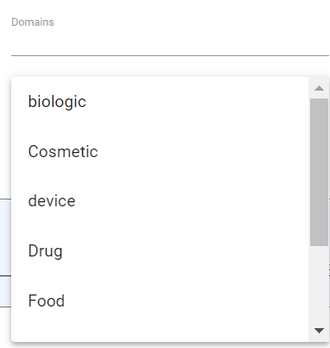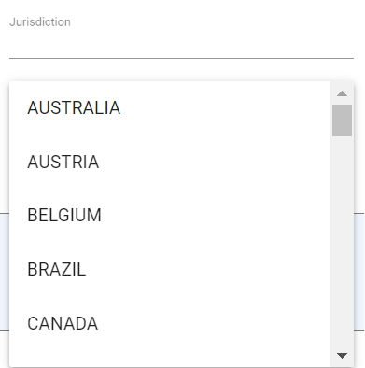

Figure 59-Names Card Language, Domains, and Jurisdiction Field Options with Scroll bars

* 1. References – a reference is required for each name that is added. Add a Reference as explained in Overview section above or if references already exist, you can select an existing reference.
     1. To Reuse an existing Reference select the down arrow next to Reuse button



* + 1. Reuse Substance References window appears with a list of previously used references. Select using the Apply box(es) on the left
    2. Select Save

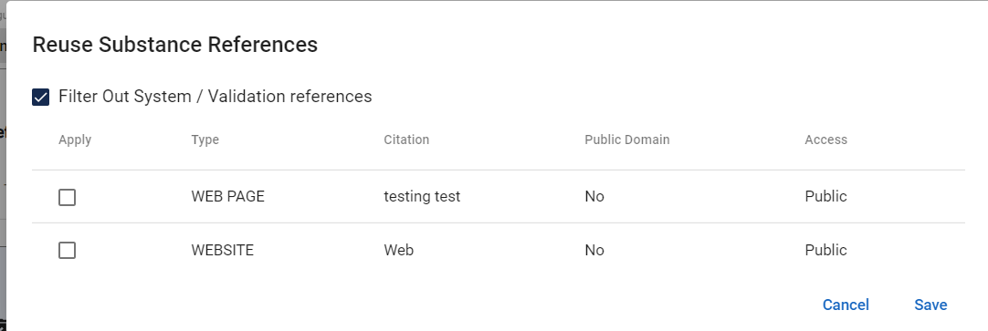

Figure 60-Reuse Substance References window, Select and Save

* 1. Access – if you are adding a Reference instead of reusing one, update the Access by deselecting PROTECTED, if applicable

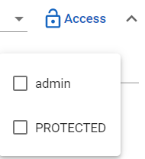

Figure 61-Access Options

1. Select Add Names + to add additional Names.
2. Apply reference to all Names at one time

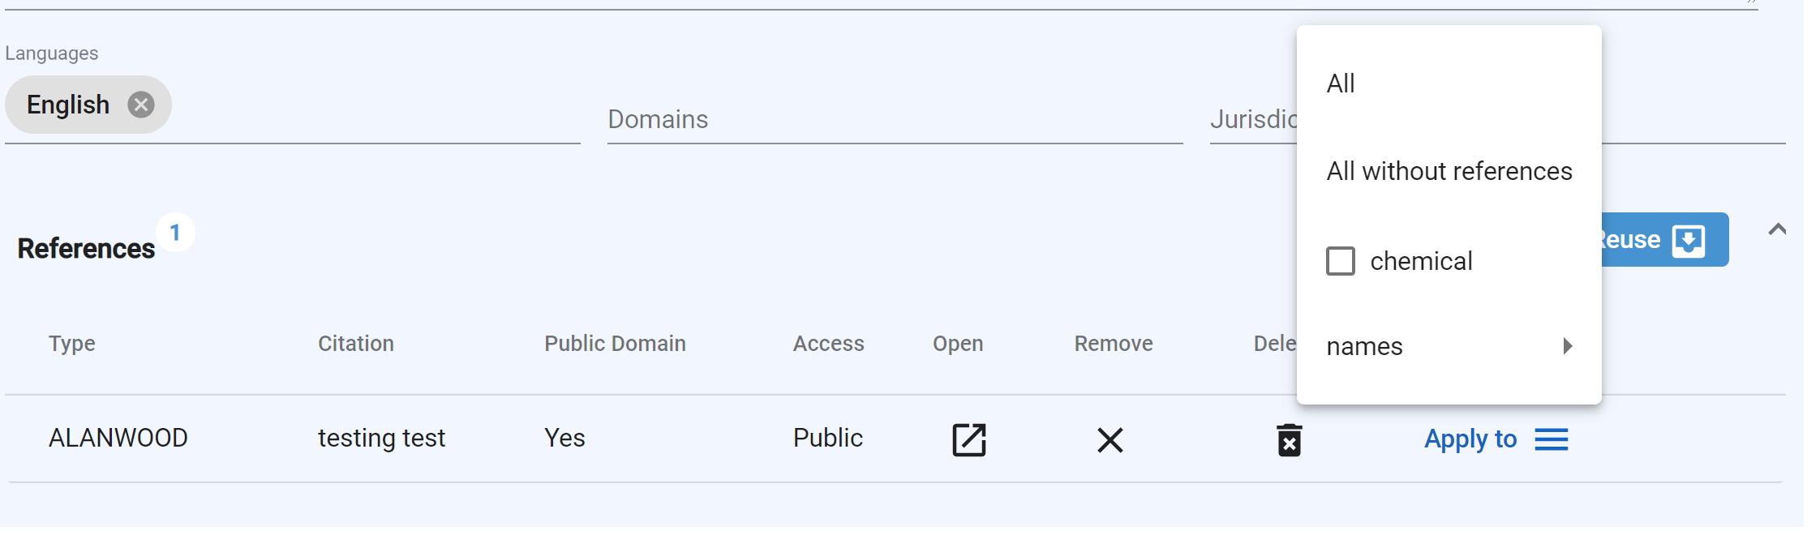

Figure 62- References Apply to Options

### Structure

The Structure card canvas is populated using any method described in the **Structure Search** to upload a structure.

1. After entering the structure in the Chemical web editor canvas, click Check for Duplicates button
2. Verify the system correctly auto populated the remaining fields:
   1. Molecular Formula
   2. Stereochemistry – calculated based on stereo bond, update as needed
      1. Ex: Asenapine is racemic, however GSRS would recognize the structure as “absolute, chiral” because it has stereo bonds and user would have to change the identify to racemic
   3. Optical Activity
   4. Additional Stereochemistry (e.g., axial stereochemistry)
   5. Molecular Weight
   6. Defined Stereocenters
   7. EZ Centers
   8. Structure Charge
   9. Access – update to Protected for nonpublic substances
   10. Stereo Comments - Add if applicable, e.g. meso, Assumed racemic (if one stereo center and we can safely assume racemic), AXIAL, S; AXIAL, R; AXIAL, RACEMIC for additional stereochemistry

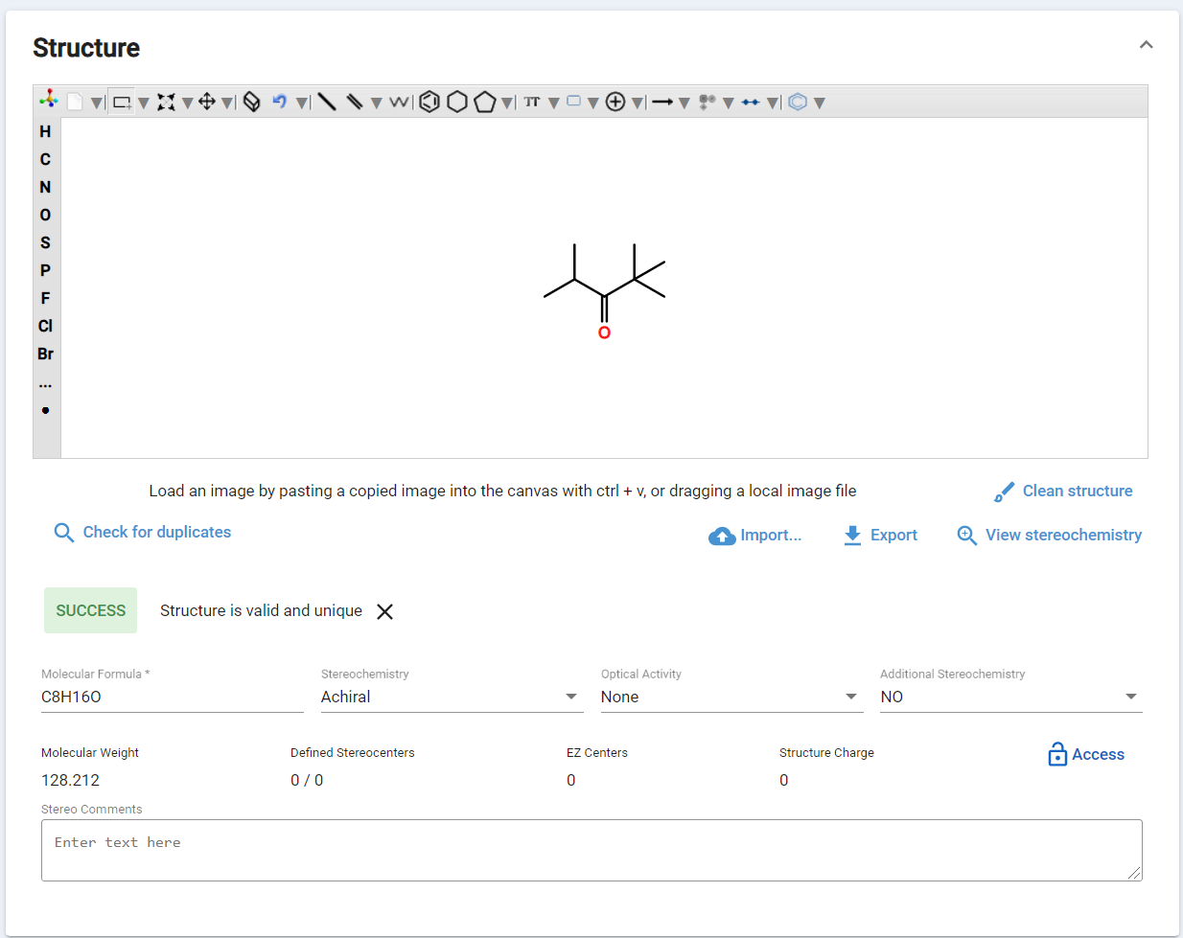

Figure 63- Structure card canvas, Check for Duplicates, Success renders completed fields

### Codes

The Codes card accommodates multiple codes. By default, the section is collapsed but can be expanded to view more codes.

1. Select the Add Codes + button or the down arrow next to Add Codes



1. The Codes screen appears and additional fields will be displayed

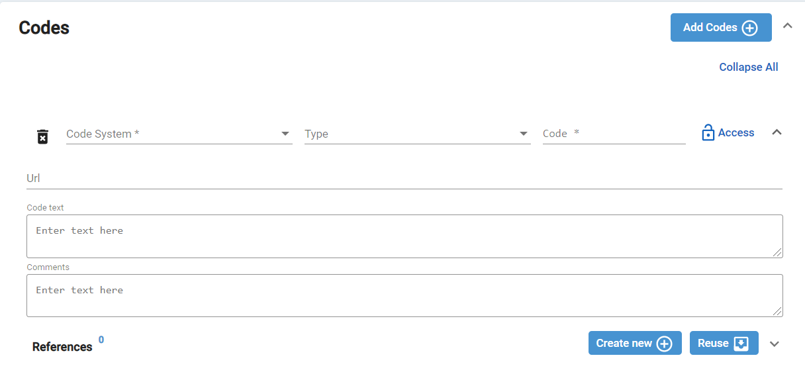

Figure 64- Codes Card

* 1. Code System - Select the Code System field to pull up the Codes menu; scroll on the right to view all Codes and select a Code
  2. Type - Select the Type field to pull up the Type menu, scroll on the right to view all Types and select a Type

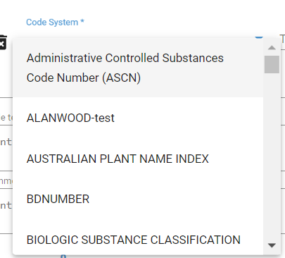 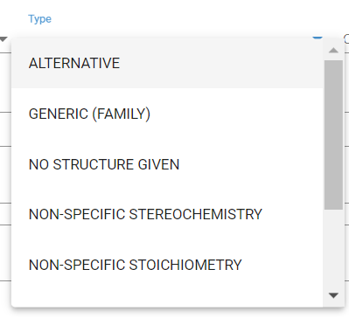 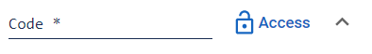

Figure 64- Codes Card – Code System and Type

* 1. Code - Enter a Code in the Code field
  2. Access - update the Access by deselecting PROTECTED, if applicable
  3. GSRS will automatically construct URLs for the following Code Systems which can be accessed in the hyperlink on the view page

|  |  |  |
| --- | --- | --- |
| ALANWOOD | GRIN | NCI_THESAURUS |
| CAS | INN | NDF-RT |
| CFR | ITIS | PHAROS |
| CHEMBL | IUPHAR | PUBCHEM |
| CLINICAL_TRIALS.GOV | JECFA EVALUATION | RXCUI |
| CODEX ALIMENTARIUS (GSFA) | JMPR-PESTICIDE RESIDUE | UNIPROT |
| DEA NO. | MERCK INDEX | USDA PLANTS |
| DRUG BANK | MEX | WHO-ATC |
| FOOD CONTANT SUBSTANCE NOTIF, (FCN NO.) | NCBI TAXONOMY |  |

Figure 65 - Register Chemicals - URL Construction for Code Systems

1. References - If references already exist, you can select Reuse to Add a **References**

Once cards have been completed for Overview, Names, Structure and Codes, user can select Validate and Submit to enter a Chemical.

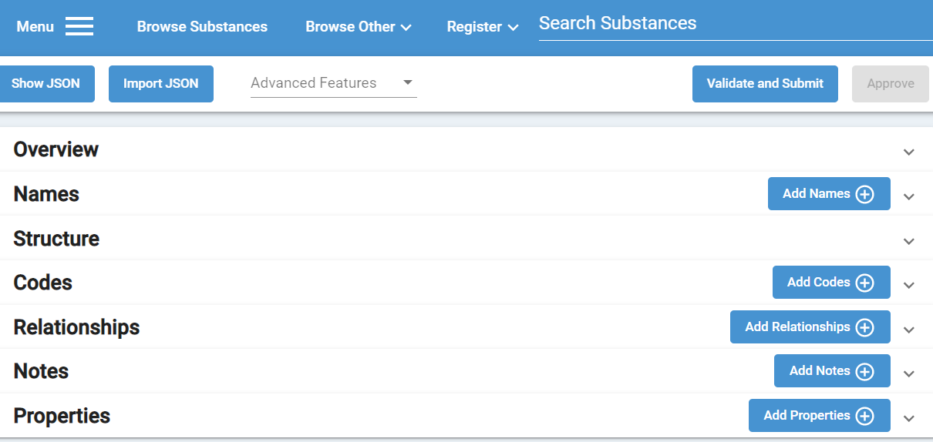

Figure 66- Minimum Cards Needing Completion in order to Validate and Submit

Once the Substance is Valid message appears, select Submit

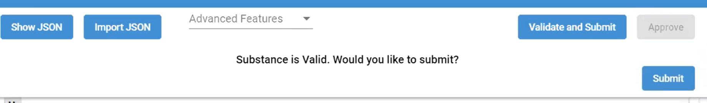

Figure 67- Valid Substance Message

Success screen appears with the message Update was performed. Select View Substance.

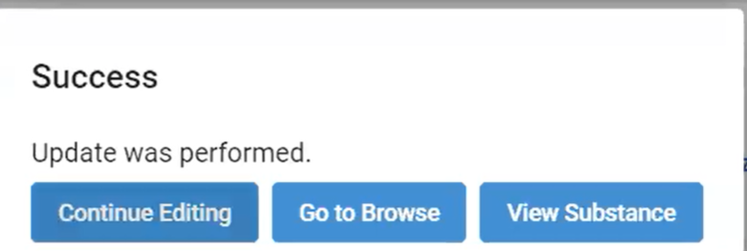

Figure 68- Success Screen

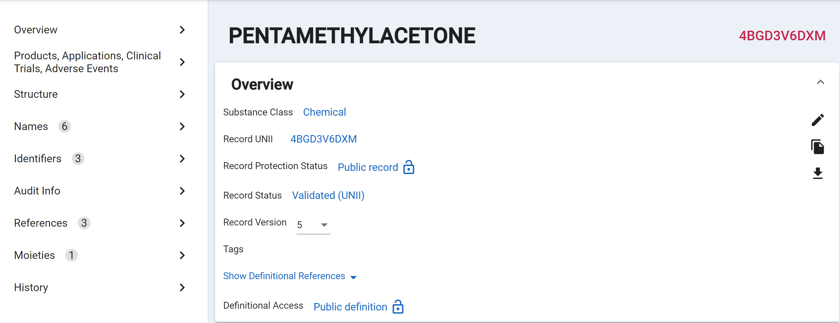

Figure 69- Substance View

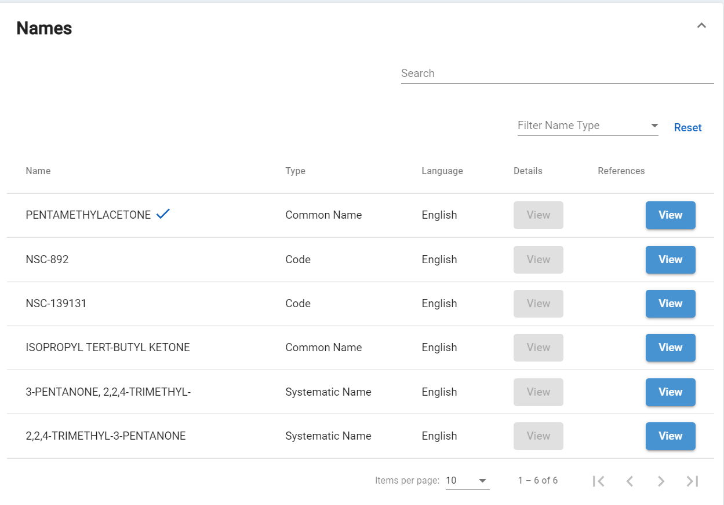

Figure 70- Substance Names

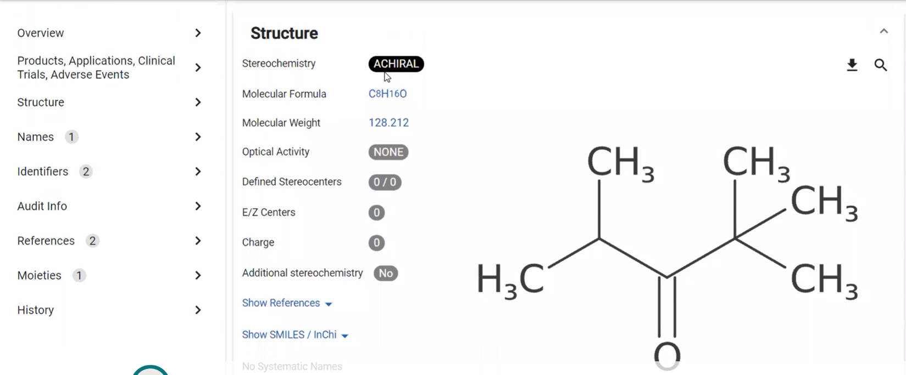

Figure 71- Substance Structure

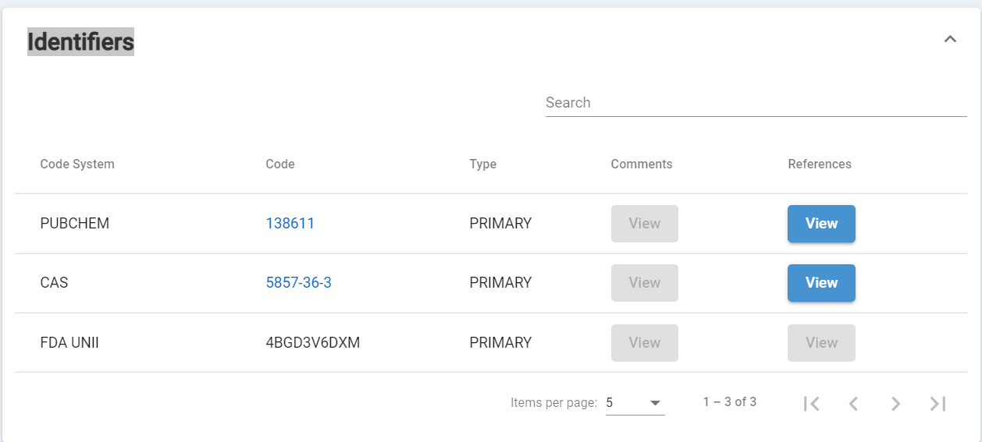

Figure 72- Substance Identifiers

### Relationships

The relationships card accommodates multiple relationships. By default, the section is collapsed but can be expanded to view more relationships. When relationships are added, the inverse relationship is added to the related substance.

1. Expand the Relationships card 
2. Select the Add Relationships + button

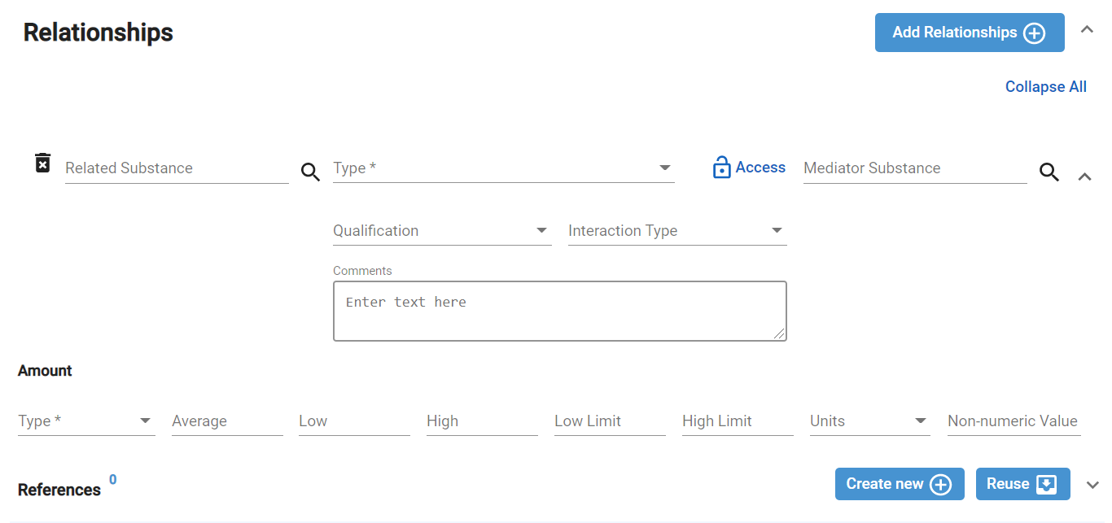

Figure 73- Relationships Card

1. Both the Related Substance and Mediator Substance are search fields. Type ahead is also available for these fields.
   1. Begin entering the name
   2. Select the correct substance if more than one option is available
   3. If no matching substances are returned, you cannot create a relationship to an unregistered substance
2. Select Relationship Type and if applicable, using the down arrow select Qualification, Interaction Type, and Amount.

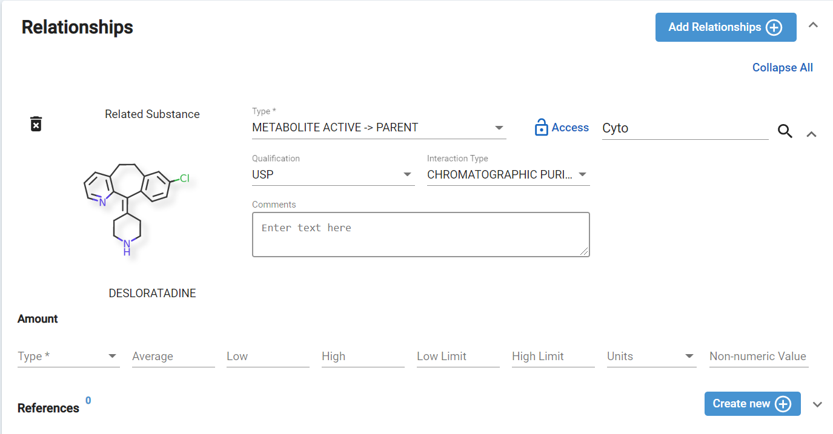 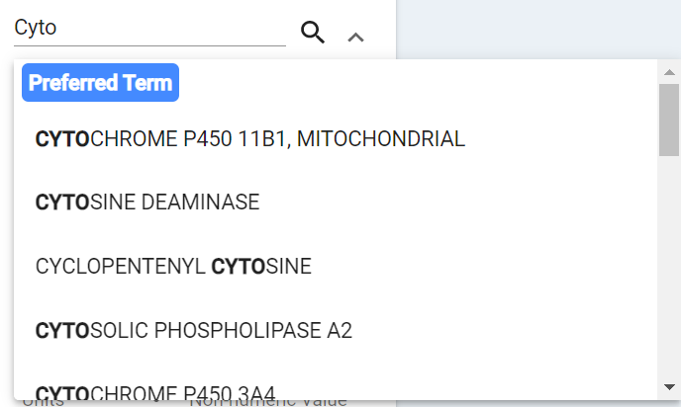



Figure 74- Relationships Card Sample Completed

Impurity Relationships should be added to the active ingredient - to the salt record, if the substance is a salt

1. The relationship Type should be IMPURITY à PARENT
   1. The related substance is always on left side of the arrow and main substance is on right side of the arrow

e.g,: PRASUGREL HYDROCHLORIDE is in USAN (<https://online.uspnf.com/uspnf/document/GUID-6F4D7843-1F3E-43B5-949B-F88DBD6DFA74_5_en-US?highlight=Prasugrel%20Hydrochloride>)

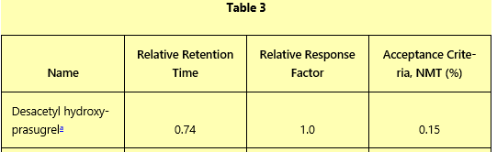

Figure 75 - Relationships - IMPURITIES USP/NF monograph; Mode LC

1. Based on this information, the additional details are:
   1. Qualification = USP
   2. Interaction Type = ASSAY (HPLC)
2. To add the USAN specification of this impurity is “NOT MORE THAN” 0.15 %”, go to the High Limit field under Amount to add amount.
   1. Select the amount Type: Percent Peak Area
   2. Enter “0.15” as the High Limit
   3. Enter Units

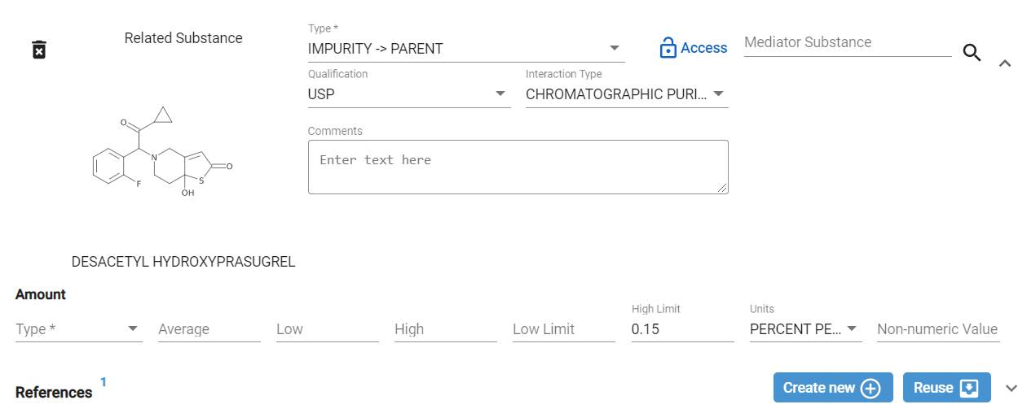

Figure 76 - Relationships - Impurity Details

Metabolite relationships always link to active moiety/prodrug. The relationship options between metabolites and the active moiety/prodrug are:

* Metabolite Active
* Metabolite Active à (as) Parent
* Metabolite Active à Prodrug
* Metabolite Inactive à Parent
* Metabolite Less Active à Parent
* Metabolite à Parent (unknown)
* Metabolite Toxic à Parent (without any activation)
* Metabolite Reactive Typeà Parent
  + Those should be covalently bind to proteins and nucleic acids for the toxicity

<https://www.ncbi.nlm.nih.gov/pmc/articles/PMC2952084/>

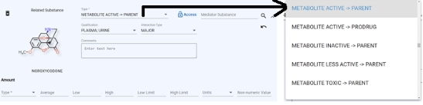

Figure 77 - Relationships - Metabolite Types

Metabolite relationships Example below: Noroxycodone is an active metabolite of oxycodone.

1. Edit Oxycodone
2. In the Relationships card, click Add another relationship
3. In Related Substance, search and select “Noroxycodone”
4. For Type, select “METABOLITE ACTIVE -> PARENT”
5. Add a Reference – a reference is required. If references already exist, you can select an existing reference or Add a Reference

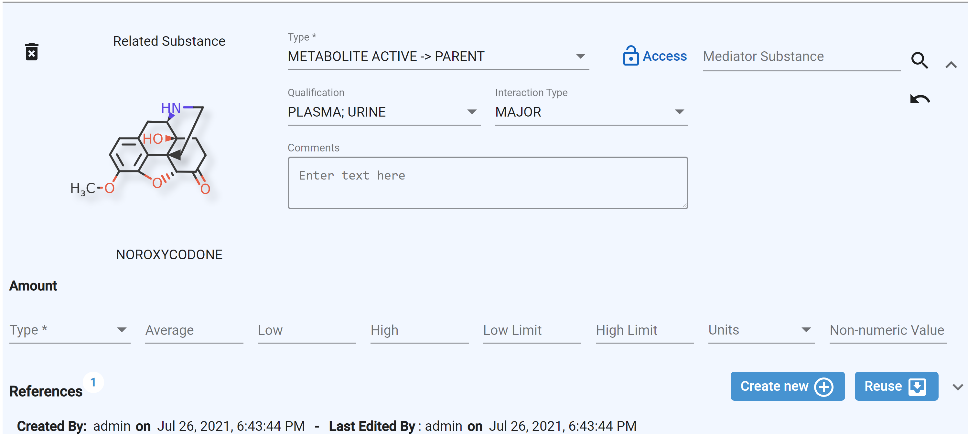

Figure 78 - Relationships - Noroxymorphone Metabolite

1. Mediator Substance - Finding information to register the mediator substance relationship. Example: R-138727 is an active metabolite of Prasugrel, which is a prodrug. R-138727 is a mixture of four isomers. It is a major metabolite in plasma and involves a two step conversion.
   * + - 1. First conversion step in the article below is mediated by esterase (not specified and therefore cannot be captured)
         2. Second step is specific and is mediated by four CYP enzymes. So, one relationship should be added for each CYP enzyme.

<https://accpjournals.onlinelibrary.wiley.com/doi/pdf/10.1592/phco.29.9.1089>

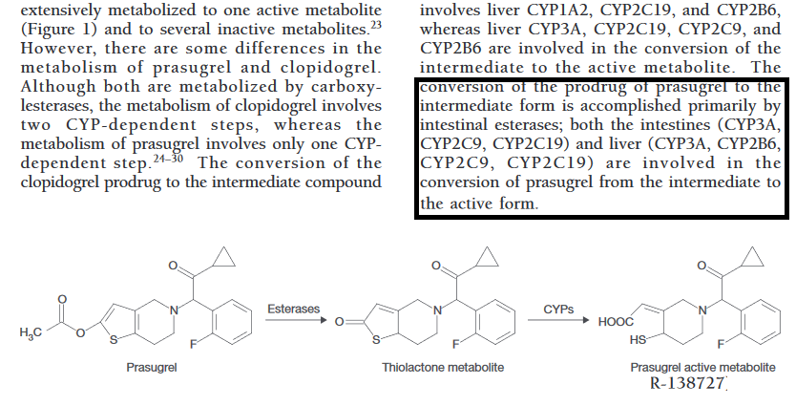

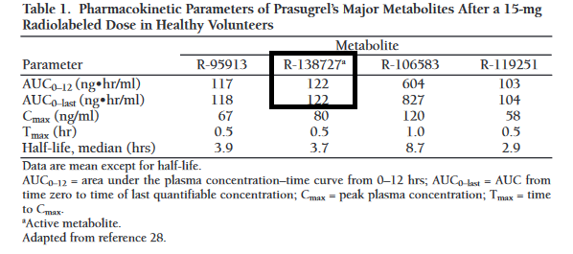

Figure 79 - Extracts of Pharmacokinetics and Pharmacodynamics of Prasugrel, a Thienopryridine P2Y12 Inhibitor

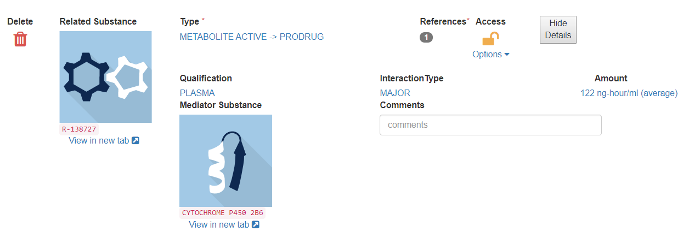

Figure 80 - Relationships – Metabolite for Prasugrel

Ionic moiety is a reflexive substance attribute. It is indicated when the chemical structure is not charge-balanced. Active moiety map be a reflexive substance attribute but may also reference another substance

### Notes

While you can add a note, you will notice that notes will also be automatically added to track Warning messages and other information related to substance validation.

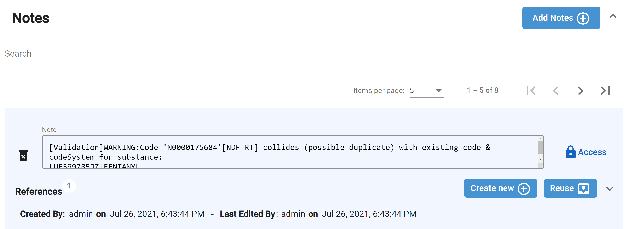

Figure 81 – Notes Sample

### Property

Additional substance details can be added to the Properties card. Properties are not significant for a chemical though.

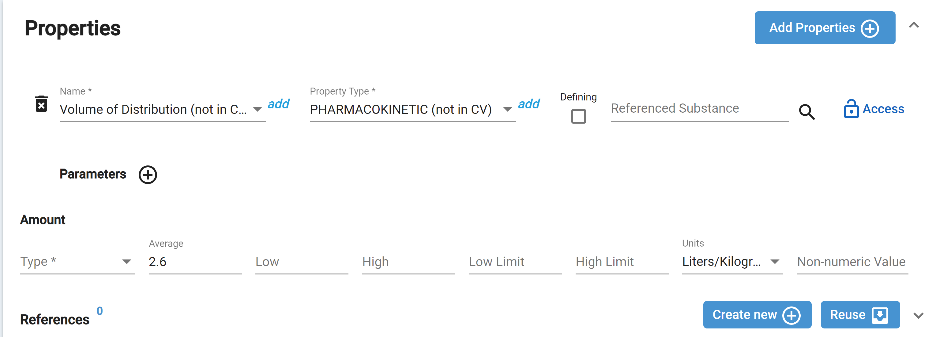

Figure 6 - Register Chemical – Properties (Prasugrel)

### References

The References card automatically accumulate the references added during registration in one section. References can be added, updated, or removed from this card.

### Submit

1. Submit the substance by clicking Submit button on top right-hand corner
2. GSRS will validate the submission, you may receive prompts for
   1. Errors (red) – substances with errors cannot be submitted, click Go Back to return to the substance form, make corrections and resubmit
   2. Warnings (yellow) – warnings should be reviewed
      1. If warnings are accepted, click Dismiss and continue
      2. If warnings should be address, click Go Back to return to the substance form, make corrections and resubmit
3. The Success window will provide three options:
   1. Continue Editing –return to the registration edit form
   2. Go to Browse – close this substance registration form and return to the substance browser of all substances
   3. View Substance – close this substance registration form and display the view version of the substance

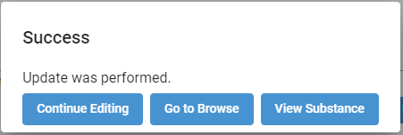

Figure 83 - Chemical Submission Success

1. If you select View Substance, you can confirm your registration. The submitted substance will be assigned the status of Pending and will not have an approval ID. Continue to Approve Substances to review the next phase of substance registration.

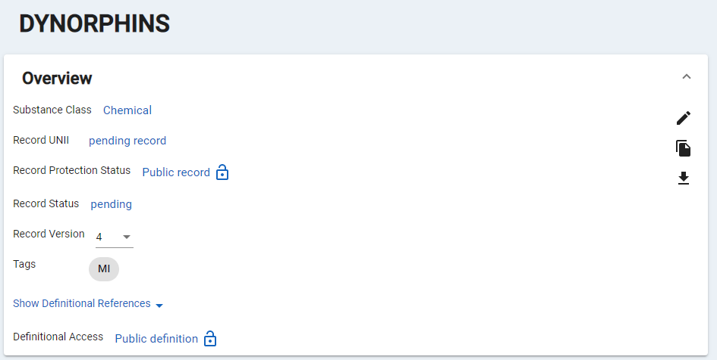

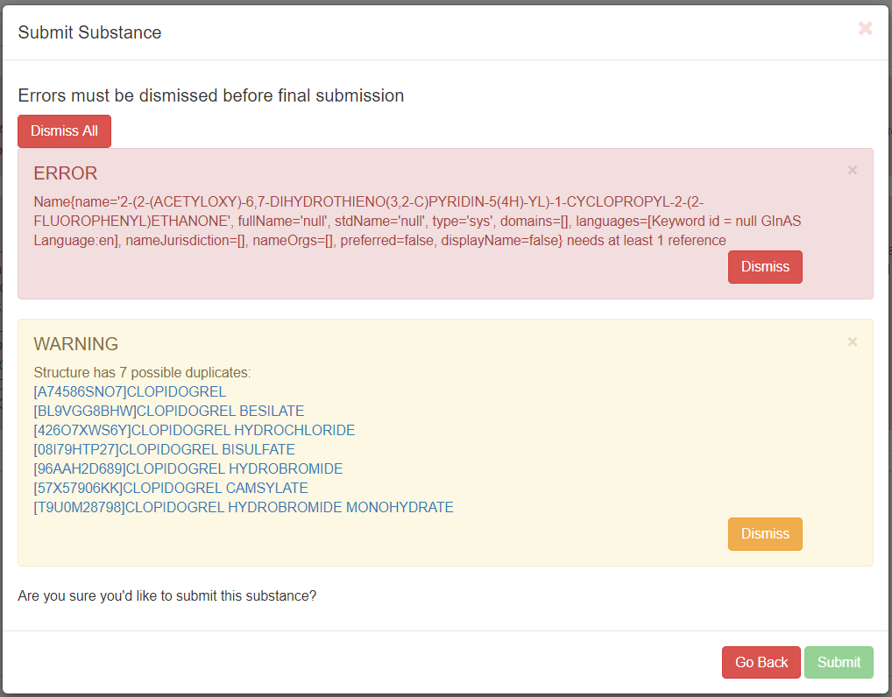

Figure 84 - Register Chemical - Submission Validation

1. After successfully submitted you will have the following options:
   1. Continue Editing – the registration form remains, and changes can be made
   2. Return to Browse – loads the Browse Substances screen
   3. View Substance – displays the current substance in view-only mode

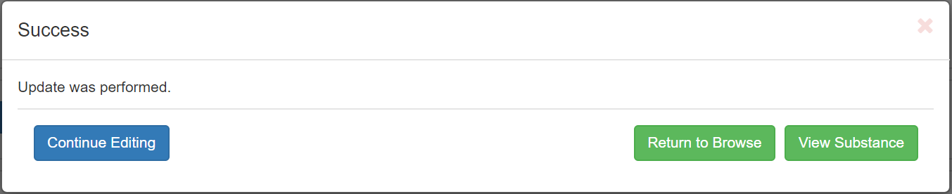

Figure 85 - Register Chemical – Submission

# Register Chemical Stereoisomers

Now that you have registered a Chemical substance, the user should identify any relevant stereoisomers that should also be registered. SciFinder can be quite useful in identifying isomers referenced in chemical literature and those that are available from commercial sources. Since many GSRS users also have access to SciFinder, we will show some of the most commonly used features. The following example illustrates the 7 stereoisomeric GSRS records typically required when a chemical possesses 2 stereocenters and has no plane of symmetry.

The SciFinder homepage is shown below. Select Draw to import chemical information. In the drawing tool, you can draw a query structure, import a molfile, or use the text box to import a structure using a CAS registry number, SMILES, or InChI.

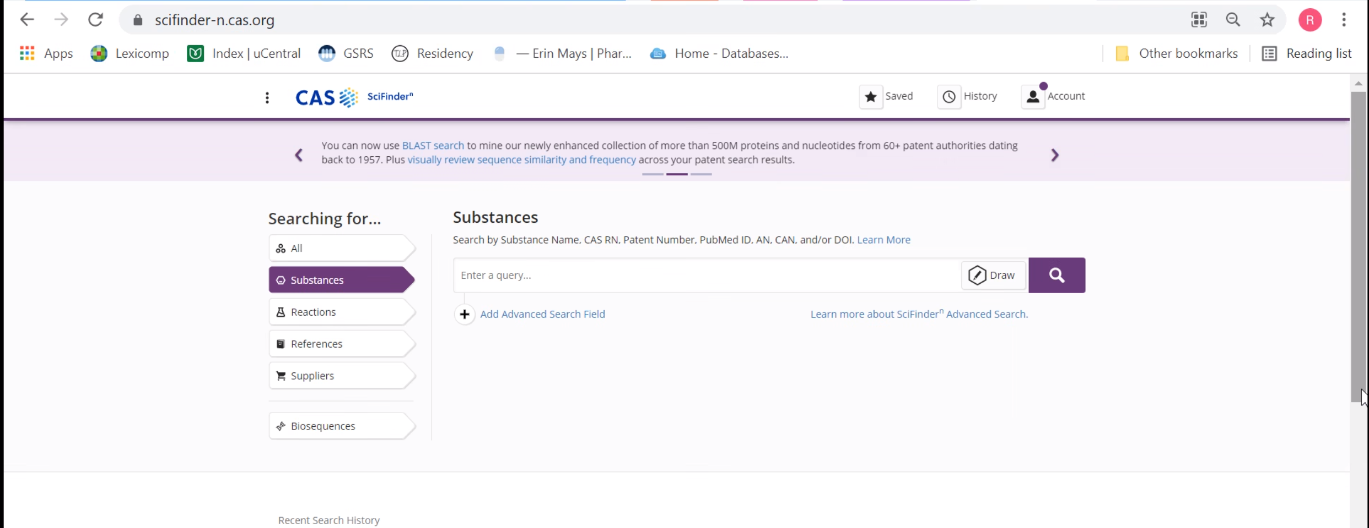

Figure 86 – CAS SciFinder– Draw

1. Copy and paste CAS number in the search field into CAS Draw and select enter, a molecule drawing will appear. Select Ok on the bottom right to exit the drawing tool

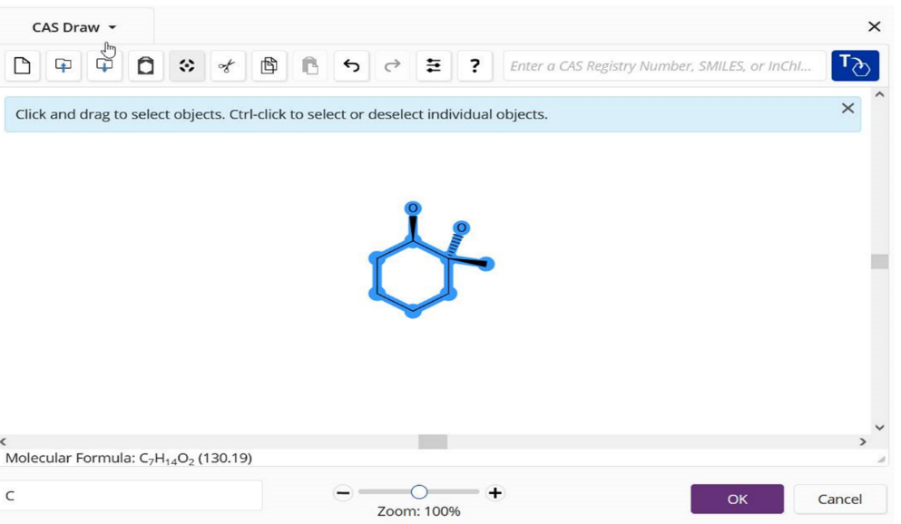

Figure 87 – CAS SciFinder– Enter CAS Number

1. Select Search

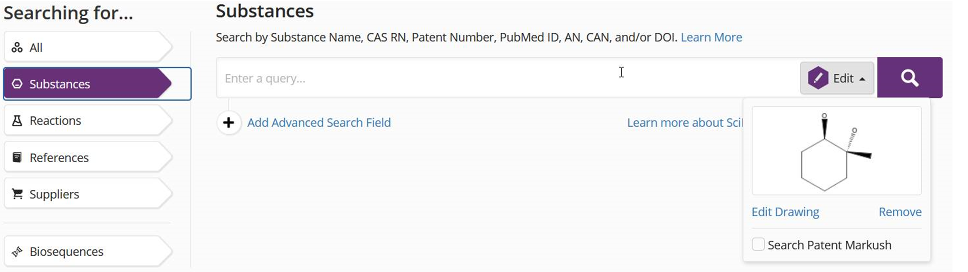

Figure 88 – CAS SciFinder– Search

Some stereoisomers may not appear in the Scifinder search results due to filters which the user can clear. The initial search results show absolute and relative stereochemistry in SciFinder. After all filters are cleared, the 7 relevant chemical structures are shown.

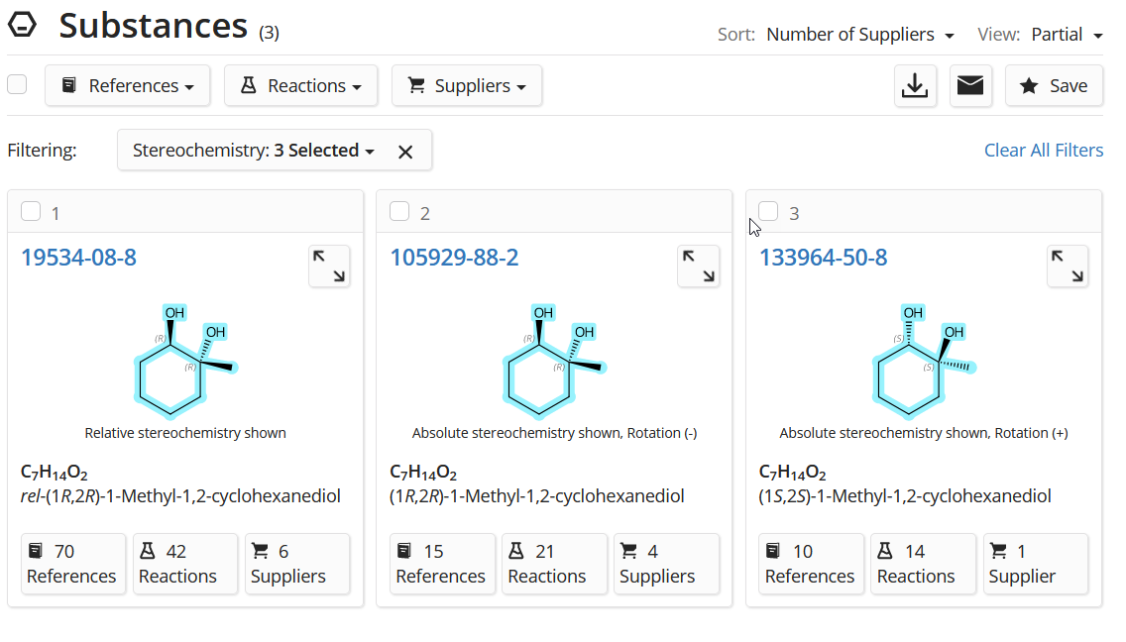

Figure 88 – CAS SciFinder– absolute and relative stereochemistry

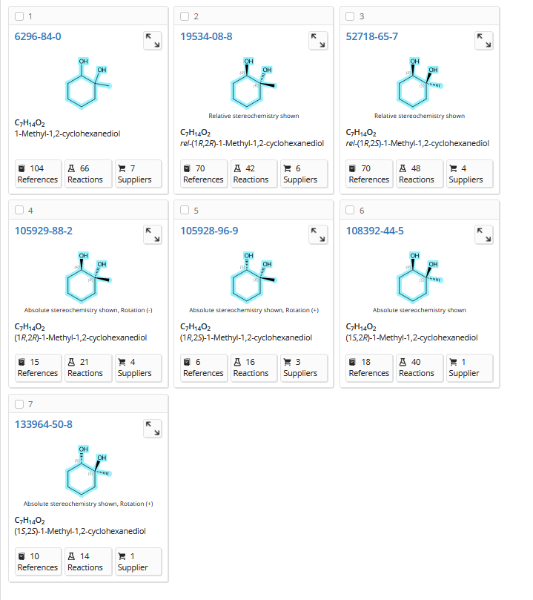

Figure 89 – CAS SciFinder– relevant chemical structures

The following chemical on the left hand side is the +/- trans isomer. The GSRS drawing tool assumes that structures drawn with dashes and wedges infer absolute stereochemistry. The initial structure input is shown in the screen shot on the right. This molecule on the other hand is racemic.

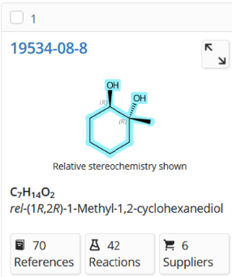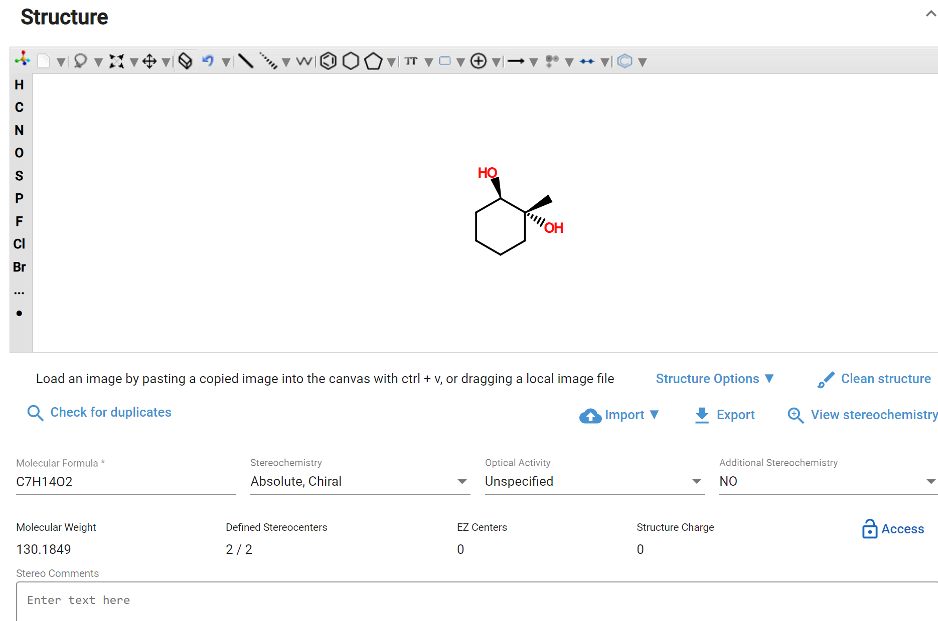

Figure 90 – +/- Trans isomer and initial structure input

We must therefore explicitly select racemic from the Stereochemistry drop down menu. We also must explicitly select the +/- Optical Activity from that drop down menu. These additional steps result in an accurate description of the molecule. Several of the structures above are absolute. Their Optical Activity defaults to unspecified, but can be selected using the information from SciFinder.

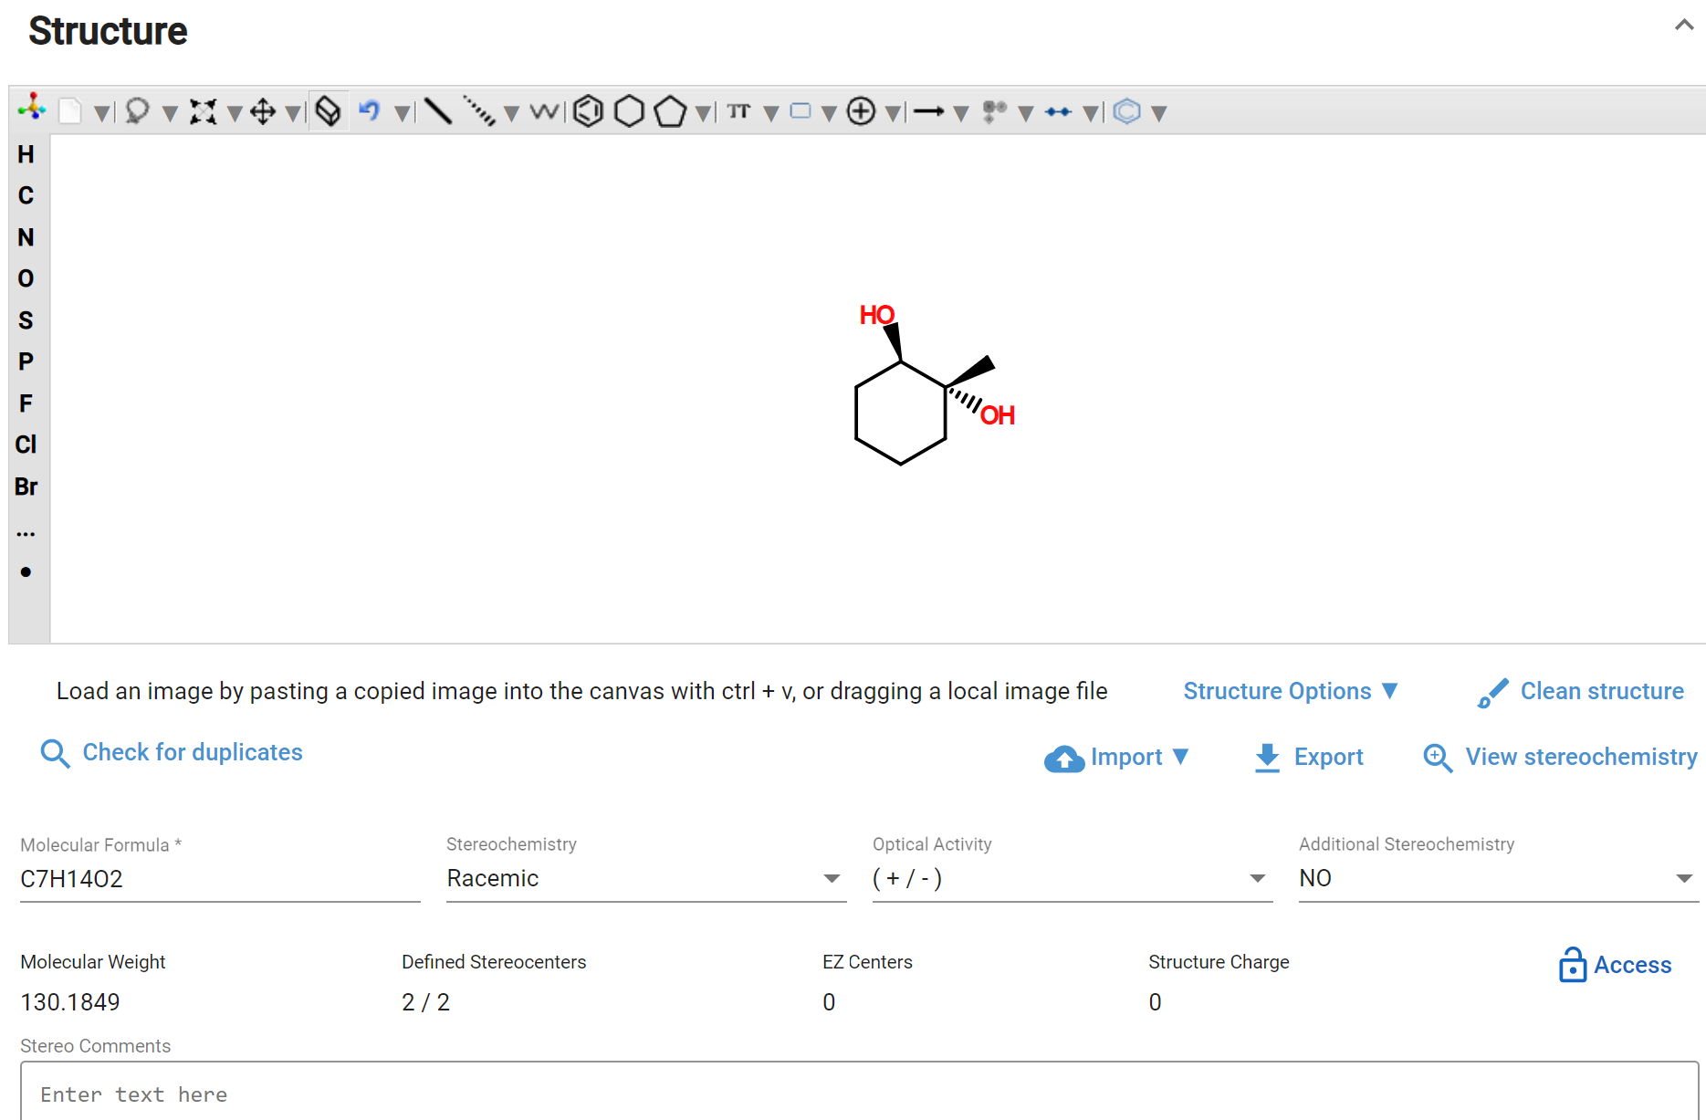

Figure 91 – Stereochemistry-Racemic and Optical Activity (+/-)

Molecule 6296-84-0 is the compound with no stereochemistry. In this case GSRS describes the molecule as a mixture of the +/- trans isomer 19534-08-0 and the +/- cis isomer 52718-65-7 as shown below. The latter structure must be registered first in GSRS. The mixture substance is then registered with the other two compounds as components.

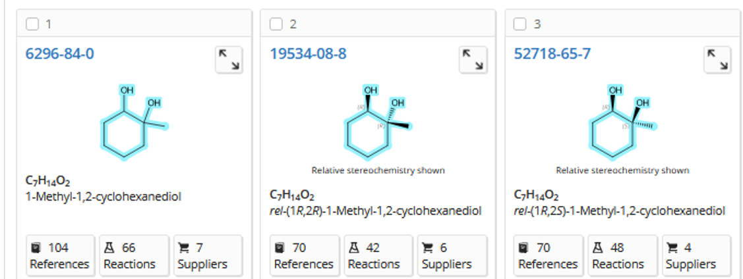

Figure 92 – Molecule 6296-84-0 is compound with no stereochemistry; mixture of +/- trans isomer 19534-08-0 and +/- cis isomer 52718-65-7

Complete registering a chemical Stereoisomers as previously described in **Register Chemicals**.

# Register Proteins

## Check for Duplicates

### Global Search

Utilize the Global Search options

### Sequence Search

Same as in Sequence Search

## Protein Registration

1. After verifying the substance is not registered in GSRS via your Check for Duplicates, use the Protein Registration form to register the new substance.
   1. User accounts with registration permissions will have access to the registration menus. If you believe your account is not properly configured, contact your site admin.
2. The protein registration form will be displayed. Section cards are collapsible to ease navigation, however the elements in this form are:
3. Overview - Definitional Information
4. Names
5. Protein Details
6. Subunits
7. Other links
8. Disulfide links
9. Glycosylation
10. Agent modification
11. Structural modification
12. Physical modification
13. Code
14. Relationships
15. Notes
16. Properties
17. References

### Definitional Information

Same as in Chemical registration - Overview Definitional Information

### Names

Same as in Chemical registration - Names

### Protein Details

1. Add Protein Details for: Protein Type, Protein SubType, Sequence Origin, Sequence Type and Access level, all of which are driven by the controlled vocabulary of your instance
   1. Access level should be set to protected if the sequence information is not public, even if name and target information is public

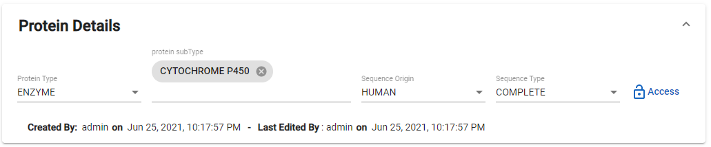

Figure 93 - Protein Details Card

### Subunits

Add subunits one at a time.

1. Press Add subunits button, the card will expand and have the following options:
   1. Add Feature
   2. Add Any Site Type
   3. Subunit 1
      1. Clean
      2. Save
      3. Convert
      4. Sequence Search
      5. Copy Disulfide links
2. Paste the sequence into the canvas
3. Press the clean button, this tool removes numbers, spaces if any
4. Press the save button

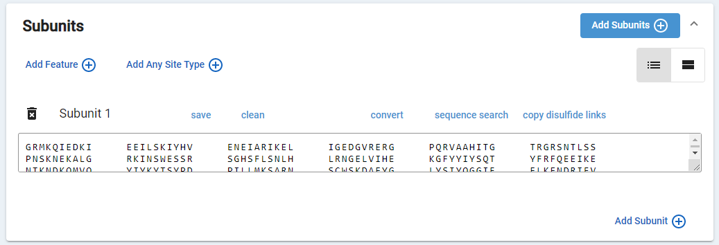

Figure 94 - Subunits

1. For some subunits, you may want to highlight specific regions of a protein that are of interest
   1. Other registrars will easily identify these regions through the display highlights
   2. Browse or Query users will have access to this information in the substance property of the Characteristic Attributes card
2. If you need to highlight a specific region, the subunit will need to be saved first (steps 1-4 of this section. Next, press the Add Feature button
3. In the Add/Modify Feature pop-up:
   1. Add a Name for display
   2. Select the range
   3. Press the Save button

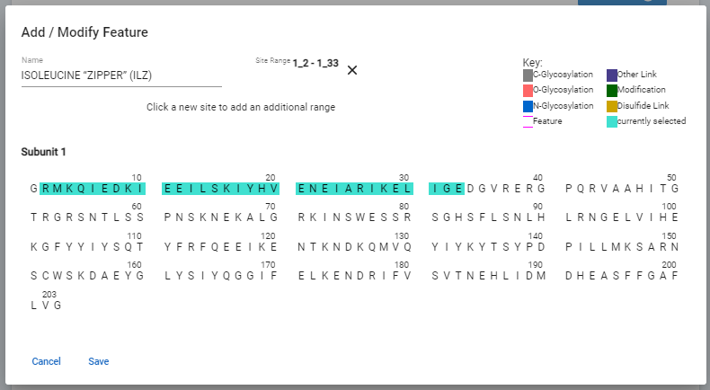

Figure 95 - Subunits “Feature”

1. Your browser will display a message that reads Feature added under “Properties”. Press OK to the browser notification.
2. The display is updated to highlight the region

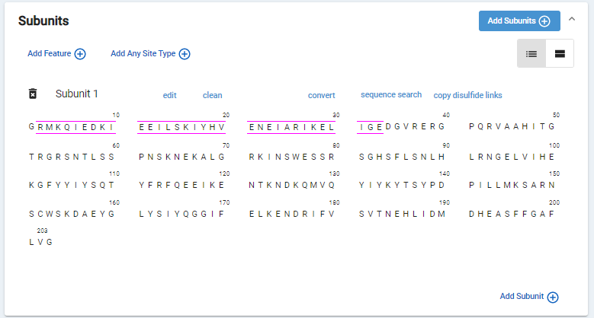

Figure 96 - Subunits Feature Highlight

1. For some subunits, you will need to add Glycosylation, Disulfide, Modification, and Other link types from the subunit card.
2. Press the Add any site type button
3. In the Select Sites pop-up:
   1. Select the link type from the drop-down (first)
   2. Then, select the range
   3. Press the Save button
   4. Repeat for as many links as you would like to add
   5. These can also be added in the [link type] card

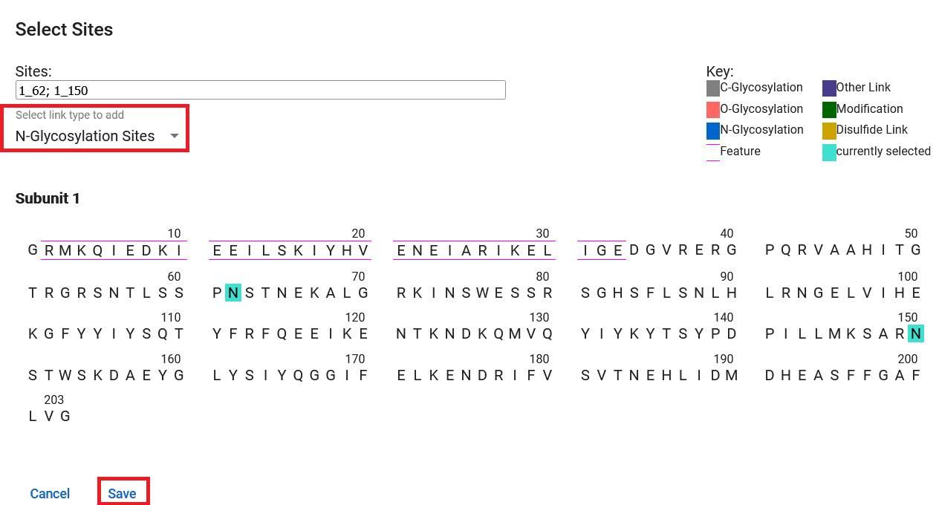

Figure 97 - Subunits Select Sites pop-up

1. To verify, scroll to the Glycosylation card.
2. Press the Add subunits button to add more subunits, or continue to another card.

### Other Links

Add other links one at time.

1. Press the Add Other Links button
2. Select the Sequence Type drop-down to identify the linkage type
3. Press the pencil button to select sites to display

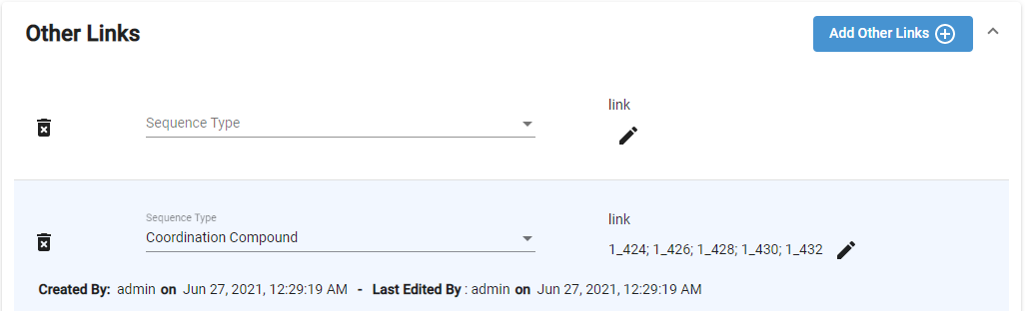

Figure 98 - Other Links - Linkage Type

1. A new pop-up will be displayed with the populated subunits.
   1. Select the subunits and the site box will populate.
   2. 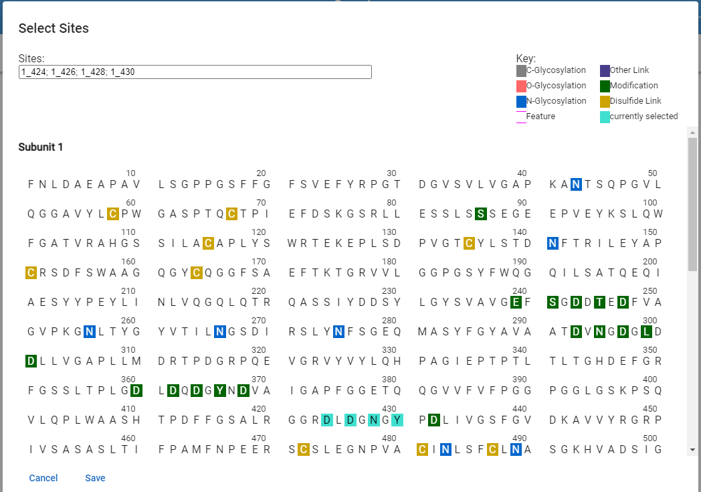You can continue for each pair, press Save

Figure 99 - Other Links - Site Selector

### Disulfide Links

Add disulfide links one at a time with the pre-populated sites for pairing

1. Press the Add Disulfide Links button

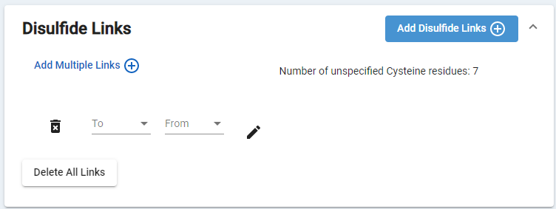

Figure 100 –Add Disulfide Links

1. There are several options to add disulfide links:
   1. Use the To and From drop-downs to select sites, one pair at a time
   2. Use the pencil button to select sites which will populate in the drop-down menu, one pair at a time
   3. Press the Add Multiple Links button
      1. The Select Sites window will pop-up
      2. Select pairs of sites which will be updated in the Links section
      3. Press Save and return to the registration form

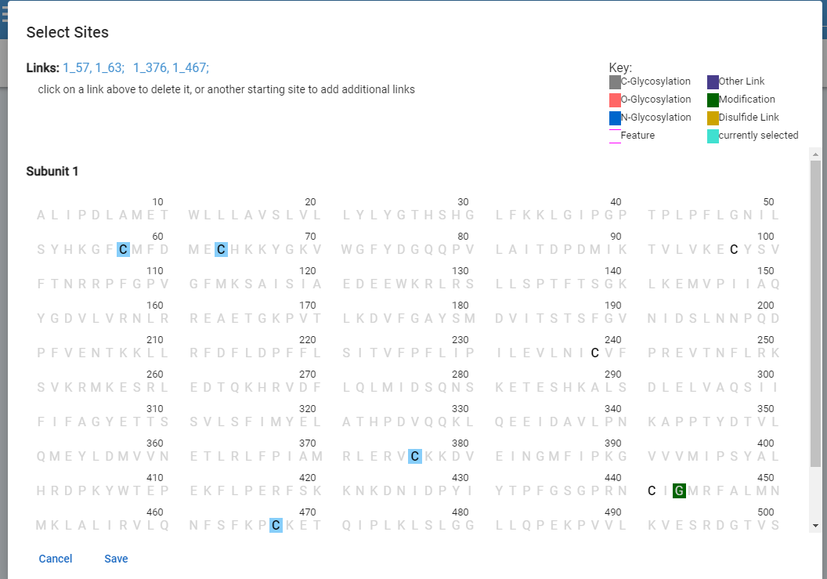

Figure 101 –Add Multiple Disulfide Links

1. Repeat for each pair
2. At any time, if you need to start over, press the Delete all links button

### Glycosylation

1. Press Glycosylation to expand the card
2. Select the Glycosylation Type – optional, based on the controlled vocabulary of your instance
3. For C, N and O Glycosylation Sites, press and the current sequence selector will be displayed

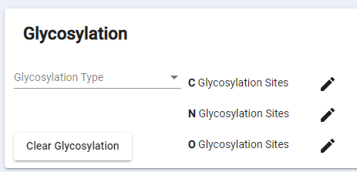

Figure 102 - Glycosylation

1. Sites should be in the form of subunit_residue, use hyphen “-“ to indicate a range, this will be automatically applied if you select the sites within the pop-up window.
2. Press the Save button

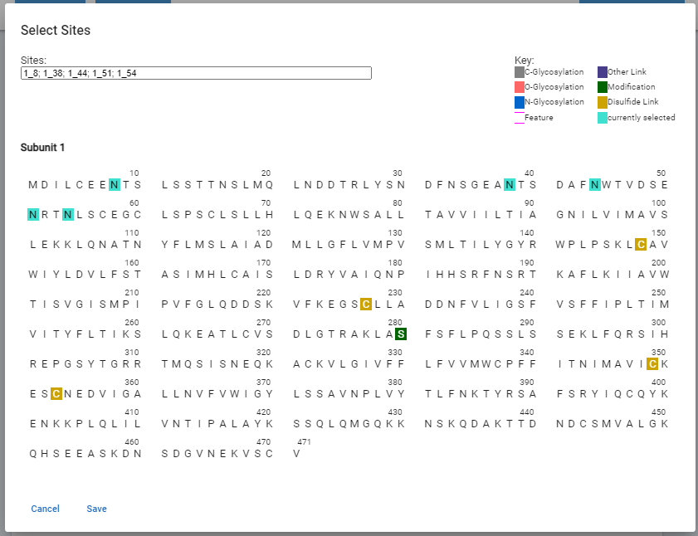

Figure 103 - Glycosylation Site Selector

### Agent Modifications

The modifications without sufficient information to capture as structural modifications should be added as agent modifications.

1. Press Add Agent Modifications button to expand the card, the following fields can be populated:
   1. Agent Substance – substance selector, search for other substance records in your instance
   2. Modification Process – drop-down values from the controlled vocabulary of your instance
   3. Modification Type – drop-down values from the controlled vocabulary of your instance
   4. Modification Role – drop-down values from the controlled vocabulary of your instance
   5. Amount – pop-up window to enter amount parameters, press Save after adding values
   6. Group – text box
2. Repeat for additional agent modifications

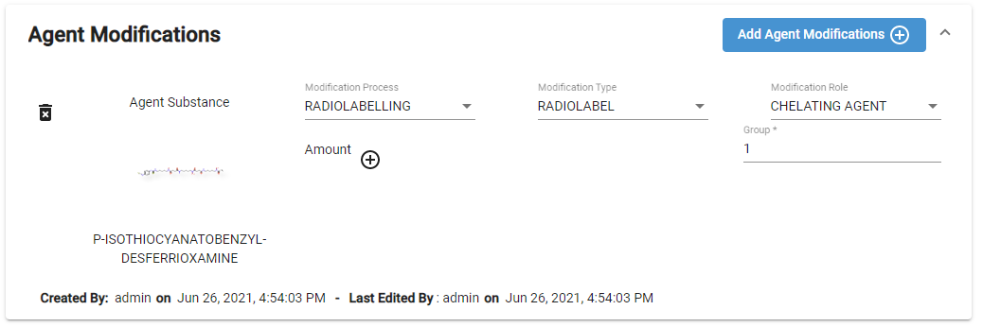

Figure 7 - Agent Modifications

### **Structural Modifications**

The common modifications are Amino Acid Removal, Amino acid replcament, Ligand Binding, Metal Binding and moiety.

1. To add a structural modification, press the Add Structural Modification button to expand the card, the following fields should be populated:
   1. Molecular Fragment – substance selector, search for other substance records in your instance
   2. Modification Type – drop-down values from the controlled vocabulary of your instance
      1. Moiety: Use moiety modification for salts or solvates
      2. Ligand Binding or Metal Binding: Use to describe chelates, metal binding sites
   3. Sites – from the site selector pop-up, select the site and press Save to return to the registration form
   4. Extent – select partial or complete
      1. If Partial press the pencil button and enter the amount details in the Edit Parameter pop-up, press Save to apply the amounts and return to the registration form
   5. Location– drop-down values from the controlled vocabulary of your instance; If modification is residue specific, sites will disappear and list of amino acids will appear. Selected the correct amino acid
   6. Amount – pop-up window to enter amount parameters, press Save after adding values
   7. Group – text box

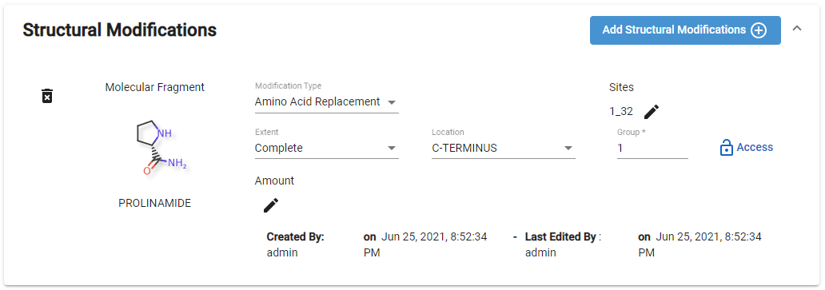

Figure 105 - Structural Modifications

1. Select the Fragment via substance search
   1. In some instances, the fragment substance may not be included in GSRS. Below is an example to register a fragment for Amino Acid Replacement
      1. Identify the substance type and register it using appropriate registration form
      2. Draw the structure to show cleary how the modifying group would connect to the amino acid
      3. If the modifying group has multiple connecting points consider it as multiple modifications and register all the possible isomers.
         1. Ex: Two lysine modifications and two leucine modifications for this example

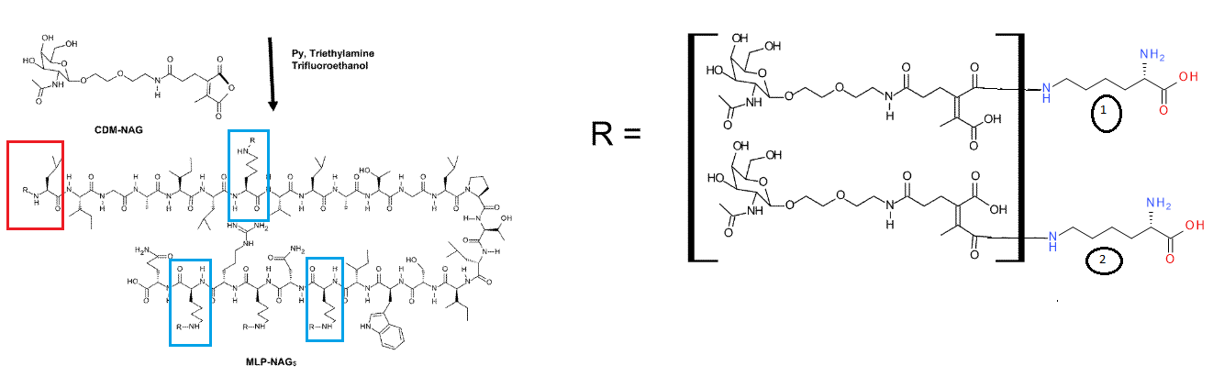

Figure 8 - Structural Modifications – Amino Acid Replacement Fragment

1. Select the location type:
   1. If the Location Type is Residue-Specific, the Residue Modified field will be displayed. Select an option from the controlled vocabular of your instance

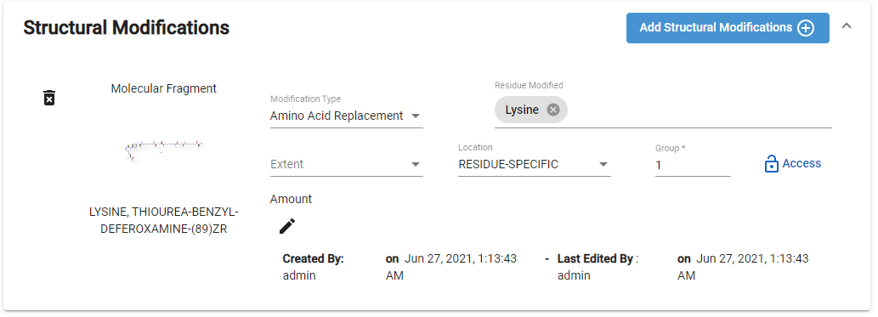

Figure 107 - Structural Modifications - RESIDUE-SPECIFIC Location Type

1. If the Location Type is N-terminus, C-terminus or Site Specific, the Site field will be displayed. Press the pencil button which will display the site selector pop-up, select the sites and press Save to return to the registration form

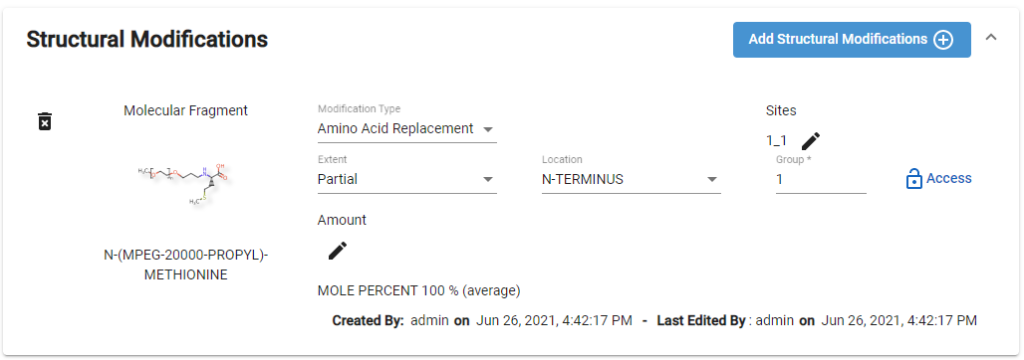

Figure 108- Structural Modification – N-TERMINUS Location Type

1. Repeat for additional structural modifications

### **Physical Modifications**

1. To add a Physical Modification, press Add Physical Modifications button to expand the card, the following fields should be populated:
   1. Modification Role – drop-down values from the controlled vocabulary of your instance
   2. Parameters – in the pop-up window, name the parameter, ex: Temperature and complete the amount fields
      1. Press save to apply the parameters and return to the registration form
   3. Group – text boc
2. Repeat for additional physical modifications

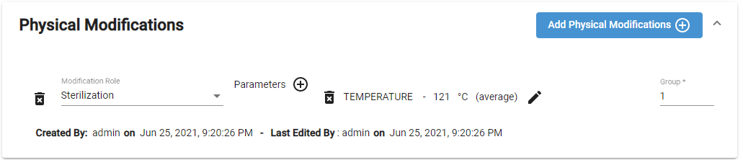

Figure 109 - Physical Modifications

### Codes

Same as in Chemical registration - Codes

### Relationships

Same as in Chemical registration - Relationships

### Notes

Same as in Chemical registration - Notes

### Properties

Same as in Chemical registration - Properties

### References

Same as in Chemical registration - References

### Submit

Same as in Chemical registration - Submit

# Register Nucleic Acids

## Check for Duplicates

There are several options to check for duplicates (using all will ensure an exhaustive search).

1. Search by name/code (CAS RN or another identifiers) using:
   1. Global Search
   2. Advanced Search
2. Sequence search

### Global Search

Same as in Global Search

### Sequence Search

Same as in Sequence Search

## Nucleic Acid Registration

1. After verifying the substance is not registered in GSRS via your Check for Duplicates, use the Nucleic Acid Registration form to register the new substance.
2. User accounts with registration permissions will have access to the registration menus. If you believe your account is not properly configured, contact your site admin.
3. The nucleic acid registration form will be displayed. Section cards are collapsible to ease navigation, however the elements in this form are:
4. Overview - Definitional Information
5. Names
6. Nucleic Acid Classification
7. Subunits
8. Links
9. Sugars
10. Physical modifications
11. Agent modifications
12. Structural modifications
13. Codes
14. Relationships
15. Properties
16. Notes
17. References

### Overview - Definitional Information

Same as in Chemical registration - Overview Definitional Information

### Names

Same as in Chemical registration - Names

### Nucleic Acid Classification

1. Select Nucleic Acid Classification to expand the card
2. Select Nucleic Acid Type, Nucleic Acid Subtype, Sequence Origin, Sequence Type, which are all drop-down options driven by the GSRS Controlled Vocabulary
3. Access level should be protected if the sequence information is not public, even if name and target information is public

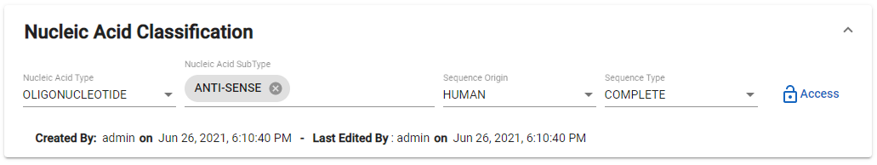

Figure 110 - Register Nucleic Acid - Classification

### Subunits

Same as in Protein registration - Subunits

### Links

1. Select the Add Links button
2. The Links card will expand and display the number of remaining links, Sequence Type drop-down, add remaining [#] sites button, pencil edit button for link

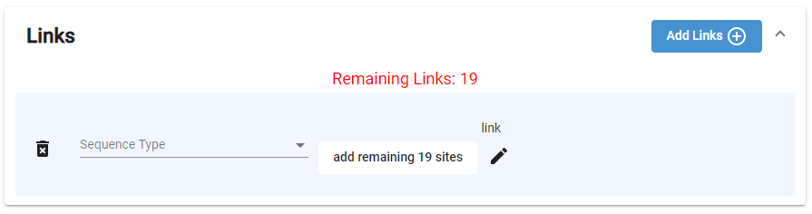

Figure 111 - Register Nucleic Acid – Add Links

1. Select a Sequence Type from the controlled vocabulary
2. Select the add remaining [#] sites button
3. If more than one link, press the  for the site selector pop-up.
   1. Either slect or type in the text box in the format subunit_residue; use “-“ for a range
   2. Press the Save button to update the link’s site list and be returned to the registration page

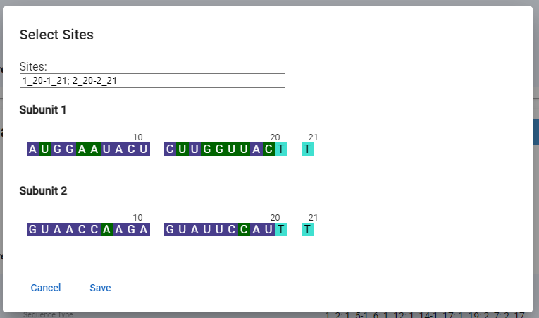

Figure 112 - Register Nucleic Acid – Links Select Sites

1. Repeat for additional links

### Sugars

1. Press the Add Sugars button
2. If the nucleic acid has one sugar, press Add remaining [#] sites button and it will auto populate all the sugars

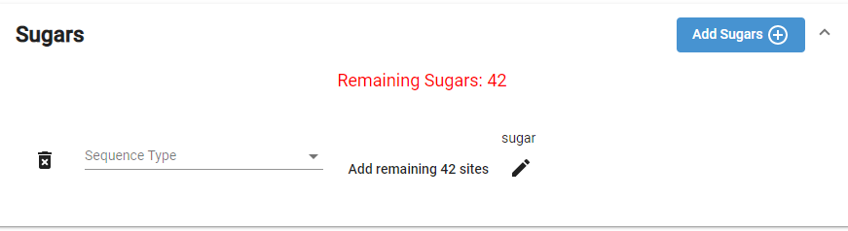

Figure 113 - Register Nucleic Acid - Sugars

1. If more than one sugar, Click on  for the site selector pop-up.
   1. Either slect or type in the text box in the format subunit_residue; use “-“ for a range
   2. Press the Save button to update the sugars and be returned to the registration form.

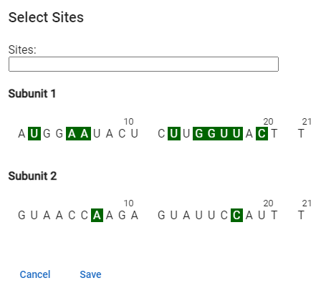

Figure 114 - Register Nucleic Acid - Sugars - Site Selector

1. Repeat for additional sugars

### Agent Modifications

Same as in Protein registration - Agent Modifications

### Structural Modifications

Follow the steps in the Protein registration – Structural Modifications.

The common structural modifications for nucleic acids are:

* Nucleoside substitution - 5’-terminus location type
* Nucleotide substitution - invert sugars with 3’-3’ linkages
* Nucleobase substitution - for inner base modifications

Note: Nucleoside substitution has been using for both 5’ and inner base modifications to remove the ambiguty of the connectivity between base and sugar. This practice may have to continue with unusual bases

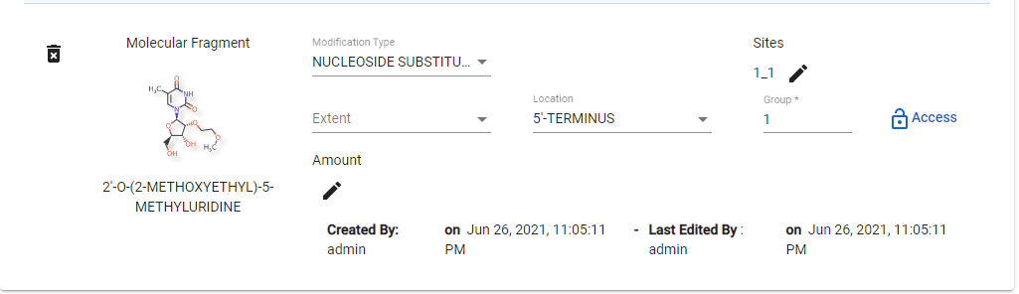

Figure 115 - Register Nucleic Acid - Structural Modifications

**Fragment registration for Nucleoside/nucleotide substitution**:

Follow the steps in the Protein Registration – Fragment section to identify the substance type and register it using appropriate registration form. Draw the structure to show clealy how modifing group would connect to the nucleoside/nucleotide.

### Physical Modifications

Same as in Protein registration - Physical Modifications

### Codes

Same as in Chemical registration - Codes

### Relationships

Same as in Chemical registration - Relationships

### Notes

Same as in Chemical registration - Notes

### Properties

Same as in Chemical registration - Properties

### References

Same as in Chemical registration - References

### Submit

Same as in Chemical registration - Submit

# Register Polymers

## Check for Duplicates

There is only one systematic way to search for polymer duplicates, using the Global Search feature.

### Global Search

Same as in Global Search

## Polymer Registration

1. After verifying the substance is not registered in GSRS via your Check for Duplicates, use the Polymer Registration form to register the new substance.
   1. User accounts with registration permissions will have access to the registration menus. If you believe your account is not properly configured, contact your site admin.
2. The polymer registration form will be displayed. Section cards are collapsible to ease navigation, however the elements in this form are:
3. Overview - Definitional Information
4. Names
5. Polymer Classification
6. Monomers
7. Idealized Structure
8. Structural Units
9. Agent Modifications
10. Structural Modifications
11. Physical Modifications
12. Codes
13. Relationships
14. Notes
15. Properties
16. References

### Definitional Information

Same as in Chemical registration - Overview Definitional Information

### Names

Same as in Chemical registration - Names

### Polymer Classification

1. Select Polymer Classification to expand the card
2. Select:
   1. Polymer Class - drop-down driven by the CV
   2. Source Type - drop-down driven by the CV
   3. Parent Substance – substance search/selector
      1. Use the substance search box to search and select the record of the Parent Substance which should be pre-registered
      2. If the Parent Substance is not in GSRS, determine the substance type and register the new record
   4. polymer subclass – multi-select drop-down driven by the CV
   5. Polymer Geometry - drop-down driven by the CV
3. Access level should be protected if the defining information is not public, even if the name is public.

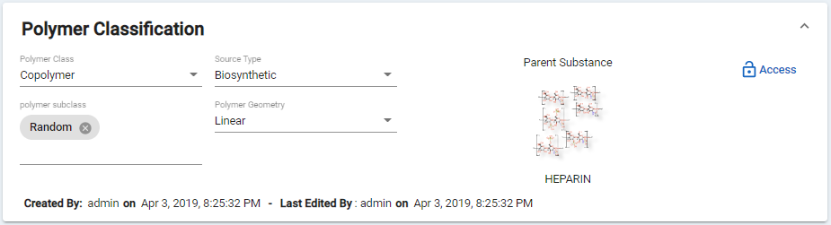

Figure 116 - Polymer Registration - Polymer Classification

Monomers

The monomers should be preregistered.

1. Select Monomers to expand the card.
2. Select
   1. Monomer Substance - substance search/selector
   2. Monomer Type - drop-down driven by the CV

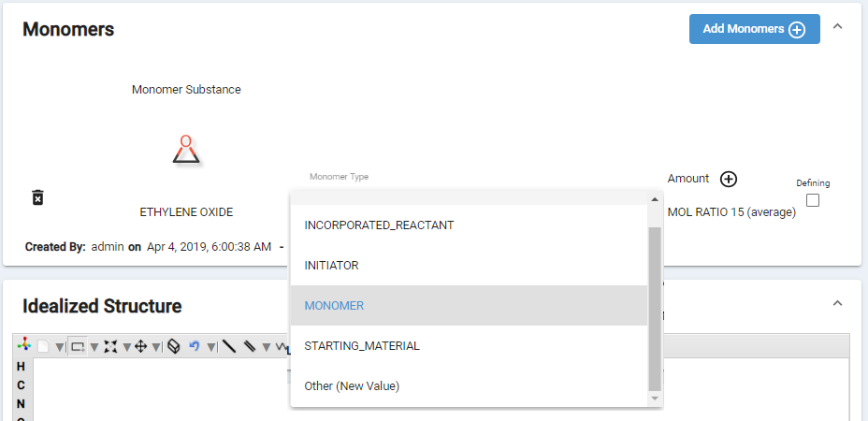

Figure 117 - Polymer Registration – Monomers

1. To add the amount, select on . A pop-up window will be displayed to Edit Parameter
2. The amount type should be Mol Ratio or Weight ratio.
   1. The amount could be a range, average or limits.
   2. The units should be per polymer for homopolymers and no units for copolymers.
3. Select Save and you are returned to the Polymer registration form and the amount details are displayed on the Monomers card.

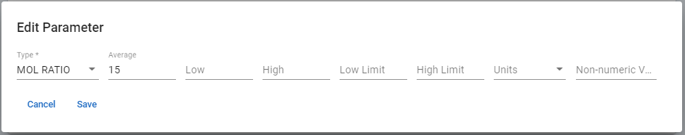

Figure 118 - Polymer Registration - Monomers - Amount

### Idealized Structure

Follow the steps to import the structure similar to the chemical registration structure.

* The bracket types [ ] can be found in the JS Draw Canvas tool bar
  + SRUs can be labelled as you draw them
* Free sites can be used to show the possible sites of substitution. To create free sites:
  + Bring the cursor to the site
  + Do not select the site, but on hover the site should high in green
  + Use the keyboard to hold Shift and * together

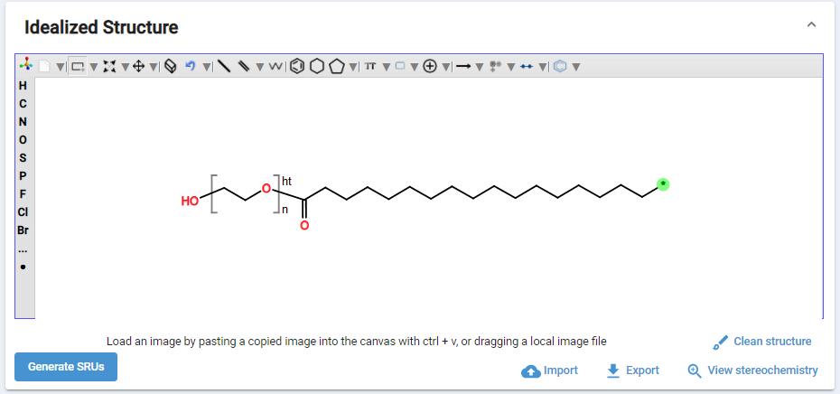

Figure 119 - Polymer Registration - Brackets and Free Site

### Structural Units

1. From the Idealized Structure canvas, select the Generate SRUs button
   1. The values can be manually updated



Figure 120 - Polymer Registration – Generate SRUs

1. Select Structural Units to expand the card

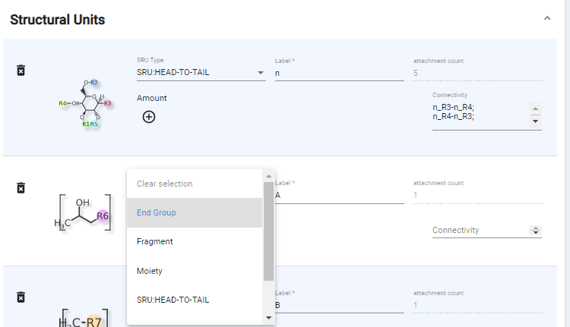

Figure 121 - Polymer Registration - Structural Units

1. Each Stuctural Unit has fields for:
   1. SRU Type – drop-down driven by the CV
   2. Label
   3. Attachment Count – computed, cannot change
   4. Amount - to add the amount, select on . A pop-up window will be displayed to Edit Parameter
      1. Type – set to:
         1. Degree of polymerization for structural repeat units
         2. Degree of Substitution for substituents.
      2. The amount can be a range, average or low/high limits.
      3. Any additional information can be captured under Non numerical values
      4. Select Save to be returned to the Polymer Registration form
   5. Connectivity

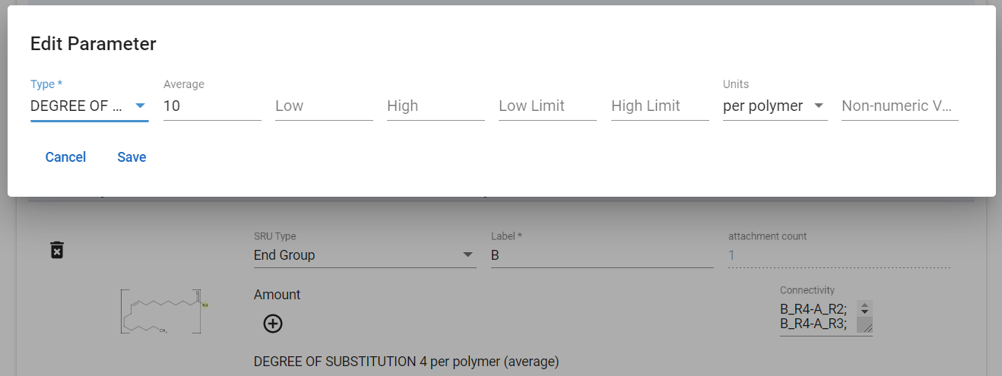

Figure 122 - Polymer Registration - Structural Unit – Amounts

### Agent Modifications

Same as in Protein registration - Agent Modifications

### Physical Modifications

Same as in Protein registration - Physical Modifications

### Codes

Same as in Chemical registration - Codes

### Relationships

Same as in Chemical registration - Relationships

### Notes

Same as in Chemical registration - Notes

### Properties

Same as in Chemical registration - Properties

### References

Same as in Chemical registration - References

### Submit

Same as in Chemical registration - Submit

# Register Structurally Diverse

## Check for Duplicates

There is only one systematic way to search for structurally diverse duplicates, using the Global Search feature.

### Global Search

Same as in Search

## Structurally Diverse Registration

1. After verifying the substance is not registered in GSRS via your Check for Duplicates, use the Structurally Diverse Registration form to register the new substance.
   1. User accounts with registration permissions will have access to the registration menus. If you believe your account is not properly configured, contact your site admin.
2. The structurally diverse registration form will be displayed. Section cards are collapsible to ease navigation, however the elements in this form are:
3. Overview - Definitional Information
4. Names
5. Source Material
6. Parts and Fractions
7. Agent modification
8. Structural modification
9. Physical modification
10. Code
11. Relationships
12. Notes
13. Properties
14. References

### Overview Definitional Information

Same as in Chemical registration - Overview Definitional Information

### Names

Same as in Chemical registration - Names

### Source Material

1. Select Source Material to expand the card
2. Select the Source Material Class and Source Material Type
   1. If you select Source Material Class = Organism, you will also have the opportunity to add the Source Material State

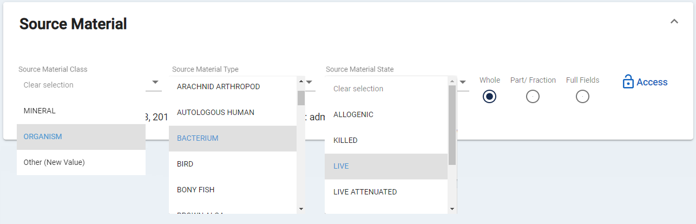

Figure 123 - Structurally Diverse Registration - Source Material

1. There are three radio buttons to indicate record type and drive the display of the Parts and Fractions card.
   1. Whole - whole organisms are plants, animals, microorganism, virus, modified virus, cell lines, modified cell lines. The Organism Details card will now include options to capture Family, Genus, Species, Author, Infra Specific Type, Infra Specific Name, Developmental Stage, Hybrid Paternal Organism and Hybrid Maternal Organism are captured
   2. Part/Fraction - additional cards for Organism Details appear as part of the form to capture Source Material Parent, Part(s) Part Location, Fraction Name, and Fraction Material Type
   3. Full Fields – structurally diverse substances will not be saved with both sets of fields. This option is for display during edit ONLY in order to view all available fields. Once changes are submitted, the record type will be saved as the original record type – either Whole or Part/Fraction.

### Parts and Fractions

1. Select Parts and Fractions to expand the card
2. Whole Fields include:
   1. Family – free text
   2. Genus – free text
   3. Species – free text
   4. Author – free text
   5. Infraspecific Type – drop-down driven by the CV
   6. Infraspecific Name – free text
   7. Developmental Stage – drop-down driven by the CV
   8. Hybrid Paternal/Maternal Organism – substance search
3. Part/Fraction fields include:
   1. Source Material Parent – substance search
   2. Part(s) – multi-select driven by the CV
   3. Part Location – drop-down driven by the CV
   4. Fraction Name – free text
   5. Fraction Material Type – drop-down driven by the CV
   6. Developmental Stage – drop-down driven by the CV
4. If the record was switched from one Whole to Part or vice versa and data persists, select Full Fields to view and edit all the fields at once and clean up the data. Note: The record type will be saved as the original, either Whole or Part/Fraction.

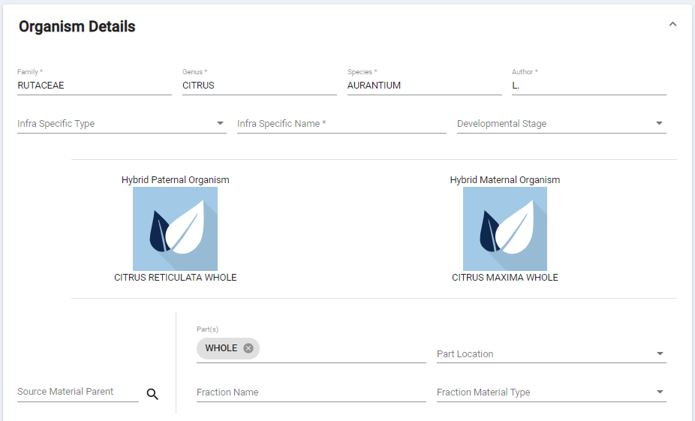

Part/Fraction Fields

Whole Fields

Figure 124 - Structurally Diverse Registration - Organism Details

### Agent Modifications

Same as in Protein registration - Agent Modifications

### Structural Modifications

Follow the steps in the Protein registration – Structural Modifications.

### Physical Modifications

Same as in Protein registration - Physical Modifications

### Modifications for Gene and Cell Therapies Example

Gene therapy and cell therapy are rapidly evolving fields for treatment. These are complex modified biological materials and captured structurally diverse substances. All the modifications should be captured under these modifications.

Example: Ad5 [E1-, E2b-]-HER2/Neu vaccine ETBX-021: A cancer vaccine composed of a genetically engineered, replication-defective oncolytic adenovirus serotype 5 (Ad5) vector, in which the E1, E2b and E3 genes are deleted, that encodes a modified version of the tumor-associated antigen (TAA) human epidermal growth factor receptor 2 (HER2/neu; ErbB-2; ERBB2), with potential antineoplastic activity.

<https://www.cancer.gov/publications/dictionaries/cancer-drug/def/793072>

This was registered as structurally diverse whole organism with structural modifications.

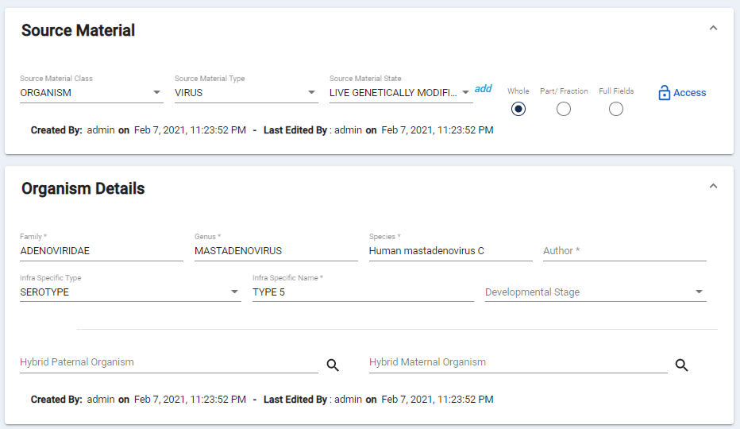

Figure 125 - Structurally Diverse Registration - Cancer Vaccine ETBX-021 Example

Most of the time, the sequence of deleted gene is not available. The expressed protein from that gene could be available. The available information has been captured when registering ETBX-021.

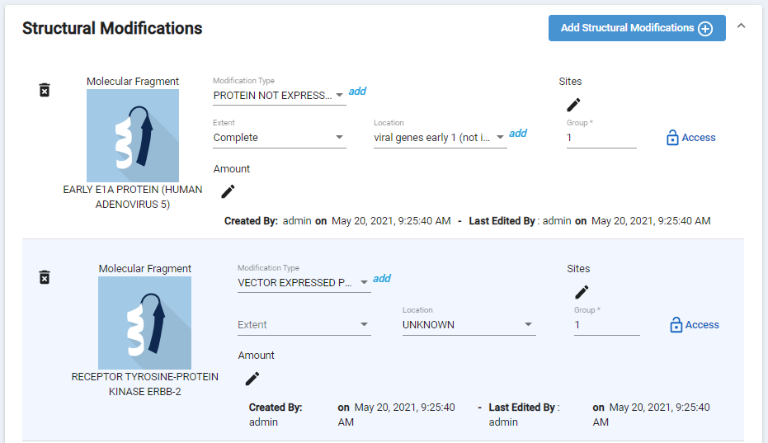

Figure 126 - Structurally Diverse Registration – Structural Modifications for ETBX-021

### Codes

Same as in Chemical registration - Codes

### Relationships

Same as in Chemical registration - Relationships

### Notes

Same as in Chemical registration - Notes

### Properties

Same as in Chemical registration - Properties, Note that, capturing a Property may be important for cell/gene therapy drugs.

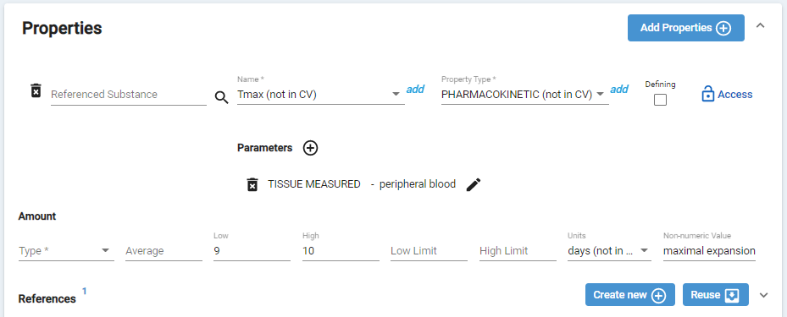

Figure 127 - Structurally Diverse Registration – Property for TISAGENLECLEUCEL

### References

Same as in Chemical registration - References

### Submit

Same as in Chemical registration - Submit

# Register Mixture

Substances that are isolated or synthesized together are considered a mixture. Common examples include coconut acid (Fatty acid isolated from coconut oil) or a mixture of isomers (most commercial products with chiral centers are mixtures of isomers).

## Check for Duplicates

There is only one systematic way to search for structurally diverse duplicates, using the Global Search feature.

### Global Search

Same as in Search. Note that, a search by a component name generates a short list of substances which may include all the mixtures with that component, this list should be reviewed for duplicates.

## Mixture Registration

1. After verifying the substance is not registered in GSRS via your Check for Duplicates, use the Mixture Registration form to register the new substance.
   1. User accounts with registration permissions will have access to the registration menus. If you believe your account is not properly configured, contact your site admin.
2. The mixture registration form will be displayed. Section cards are collapsible to ease navigation, however the elements in this form are:
3. Overview - Definitional Information
4. Names
5. Mixture Details
6. Components
7. Agent modifications
8. Structural modifications
9. Physical modifications
10. Codes
11. Relationships
12. Notes
13. Properties
14. References

### Definitional Information

Same as in Chemical registration - Overview Definitional Information

### Names

Same as in Chemical registration - Names

### Graphical user interface, text, application Description automatically generatedMixture Details

If the mixture substance is a mixture of substances that are isolated together, the Source Material Parent should be captured.

1. Select Mixture Details to expand the card
2. Use the parent substance search box to search for the record for parent substance which should be pre-registered
   1. If the substance is not in GSRS, determine the substance type and register the new record
3. Access level should be protected if the component information is not public, even if name is public.

### Components

Figure 128 - Register Mixture - Mixture Details

1. Select Components to expand the card.
2. Select Add Components button
3. Use the Component Substance field to search GSRS for substances
4. Select the type from drop down
   1. Typically the type will be “must be present (all of)”
   2. At least two components are required

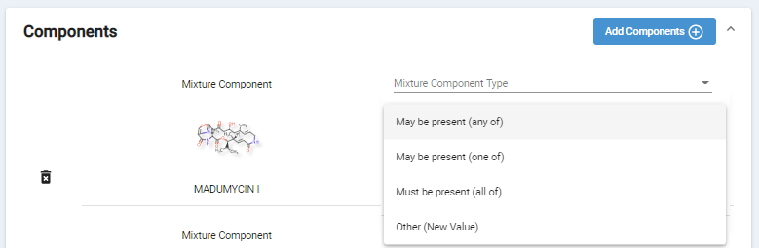

Figure 129 - Register Mixture - Components

### Agent Modifications

Same as in Protein registration - Agent Modifications

### Structural Modifications

Same as in Protein registration – Structural Modifications.

### Physical Modifications

Same as in Protein registration - Physical Modifications

### Names

Same as in Chemical registration - Names

### Codes

Same as in Chemical registration - Codes

### Relationships

Same as in Chemical registration - Relationships

### Notes

Same as in Chemical registration - Notes

### Properties

Same as in Chemical registration - Properties

### References

Same as in Chemical registration - References

### Submit

Same as in Chemical registration - Submit

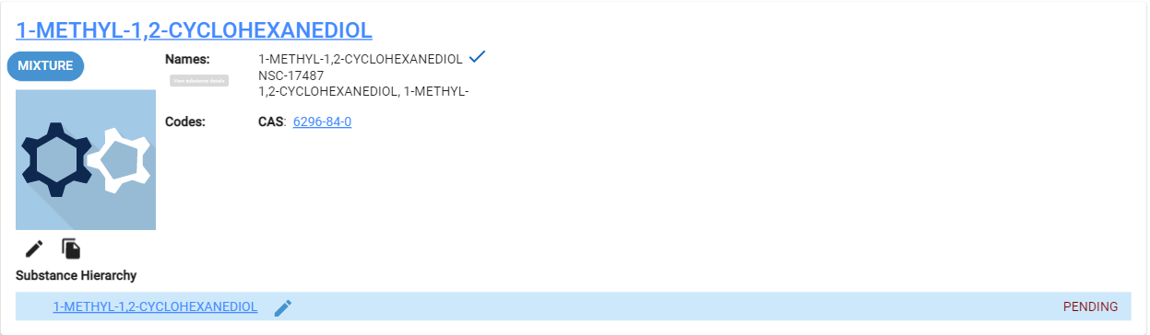

Figure 130 - Mixture

# Register Concept

## Check for Duplicates

There is only one systematic way to search for concept duplicates, using the Global Search feature.

### Global Search

Same as in Search. Note that, a search by a concept name generates a short list of substances which may include all substance types, this list should be reviewed for duplicates.

## Concept Registration

Concepts have no defining information but are collections of terms, codes and related information. They can be promoted to a defined substance later, when appropriate. Examples of concepts include herbal extract/tincture and biosimilars.

1. After verifying the substance is not registered in GSRS via your Check for Duplicates, use the Concept Registration form to register the new substance.
2. User accounts with registration permissions will have access to the registration menus. If you believe your account is not properly configured, contact your site admin.
3. The concept registration form will be displayed. Section cards are collapsible to ease navigation, however the elements in this form are:
4. Overview - Definitional Information
5. Names
6. Code
7. Relationships
8. Notes
9. Properties
10. References

### Names

Same as in Chemical registration - Names

### Codes

Same as in Chemical registration - Codes.

### Relationships

Same as in Chemical registration - Relationships

* Use the relationship type Substance -> Sub_concept for herbal extracts/tincture and biosimilars
* Use the Constituent Always Present -> Parent relationship types for components

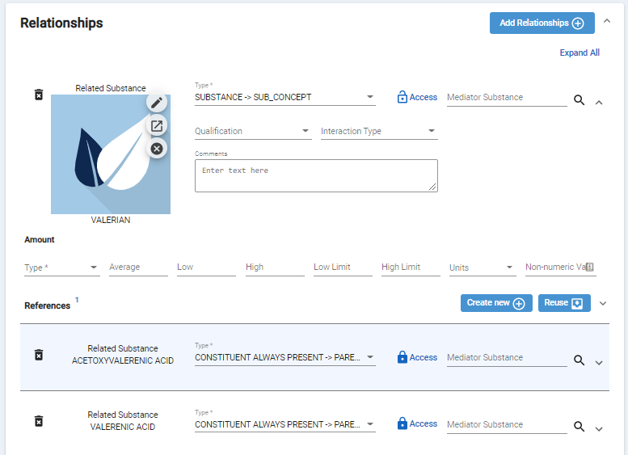

Figure 131 - Concept Registration – Relationships - New

### Notes

Same as in Chemical registration - Notes

### Properties

Same as in Chemical registration - Properties

### References

Same as in Chemical registration - References

### Submit

Same as in Chemical registration - Submit

# Approve Substances

Substance registration require two subject matter experts to review, verify, and confirm that the registered definition is valid, unique, and descriptive of the substance. Once this has been determined, a second reviewer will approve/curate the substance.

1. There are several options to find recently registered substances:
   1. Share the link, ex: <https://gsrs.ncats.nih.gov/ginas/app/beta/substances/fa9f99b9-c77f-45c8-ab7f-a75b36ae65df>
   2. Search
   3. Browse and filter on Record Created By and filter based on the registrar
   4. From the registrars landing page, under Quick Links, select Pending [by substance type]
2. After locating the pending substance, edit the substance
3. At the top of the registration form, the following buttons will be displayed:
   1. Show JSON
   2. Import JSON
   3. Advanced Features
   4. Validate and Submit
   5. Approve – this button is activated if your user account did not register the subject substance and the substance is not already validated
4. If you have changes, request the originating registrar to make the required updates. If you make the updates, you will no longer be able to Approve the substance
5. If you have confirmed that the registration indicates that the substance is valid, unique, and descriptive, press the Approve button

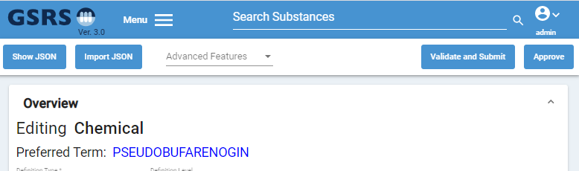

Figure 132 – Substance - Approve

1. GSRS may prompt with Warning messages that were previously dismissed. You may continue by pressing the Confirm Approval button

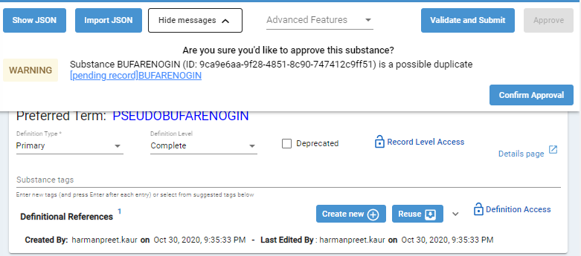

Figure 133 – Substance – Confirm Approval

1. At the Success window, select View Substance, in order to can confirm your approval.
   1. The approved substance record will be assigned the status of Validated
   2. The approval ID will be displayed in red text next to the substance name. For US FDA, the approval ID is the Unique Ingredient Identifier (UNII).

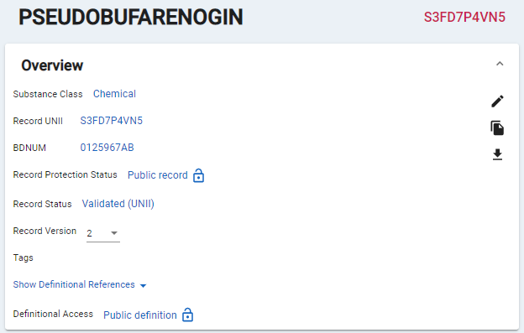

Figure 134 – Substance –Approved

# Edit Substances

Substances in any status can be edited.

1. There are several options to find substances:
   1. Share the link, ex: <https://gsrs.ncats.nih.gov/ginas/app/beta/substances/fa9f99b9-c77f-45c8-ab7f-a75b36ae65df>
   2. Search
   3. Browse and filter
   4. Select a register option from the registrars landing page
2. From the results select the edit pencil

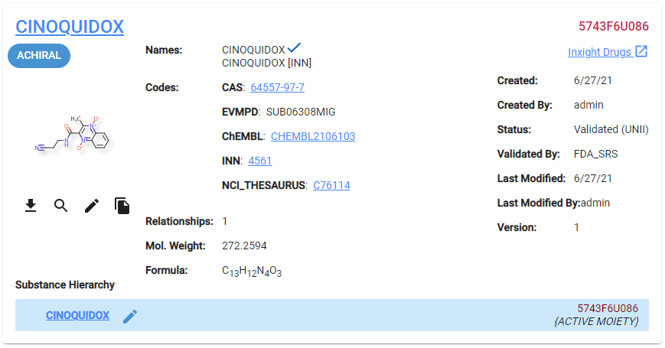

Figure 135 – Substance –Edit

1. The registration form will be displayed. You can update any of the previously entered data or add data that was not previously entered for perform functions under Advanced Features

# Advanced Features

1. After locating the substance, press the Edit pencil
2. At the top of the registration form, the following buttons will be displayed:
   1. Show JSON
   2. Import JSON
   3. Advanced Features
   4. Validate and Submit
   5. Approve – this button is activated if your user account did not register the subject substance and the substance is not already validated
3. Advanced Features is a drop-down menu with options for administrator level users.

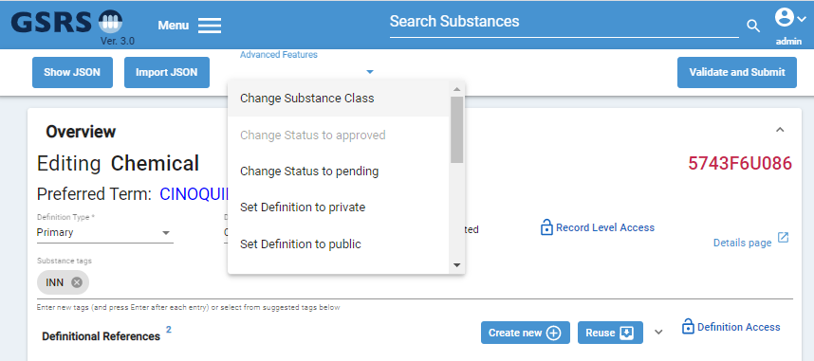

Figure 136 – Substance – Advanced Features

## Change Substance Class

This advanced feature is used to switch a record from one type to another, a common example is to switch a chemical to a protein.

1. In the edit form of the subject substance select Change Substance Class from the Advanced Features drop-down. A second drop-down is displayed for New Class.
2. Select the target class that you want the substance to be updated to from this field

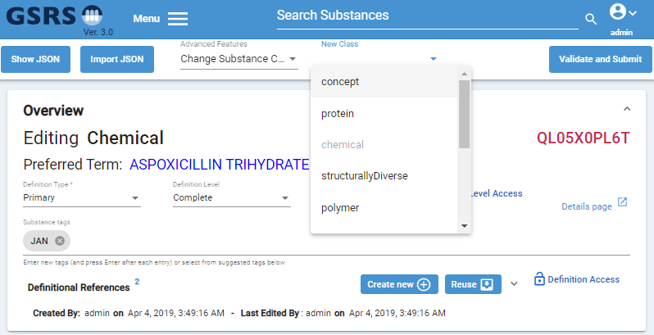

Figure 137 – Substance – Advanced Features – Change Substance Class

1. Your browser will confirm that that “Substance type switched. Submit changes to save”. Press OK.
2. You are returned to the registration form and the substance type is updated, the cards specific to that substance class are not available

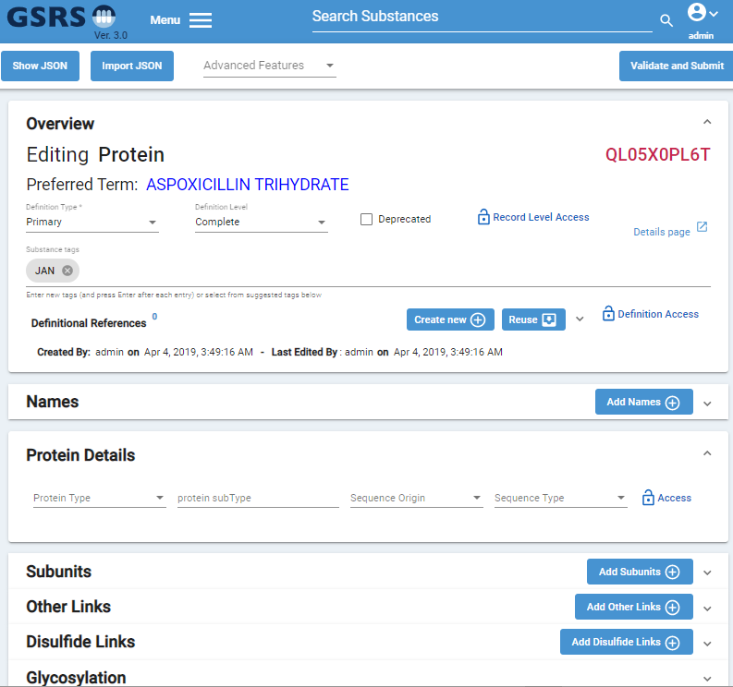

Figure 138 – Substance – Advanced Features – Change Substance Class Results

## Change Status to Pending

In some instances, substances may have an inaccurate status. A common example is a processing or import error that should be reviewed or a mistake that needs to be reverted.

1. In the edit form of the subject substance select Change Status to Pending from the Advanced Features drop-down.
2. Your browser will confirm that that “Status changed to pending”. Press OK.

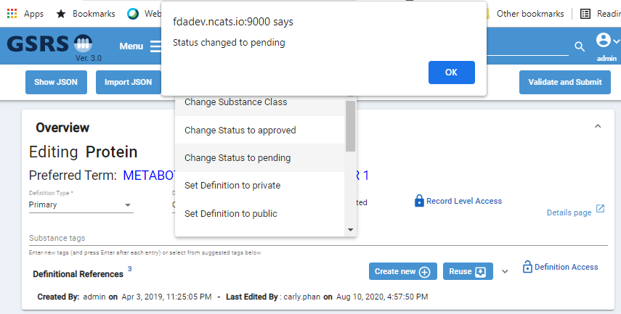

Figure 139 – Substance – Advanced Features – Change Status to Pending

1. The status is not displayed in the registration form, to apply these changes press Validation and Submit.
   1. If you are prompted with existing Errors or Warning, resolve and dismiss as necessary.
2. At the Success window, press the View Substance button. Verify the status and version was updated.

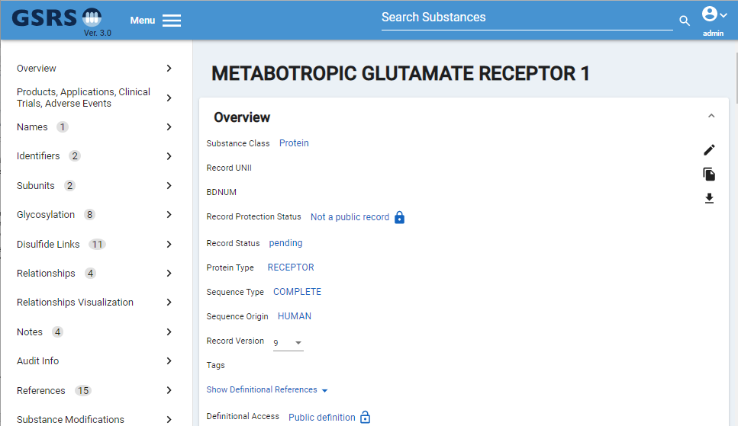

Figure 140 – Substance – Advanced Features –Status to Changed to Pending

## Change Status to Approved

In some instances, substances may have an inaccurate status. A common example is a processing or import error. If after a bulk transfer or mass import of approved records, you have records in Failed status, but you know are already approved use the Change Status to Approved Advanced Feature.

1. In the edit form of the subject substance select Change Status to Approved from the Advanced Features drop-down.
2. Your browser will confirm that that “Status changed to approved”. Press OK.

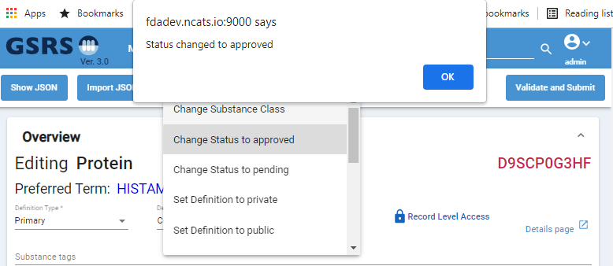

Figure 141 – Substance – Advanced Features – Change Status to Approved

1. The status is not displayed in the registration form, to apply and save your updates, press Validation and Submit.
   1. If you are prompted with existing Errors or Warnings, resolve and dismiss as necessary.
2. At the Success window, press the View Substance button. Verify the status and version are updated and the approval ID was maintained.

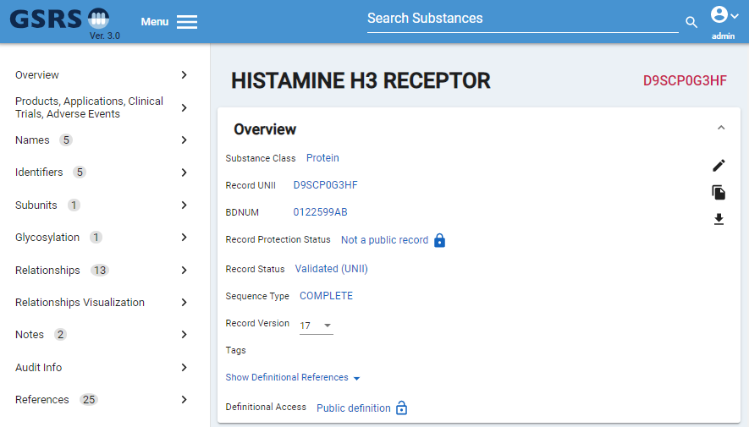

Figure 142 – Substance – Advanced Features –Status Changed to Approved

## Check for Duplicates

When registering a new substance, the first step is to check for duplicates. Performing these steps prior to starting registration ensures that your new registration is unique. There are a few ways to check for duplicates.

1. Go to the Name card and select Validate and submit and look for errors;

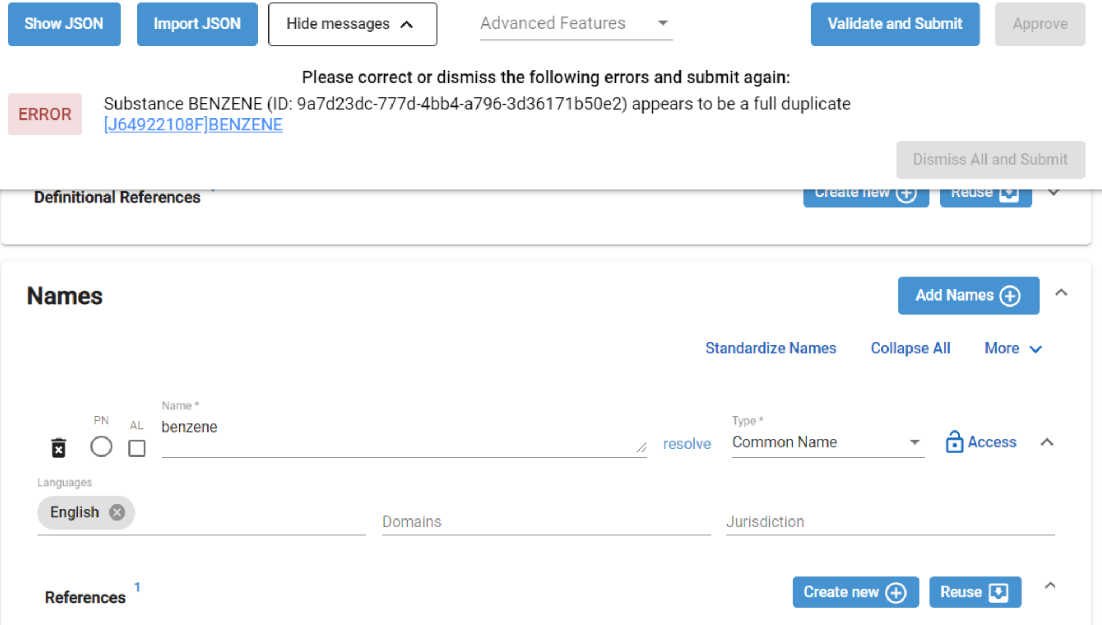

Figure 143 – Names Card – Sample Benzene

1. Select resolve and see the duplicates in the GSRS system;

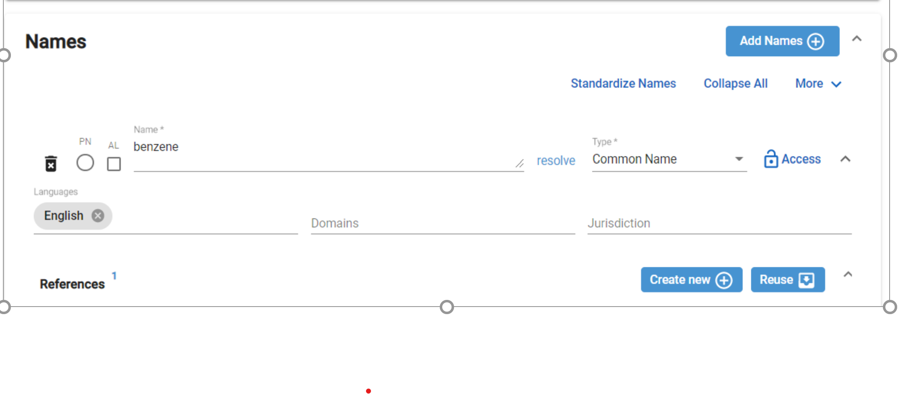 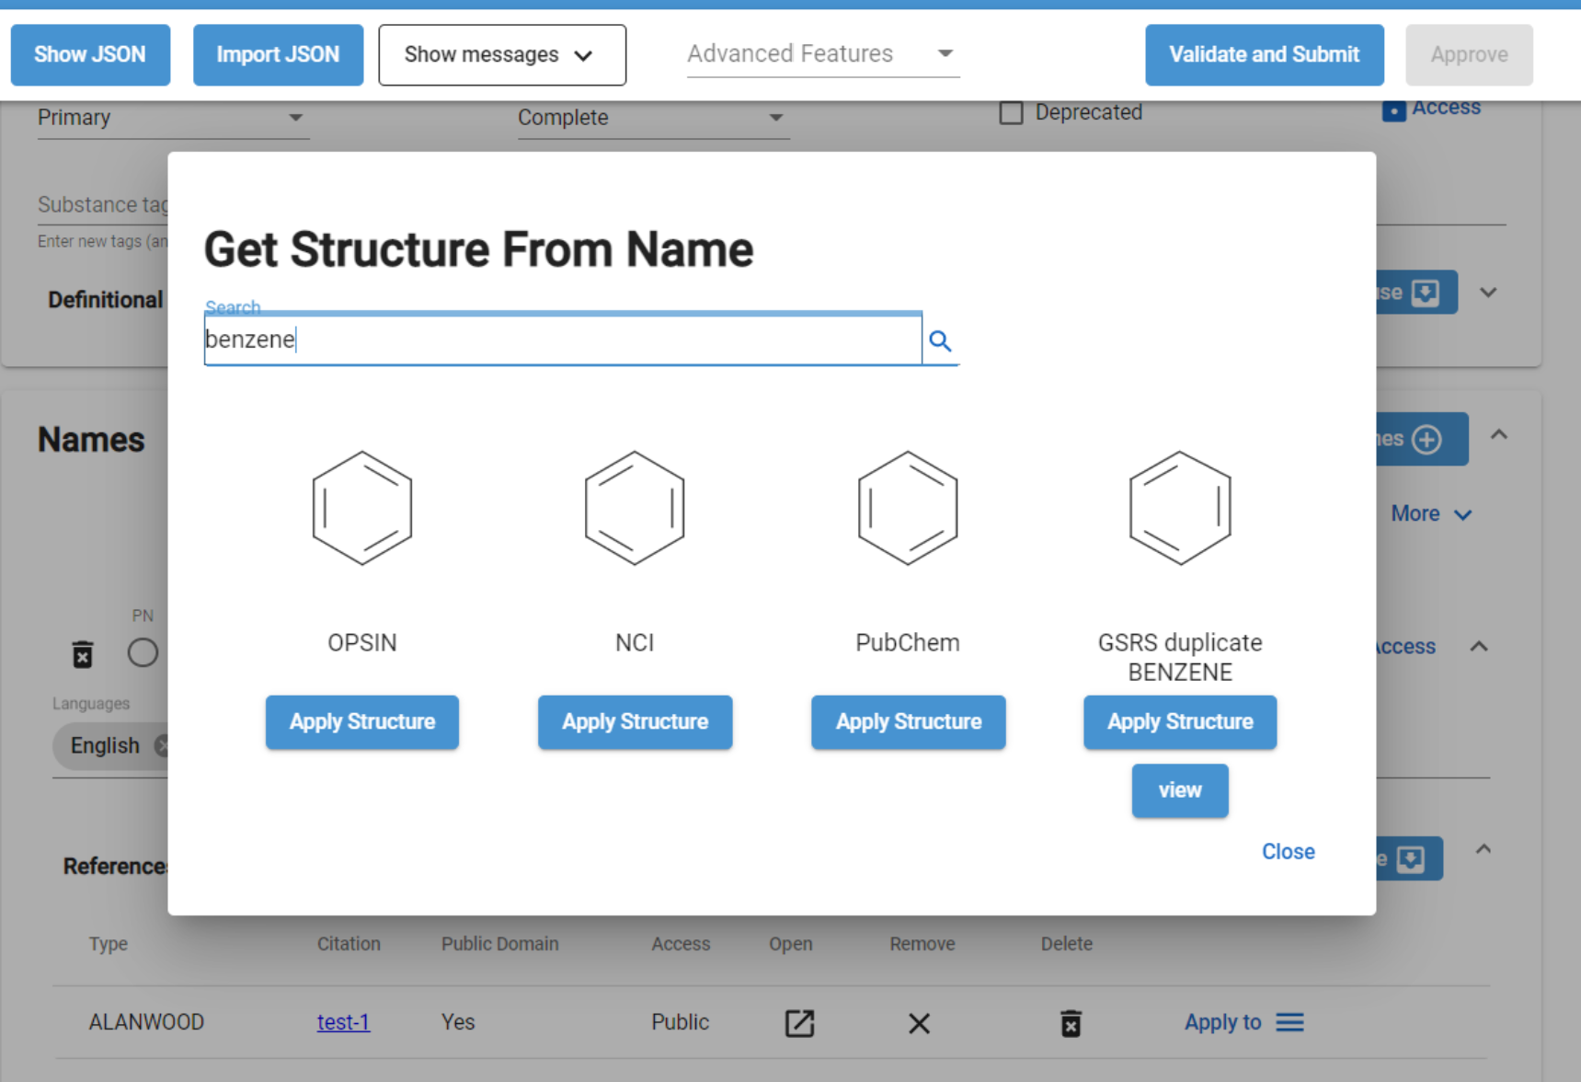

Figure 144 – Names Card – Standardize Name and Resolve; Select Structure from Options

1. Look for structure duplicates by clicking on check for duplicates below the Chemical web editorbox

The search options are available for all users, both registrars and research users. There are several options to check for duplicates (using all will ensure an exhaustive search), search by one of the search options below:

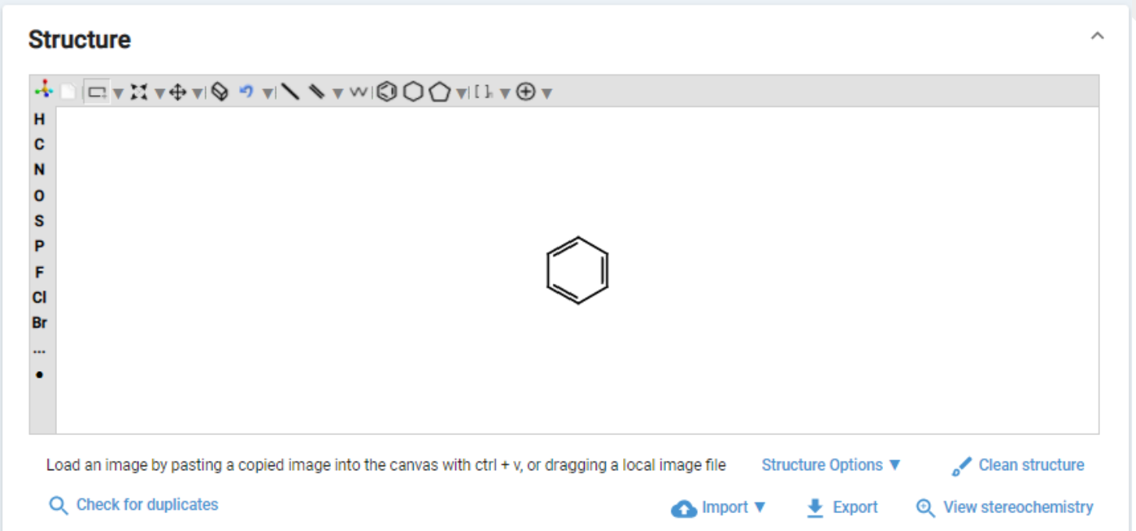

Figure 145 – Structure – Check for Duplicates